**SNOWFLAKE-2025**

**LOADING DATA in Snowflake**

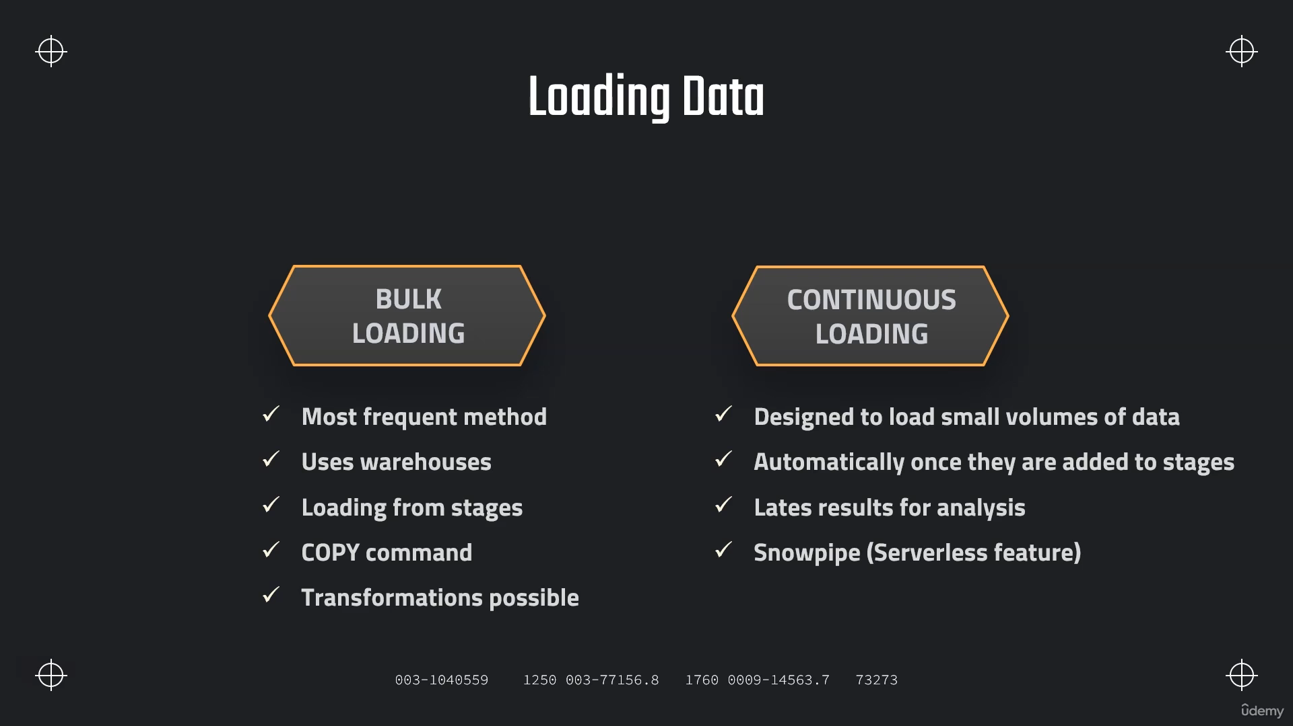

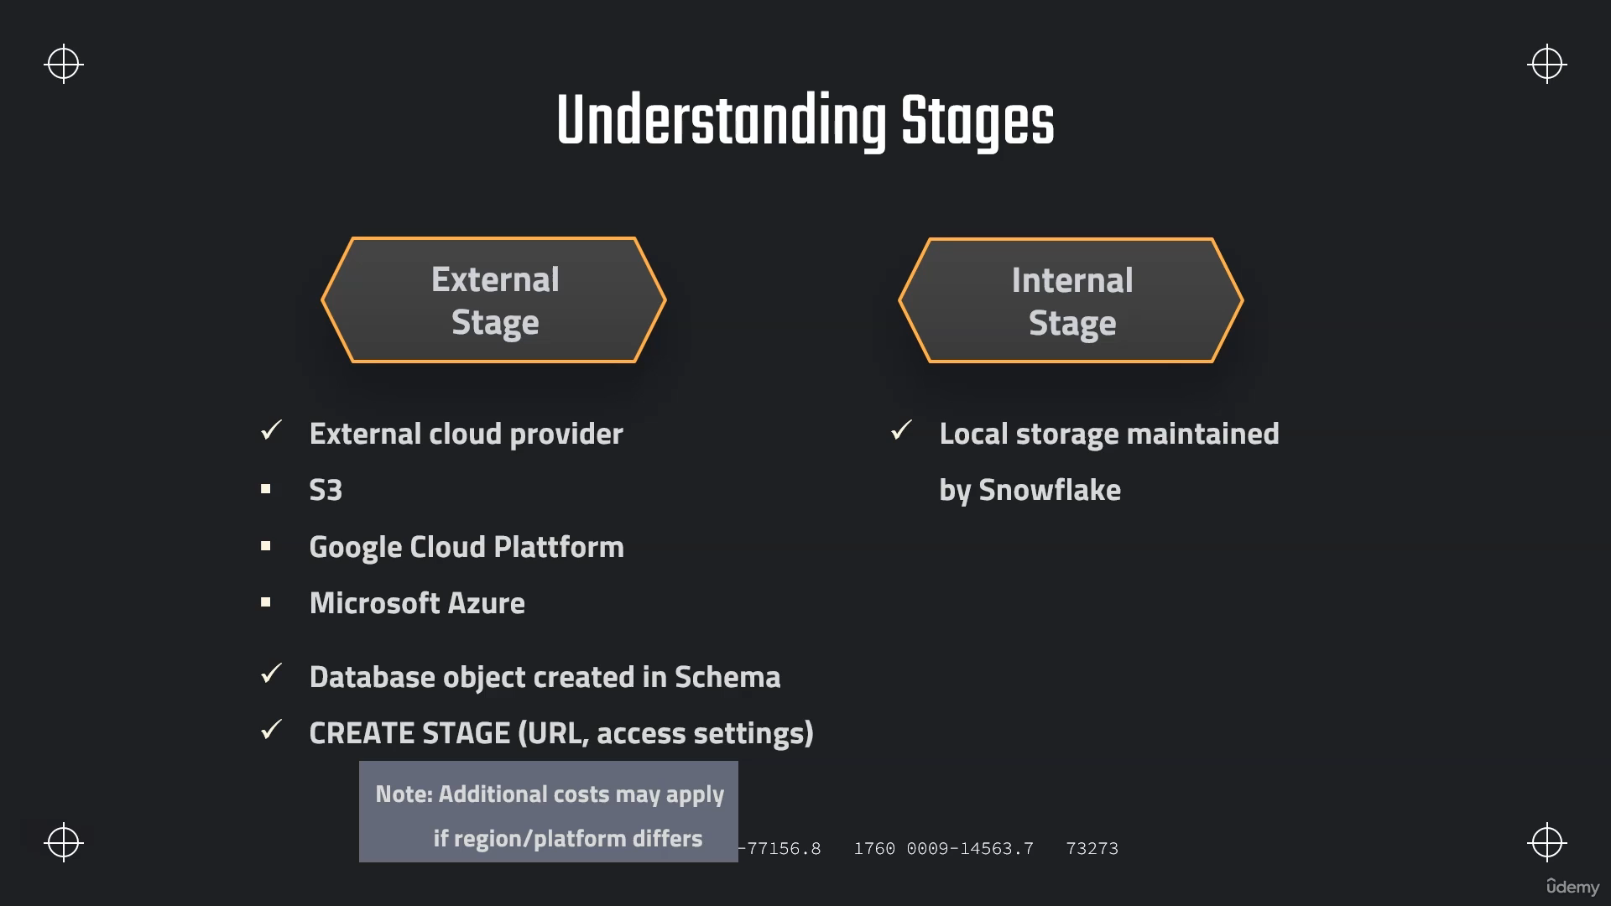

**// Database to manage stage objects, fileformats etc.**

**CREATE OR REPLACE DATABASE MANAGE_DB;**

**CREATE OR REPLACE SCHEMA external_stages;**

**// Creating external stage**

**CREATE OR REPLACE STAGE MANAGE_DB.external_stages.aws_stage**

**url='s3://bucketsnowflakes3'**

**credentials=(aws_key_id='ABCD_DUMMY_ID' aws_secret_key='1234abcd_key');**

**// Description of external stage**

**DESC STAGE MANAGE_DB.external_stages.aws_stage;**

**// Alter external stage**

**ALTER STAGE aws_stage**

**SET credentials=(aws_key_id='XYZ_DUMMY_ID' aws_secret_key='987xyz');**

**// Publicly accessible staging area**

**CREATE OR REPLACE STAGE MANAGE_DB.external_stages.aws_stage**

**url='s3://bucketsnowflakes3';**

**// List files in stage**

**LIST @aws_stage;**

**Copy Command**

**// Creating ORDERS table**

**CREATE OR REPLACE TABLE OUR_FIRST_DB.PUBLIC.ORDERS (**

**ORDER_ID VARCHAR(30),**

**AMOUNT INT,**

**PROFIT INT,**

**QUANTITY INT,**

**CATEGORY VARCHAR(30),**

**SUBCATEGORY VARCHAR(30));**

**SELECT * FROM OUR_FIRST_DB.PUBLIC.ORDERS;**

**// First copy command**

**COPY INTO OUR_FIRST_DB.PUBLIC.ORDERS**

**FROM @aws_stage**

**file_format = (type = csv field_delimiter=',' skip_header=1);**

**// Copy command with fully qualified stage object**

**COPY INTO OUR_FIRST_DB.PUBLIC.ORDERS**

**FROM @MANAGE_DB.external_stages.aws_stage**

**file_format= (type = csv field_delimiter=',' skip_header=1);**

**// List files contained in stage**

**LIST @MANAGE_DB.external_stages.aws_stage;**

**// Copy command with specified file(s)**

**COPY INTO OUR_FIRST_DB.PUBLIC.ORDERS**

**FROM @MANAGE_DB.external_stages.aws_stage**

**file_format= (type = csv field_delimiter=',' skip_header=1)**

**files = ('OrderDetails.csv');**

**// Copy command with pattern for file names**

**COPY INTO OUR_FIRST_DB.PUBLIC.ORDERS**

**FROM @MANAGE_DB.external_stages.aws_stage**

**file_format= (type = csv field_delimiter=',' skip_header=1)**

**pattern='.*Order.*';**

**// Transforming using the SELECT statement**

COPY INTO OUR_FIRST_DB.PUBLIC.ORDERS_EX

FROM (select s.$1, s.$2 from @MANAGE_DB.external_stages.aws_stage s)

file_format= (type = csv field_delimiter=',' skip_header=1)

files=('OrderDetails.csv');

**// Example 1 - Table**

**CREATE OR REPLACE TABLE OUR_FIRST_DB.PUBLIC.ORDERS_EX (**

**ORDER_ID VARCHAR(30),**

**AMOUNT INT);**

**SELECT * FROM OUR_FIRST_DB.PUBLIC.ORDERS_EX;**

**// Example 2 - Table**

**CREATE OR REPLACE TABLE OUR_FIRST_DB.PUBLIC.ORDERS_EX (**

**ORDER_ID VARCHAR(30),**

**AMOUNT INT,**

**PROFIT INT,**

**PROFITABLE_FLAG VARCHAR(30));**

**// Example 2 - Copy Command using a SQL function (subset of functions available)**

**COPY INTO OUR_FIRST_DB.PUBLIC.ORDERS_EX**

**FROM (select**

**s.$1,**

**s.$2,**

**s.$3,**

**CASE WHEN CAST(s.$3 as int) < 0 THEN 'not profitable' ELSE 'profitable' END**

**from @MANAGE_DB.external_stages.aws_stage s)**

**file_format= (type = csv field_delimiter=',' skip_header=1)**

**files=('OrderDetails.csv');**

**SELECT * FROM OUR_FIRST_DB.PUBLIC.ORDERS_EX;**

**// Example 3 - Table**

**CREATE OR REPLACE TABLE OUR_FIRST_DB.PUBLIC.ORDERS_EX (**

**ORDER_ID VARCHAR(30),**

**AMOUNT INT,**

**PROFIT INT,**

**CATEGORY_SUBSTRING VARCHAR(5)**

**);**

**// Example 3 - Copy Command using a SQL function (subset of functions available)**

**COPY INTO OUR_FIRST_DB.PUBLIC.ORDERS_EX**

**FROM (select**

**s.$1,**

**s.$2,**

**s.$3,**

**substring(s.$5,1,5)**

**from @MANAGE_DB.external_stages.aws_stage s)**

**file_format= (type = csv field_delimiter=',' skip_header=1)**

**files=('OrderDetails.csv');**

**SELECT * FROM OUR_FIRST_DB.PUBLIC.ORDERS_EX;**

**//Example 3 - Table**

**CREATE OR REPLACE TABLE OUR_FIRST_DB.PUBLIC.ORDERS_EX (**

**ORDER_ID VARCHAR(30),**

**AMOUNT INT,**

**PROFIT INT,**

**PROFITABLE_FLAG VARCHAR(30)**

**);**

**//Example 4 - Using subset of columns**

**COPY INTO OUR_FIRST_DB.PUBLIC.ORDERS_EX (ORDER_ID,PROFIT)**

**FROM (select**

**s.$1,**

**s.$3**

**from @MANAGE_DB.external_stages.aws_stage s)**

**file_format= (type = csv field_delimiter=',' skip_header=1)**

**files=('OrderDetails.csv');**

**SELECT * FROM OUR_FIRST_DB.PUBLIC.ORDERS_EX;**

**//Example 5 - Table Auto increment**

**CREATE OR REPLACE TABLE OUR_FIRST_DB.PUBLIC.ORDERS_EX (**

**ORDER_ID number autoincrement start 1 increment 1,**

**AMOUNT INT,**

**PROFIT INT,**

**PROFITABLE_FLAG VARCHAR(30)**

**);**

**//Example 5 - Auto increment ID**

**COPY INTO OUR_FIRST_DB.PUBLIC.ORDERS_EX (PROFIT,AMOUNT)**

**FROM (select**

**s.$2,**

**s.$3**

**from @MANAGE_DB.external_stages.aws_stage s)**

**file_format= (type = csv field_delimiter=',' skip_header=1)**

**files=('OrderDetails.csv');**

**SELECT * FROM OUR_FIRST_DB.PUBLIC.ORDERS_EX WHERE ORDER_ID > 15;**

**DROP TABLE OUR_FIRST_DB.PUBLIC.ORDERS_EX;**

**COPY OPTION ON_ERROR**

**// Create new stage**

**CREATE OR REPLACE STAGE MANAGE_DB.external_stages.aws_stage_errorex**

**url='s3://bucketsnowflakes4';**

**// List files in stage**

**LIST @MANAGE_DB.external_stages.aws_stage_errorex;**

**// Create example table**

**CREATE OR REPLACE TABLE OUR_FIRST_DB.PUBLIC.ORDERS_EX (**

**ORDER_ID VARCHAR(30),**

**AMOUNT INT,**

**PROFIT INT,**

**QUANTITY INT,**

**CATEGORY VARCHAR(30),**

**SUBCATEGORY VARCHAR(30));**

**// Demonstrating error message**

**COPY INTO OUR_FIRST_DB.PUBLIC.ORDERS_EX**

**FROM @MANAGE_DB.external_stages.aws_stage_errorex**

**file_format= (type = csv field_delimiter=',' skip_header=1)**

**files = ('OrderDetails_error.csv');**

**// Validating table is empty**

**SELECT * FROM OUR_FIRST_DB.PUBLIC.ORDERS_EX ;**

**// Error handling using the ON_ERROR option**

**COPY INTO OUR_FIRST_DB.PUBLIC.ORDERS_EX**

**FROM @MANAGE_DB.external_stages.aws_stage_errorex**

**file_format= (type = csv field_delimiter=',' skip_header=1)**

**files = ('OrderDetails_error.csv')**

**ON_ERROR = 'CONTINUE';**

**// Validating results and truncating table**

**SELECT * FROM OUR_FIRST_DB.PUBLIC.ORDERS_EX;**

**SELECT COUNT(*) FROM OUR_FIRST_DB.PUBLIC.ORDERS_EX;**

**TRUNCATE TABLE OUR_FIRST_DB.PUBLIC.ORDERS_EX;**

**// Error handling using the ON_ERROR option = ABORT_STATEMENT (default)**

**COPY INTO OUR_FIRST_DB.PUBLIC.ORDERS_EX**

**FROM @MANAGE_DB.external_stages.aws_stage_errorex**

**file_format= (type = csv field_delimiter=',' skip_header=1)**

**files = ('OrderDetails_error.csv','OrderDetails_error2.csv')**

**ON_ERROR = 'ABORT_STATEMENT';**

**// Validating results and truncating table**

**SELECT * FROM OUR_FIRST_DB.PUBLIC.ORDERS_EX;**

**SELECT COUNT(*) FROM OUR_FIRST_DB.PUBLIC.ORDERS_EX;**

**TRUNCATE TABLE OUR_FIRST_DB.PUBLIC.ORDERS_EX;**

**// Error handling using the ON_ERROR option = SKIP_FILE**

**COPY INTO OUR_FIRST_DB.PUBLIC.ORDERS_EX**

**FROM @MANAGE_DB.external_stages.aws_stage_errorex**

**file_format= (type = csv field_delimiter=',' skip_header=1)**

**files = ('OrderDetails_error.csv','OrderDetails_error2.csv')**

**ON_ERROR = 'SKIP_FILE';**

**// Validating results and truncating table**

**SELECT * FROM OUR_FIRST_DB.PUBLIC.ORDERS_EX;**

**SELECT COUNT(*) FROM OUR_FIRST_DB.PUBLIC.ORDERS_EX;**

**TRUNCATE TABLE OUR_FIRST_DB.PUBLIC.ORDERS_EX;**

**// Error handling using the ON_ERROR option = SKIP_FILE_<number>**

**COPY INTO OUR_FIRST_DB.PUBLIC.ORDERS_EX**

**FROM @MANAGE_DB.external_stages.aws_stage_errorex**

**file_format= (type = csv field_delimiter=',' skip_header=1)**

**files = ('OrderDetails_error.csv','OrderDetails_error2.csv')**

**ON_ERROR = 'SKIP_FILE_2';**

**// Validating results and truncating table**

**SELECT * FROM OUR_FIRST_DB.PUBLIC.ORDERS_EX;**

**SELECT COUNT(*) FROM OUR_FIRST_DB.PUBLIC.ORDERS_EX;**

**TRUNCATE TABLE OUR_FIRST_DB.PUBLIC.ORDERS_EX;**

**// Error handling using the ON_ERROR option = SKIP_FILE_<number>**

**COPY INTO OUR_FIRST_DB.PUBLIC.ORDERS_EX**

**FROM @MANAGE_DB.external_stages.aws_stage_errorex**

**file_format= (type = csv field_delimiter=',' skip_header=1)**

**files = ('OrderDetails_error.csv','OrderDetails_error2.csv')**

**ON_ERROR = 'SKIP_FILE_3%';**

**SELECT * FROM OUR_FIRST_DB.PUBLIC.ORDERS_EX;**

**CREATE OR REPLACE TABLE OUR_FIRST_DB.PUBLIC.ORDERS_EX (**

**ORDER_ID VARCHAR(30),**

**AMOUNT INT,**

**PROFIT INT,**

**QUANTITY INT,**

**CATEGORY VARCHAR(30),**

**SUBCATEGORY VARCHAR(30));**

**COPY INTO OUR_FIRST_DB.PUBLIC.ORDERS_EX**

**FROM @MANAGE_DB.external_stages.aws_stage_errorex**

**file_format= (type = csv field_delimiter=',' skip_header=1)**

**files = ('OrderDetails_error.csv','OrderDetails_error2.csv')**

**ON_ERROR = SKIP_FILE_3**

**SIZE_LIMIT = 30;**

**File Format Object :-**

**// Specifying file_format in Copy command**

**COPY INTO OUR_FIRST_DB.PUBLIC.ORDERS_EX**

**FROM @MANAGE_DB.external_stages.aws_stage_errorex**

**file_format = (type = csv field_delimiter=',' skip_header=1)**

**files = ('OrderDetails_error.csv')**

**ON_ERROR = 'SKIP_FILE_3';**

**// Creating table**

**CREATE OR REPLACE TABLE OUR_FIRST_DB.PUBLIC.ORDERS_EX (**

**ORDER_ID VARCHAR(30),**

**AMOUNT INT,**

**PROFIT INT,**

**QUANTITY INT,**

**CATEGORY VARCHAR(30),**

**SUBCATEGORY VARCHAR(30));**

**// Creating schema to keep things organized**

**CREATE OR REPLACE SCHEMA MANAGE_DB.file_formats;**

**// Creating file format object**

**CREATE OR REPLACE file format MANAGE_DB.file_formats.my_file_format;**

**// See properties of file format object**

**DESC file format MANAGE_DB.file_formats.my_file_format;**

**// Using file format object in Copy command**

**COPY INTO OUR_FIRST_DB.PUBLIC.ORDERS_EX**

**FROM @MANAGE_DB.external_stages.aws_stage_errorex**

**file_format= (FORMAT_NAME=MANAGE_DB.file_formats.my_file_format)**

**files = ('OrderDetails_error.csv')**

**ON_ERROR = 'SKIP_FILE_3';**

**// Altering file format object**

**ALTER file format MANAGE_DB.file_formats.my_file_format**

**SET SKIP_HEADER = 1;**

**// Defining properties on creation of file format object**

**CREATE OR REPLACE file format MANAGE_DB.file_formats.my_file_format**

**TYPE=JSON,**

**TIME_FORMAT=AUTO;**

**// See properties of file format object**

**DESC file format MANAGE_DB.file_formats.my_file_format;**

**// Using file format object in Copy command**

**COPY INTO OUR_FIRST_DB.PUBLIC.ORDERS_EX**

**FROM @MANAGE_DB.external_stages.aws_stage_errorex**

**file_format= (FORMAT_NAME=MANAGE_DB.file_formats.my_file_format)**

**files = ('OrderDetails_error.csv')**

**ON_ERROR = 'SKIP_FILE_3';**

**// Altering the type of a file format is not possible**

**ALTER file format MANAGE_DB.file_formats.my_file_format**

**SET TYPE = CSV;**

**// Recreate file format (default = CSV)**

**CREATE OR REPLACE file format MANAGE_DB.file_formats.my_file_format;**

**// See properties of file format object**

**DESC file format MANAGE_DB.file_formats.my_file_format;**

**// Truncate table**

**TRUNCATE table OUR_FIRST_DB.PUBLIC.ORDERS_EX;**

**// Overwriting properties of file format object**

**COPY INTO OUR_FIRST_DB.PUBLIC.ORDERS_EX**

**FROM @MANAGE_DB.external_stages.aws_stage_errorex**

**file_format = (FORMAT_NAME= MANAGE_DB.file_formats.my_file_format field_delimiter = ',' skip_header=1 )**

**files = ('OrderDetails_error.csv')**

**ON_ERROR = 'SKIP_FILE_3';**

**DESC STAGE MANAGE_DB.external_stages.aws_stage_errorex;**

**Example 1:-**

**---- Assignment - Create file format & load data ----**

**-- create stage object**

**CREATE OR REPLACE STAGE EXERCISE_DB.public.aws_stage**

**url='s3://snowflake-assignments-mc/fileformat';**

**-- List files in stage**

**LIST @EXERCISE_DB.public.aws_stage;**

**-- create file format object**

**CREATE OR REPLACE FILE FORMAT EXERCISE_DB.public.aws_fileformat**

**TYPE = CSV**

**FIELD_DELIMITER='|'**

**SKIP_HEADER=1;**

**-- Load the data**

**COPY INTO EXERCISE_DB.PUBLIC.CUSTOMERS**

**FROM @aws_stage**

**file_format= (FORMAT_NAME=EXERCISE_DB.public.aws_fileformat)**

**-- Alternative**

**COPY INTO EXERCISE_DB.PUBLIC.CUSTOMERS**

**FROM @aws_stage**

**file_format= EXERCISE_DB.public.aws_fileformat**

**Copy Options :-**

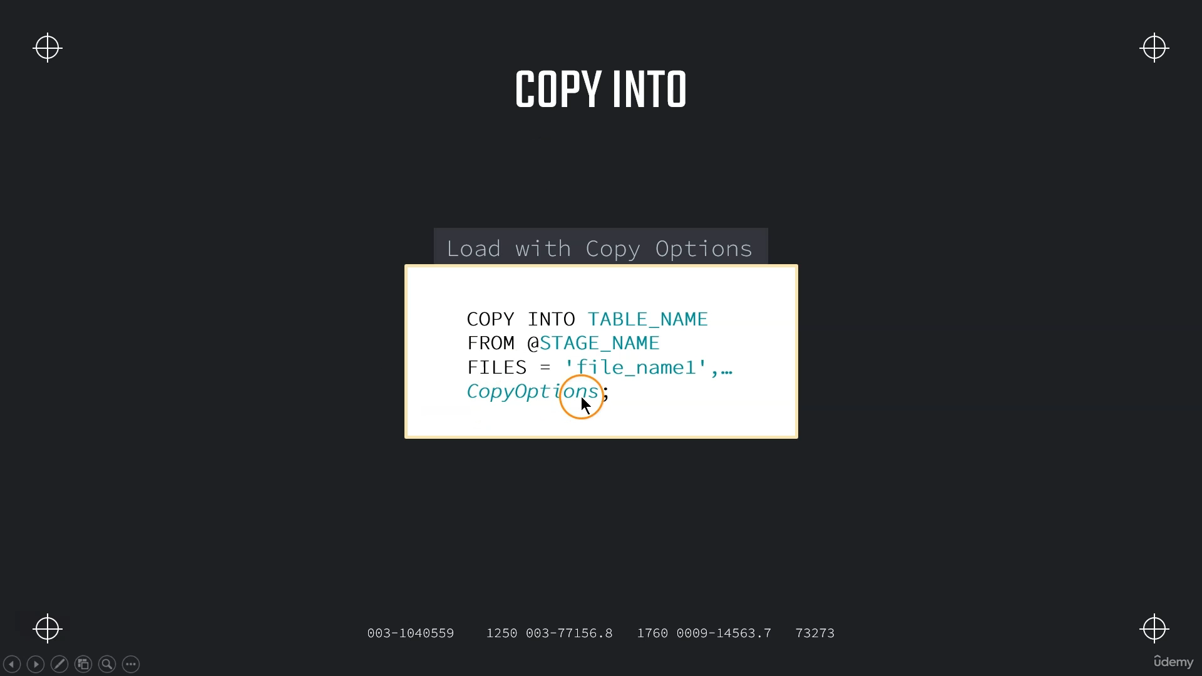

**Valdaition Mode**

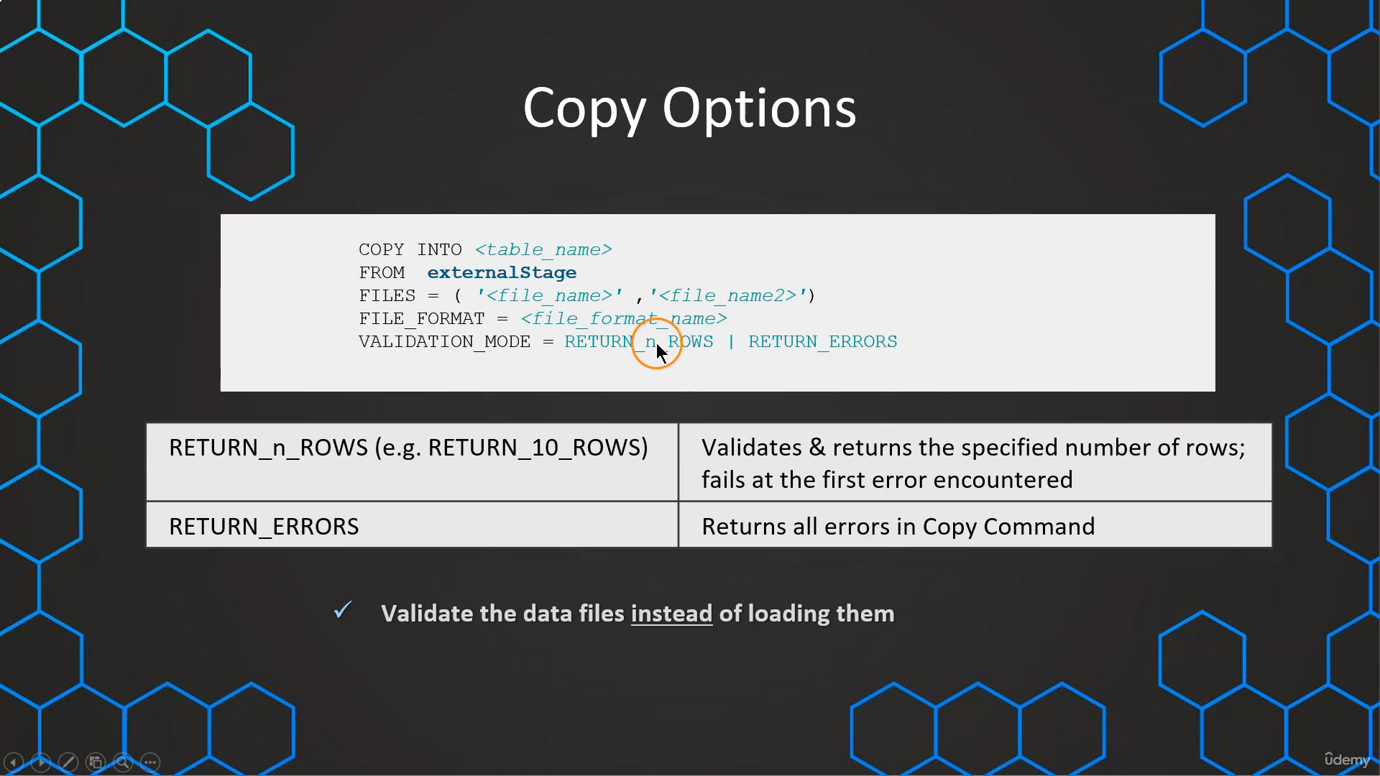

**---- VALIDATION_MODE ----**

**// Prepare database & table**

**CREATE OR REPLACE DATABASE COPY_DB;**

**CREATE OR REPLACE TABLE COPY_DB.PUBLIC.ORDERS (**

**ORDER_ID VARCHAR(30),**

**AMOUNT VARCHAR(30),**

**PROFIT INT,**

**QUANTITY INT,**

**CATEGORY VARCHAR(30),**

**SUBCATEGORY VARCHAR(30));**

**// Prepare stage object**

**CREATE OR REPLACE STAGE COPY_DB.PUBLIC.aws_stage_copy**

**url='s3://snowflakebucket-copyoption/size/';**

**LIST @COPY_DB.PUBLIC.aws_stage_copy;**

**//Load data using copy command**

**COPY INTO COPY_DB.PUBLIC.ORDERS**

**FROM @aws_stage_copy**

**file_format= (type = csv field_delimiter=',' skip_header=1)**

**pattern='.*Order.*'**

**VALIDATION_MODE = RETURN_ERRORS;**

**SELECT * FROM ORDERS;**

**COPY INTO COPY_DB.PUBLIC.ORDERS**

**FROM @aws_stage_copy**

**file_format= (type = csv field_delimiter=',' skip_header=1)**

**pattern='.*Order.*'**

**VALIDATION_MODE = RETURN_5_ROWS ;**

**--- Use files with errors ---**

**create or replace stage copy_db.public.aws_stage_copy**

**url ='s3://snowflakebucket-copyoption/returnfailed/';**

**list @copy_db.public.aws_stage_copy;**

**-- show all errors --**

**copy into copy_db.public.orders**

**from @copy_db.public.aws_stage_copy**

**file_format = (type=csv field_delimiter=',' skip_header=1)**

**pattern='.*Order.*'**

**validation_mode=return_errors;**

**copy into copy_db.public.orders**

**from @copy_db.public.aws_stage_copy**

**file_format = (type=csv field_delimiter=',' skip_header=1)**

**pattern='.*Order.*'**

**validation_mode=return_5_rows;**

**-- validate first n rows --**

**copy into copy_db.public.orders**

**from @copy_db.public.aws_stage_copy**

**file_format = (type=csv field_delimiter=',' skip_header=1)**

**pattern='.*error.*'**

**validation_mode=return_1_rows;**

**Exercise Example**

**--- Assignment - Create file format & load data ----**

**-- create table**

**create or replace table employees(**

**customer_id int,**

**first_name varchar(50),**

**last_name varchar(50),**

**email varchar(50),**

**age int,**

**city varchar(50));**

**-- create file format object**

**CREATE OR REPLACE FILE FORMAT EXERCISE_DB.public.aws_fileformat**

**TYPE = CSV**

**FIELD_DELIMITER=','**

**SKIP_HEADER=1;**

**-- create stage object**

**CREATE OR REPLACE STAGE EXERCISE_DB.public.aws_stage**

**url='s3://snowflake-assignments-mc/copyoptions/example1';**

**-- List files in stage**

**LIST @EXERCISE_DB.public.aws_stage;**

**-- Use validation mode**

**COPY INTO EXERCISE_DB.PUBLIC.EMPLOYEES**

**FROM @aws_stage**

**file_format= EXERCISE_DB.public.aws_fileformat**

**VALIDATION_MODE = RETURN_ERRORS;**

**-- Use ON_ERROR**

**COPY INTO EXERCISE_DB.PUBLIC.EMPLOYEES**

**FROM @aws_stage**

**file_format= EXERCISE_DB.public.aws_fileformat**

**ON_ERROR = CONTINUE;**

**Working With Rejected Records**

**---- Use files with errors ----**

**CREATE OR REPLACE STAGE COPY_DB.PUBLIC.aws_stage_copy**

**url='s3://snowflakebucket-copyoption/returnfailed/';**

**LIST @COPY_DB.PUBLIC.aws_stage_copy;**

**COPY INTO COPY_DB.PUBLIC.ORDERS**

**FROM @aws_stage_copy**

**file_format= (type = csv field_delimiter=',' skip_header=1)**

**pattern='.*Order.*'**

**VALIDATION_MODE = RETURN_ERRORS;**

**COPY INTO COPY_DB.PUBLIC.ORDERS**

**FROM @aws_stage_copy**

**file_format= (type = csv field_delimiter=',' skip_header=1)**

**pattern='.*Order.*'**

**VALIDATION_MODE = RETURN_1_rows;**

**-------------- Working with error results -----------**

**---- 1) Saving rejected files after VALIDATION_MODE ----**

**CREATE OR REPLACE TABLE COPY_DB.PUBLIC.ORDERS (**

**ORDER_ID VARCHAR(30),**

**AMOUNT VARCHAR(30),**

**PROFIT INT,**

**QUANTITY INT,**

**CATEGORY VARCHAR(30),**

**SUBCATEGORY VARCHAR(30));**

**COPY INTO COPY_DB.PUBLIC.ORDERS**

**FROM @aws_stage_copy**

**file_format= (type = csv field_delimiter=',' skip_header=1)**

**pattern='.*Order.*'**

**VALIDATION_MODE = RETURN_ERRORS;**

**01b94387-030b-c8b6-000a-7df70001b66a;**

**// Storing rejected /failed results in a table**

**CREATE OR REPLACE TABLE rejected AS**

**select rejected_record from table(result_scan('01b94387-030b-c8b6-000a-7df70001b66a'));**

**select * from rejected;**

**-- Adding additional records --**

**INSERT INTO rejected**

**select rejected_record from table(result_scan(last_query_id()));**

**SELECT * FROM rejected;**

**---- 2) Saving rejected files without VALIDATION_MODE ----**

**COPY INTO COPY_DB.PUBLIC.ORDERS**

**FROM @aws_stage_copy**

**file_format= (type = csv field_delimiter=',' skip_header=1)**

**pattern='.*Order.*'**

**ON_ERROR=CONTINUE;**

**select * from table(validate(orders, job_id => '_last'));**

**---- 3) Working with rejected records ----**

**SELECT REJECTED_RECORD FROM rejected;**

**CREATE OR REPLACE TABLE rejected_values as**

**SELECT**

**SPLIT_PART(rejected_record,',',1) as ORDER_ID,**

**SPLIT_PART(rejected_record,',',2) as AMOUNT,**

**SPLIT_PART(rejected_record,',',3) as PROFIT,**

**SPLIT_PART(rejected_record,',',4) as QUATNTITY,**

**SPLIT_PART(rejected_record,',',5) as CATEGORY,**

**SPLIT_PART(rejected_record,',',6) as SUBCATEGORY**

**FROM rejected;**

**SELECT * FROM rejected_values;**

**SIZE_LIMIT;**

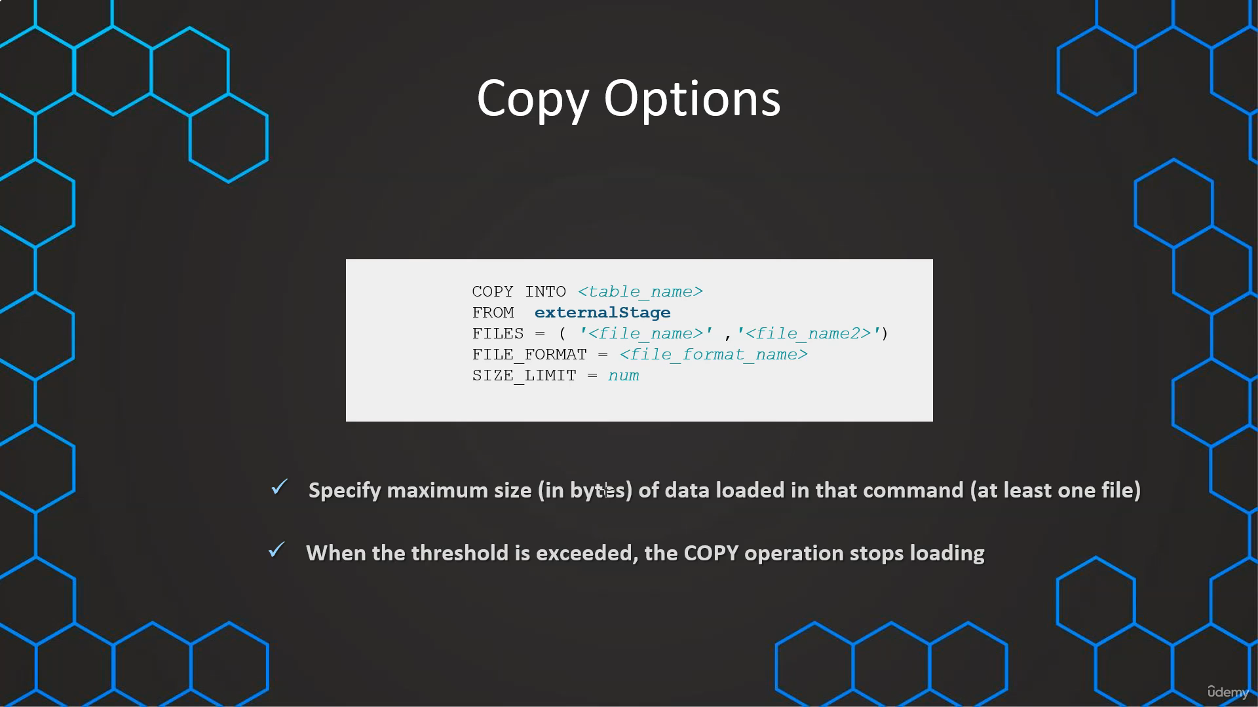

**SELECT * FROM ORDERS;**

**---- SIZE_LIMIT ----**

**// Prepare database & table**

**CREATE OR REPLACE DATABASE COPY_DB;**

**CREATE OR REPLACE TABLE COPY_DB.PUBLIC.ORDERS (**

**ORDER_ID VARCHAR(30),**

**AMOUNT VARCHAR(30),**

**PROFIT INT,**

**QUANTITY INT,**

**CATEGORY VARCHAR(30),**

**SUBCATEGORY VARCHAR(30));**

**// Prepare stage object**

**CREATE OR REPLACE STAGE COPY_DB.PUBLIC.aws_stage_copy**

**url='s3://snowflakebucket-copyoption/size/';**

**// List files in stage**

**LIST @aws_stage_copy;**

**//Load data using copy command**

**COPY INTO COPY_DB.PUBLIC.ORDERS**

**FROM @aws_stage_copy**

**file_format= (type = csv field_delimiter=',' skip_header=1)**

**pattern='.*Order.*'**

**SIZE_LIMIT=60000;**

**RETURN FAILED ONLY**

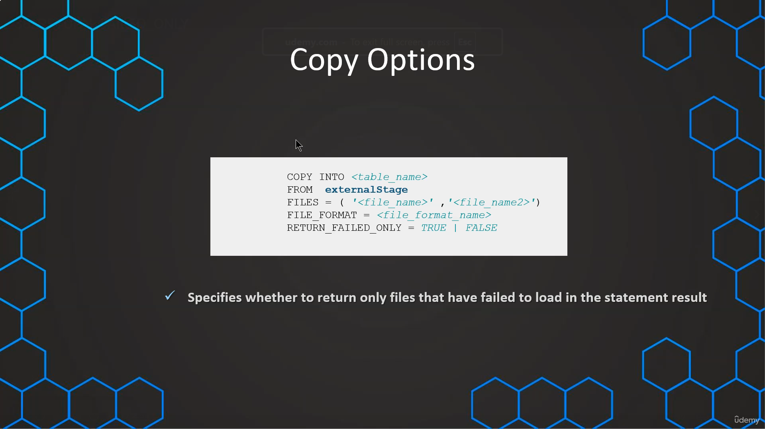

**---- RETURN_FAILED_ONLY ----**

**CREATE OR REPLACE TABLE COPY_DB.PUBLIC.ORDERS (**

**ORDER_ID VARCHAR(30),**

**AMOUNT VARCHAR(30),**

**PROFIT INT,**

**QUANTITY INT,**

**CATEGORY VARCHAR(30),**

**SUBCATEGORY VARCHAR(30));**

**// Prepare stage object**

**CREATE OR REPLACE STAGE COPY_DB.PUBLIC.aws_stage_copy**

**url='s3://snowflakebucket-copyoption/returnfailed/';**

**LIST @COPY_DB.PUBLIC.aws_stage_copy;**

**//Load data using copy command**

**COPY INTO COPY_DB.PUBLIC.ORDERS**

**FROM @aws_stage_copy**

**file_format= (type = csv field_delimiter=',' skip_header=1)**

**pattern='.*Order.*'**

**RETURN_FAILED_ONLY = TRUE;**

**COPY INTO COPY_DB.PUBLIC.ORDERS**

**FROM @aws_stage_copy**

**file_format= (type = csv field_delimiter=',' skip_header=1)**

**pattern='.*Order.*'**

**ON_ERROR =CONTINUE**

**RETURN_FAILED_ONLY = TRUE;**

**// Default = FALSE**

**CREATE OR REPLACE TABLE COPY_DB.PUBLIC.ORDERS (**

**ORDER_ID VARCHAR(30),**

**AMOUNT VARCHAR(30),**

**PROFIT INT,**

**QUANTITY INT,**

**CATEGORY VARCHAR(30),**

**SUBCATEGORY VARCHAR(30));**

**COPY INTO COPY_DB.PUBLIC.ORDERS**

**FROM @aws_stage_copy**

**file_format= (type = csv field_delimiter=',' skip_header=1)**

**pattern='.*Order.*'**

**ON_ERROR =CONTINUE;**

**TRUNCATE COLUMNS**

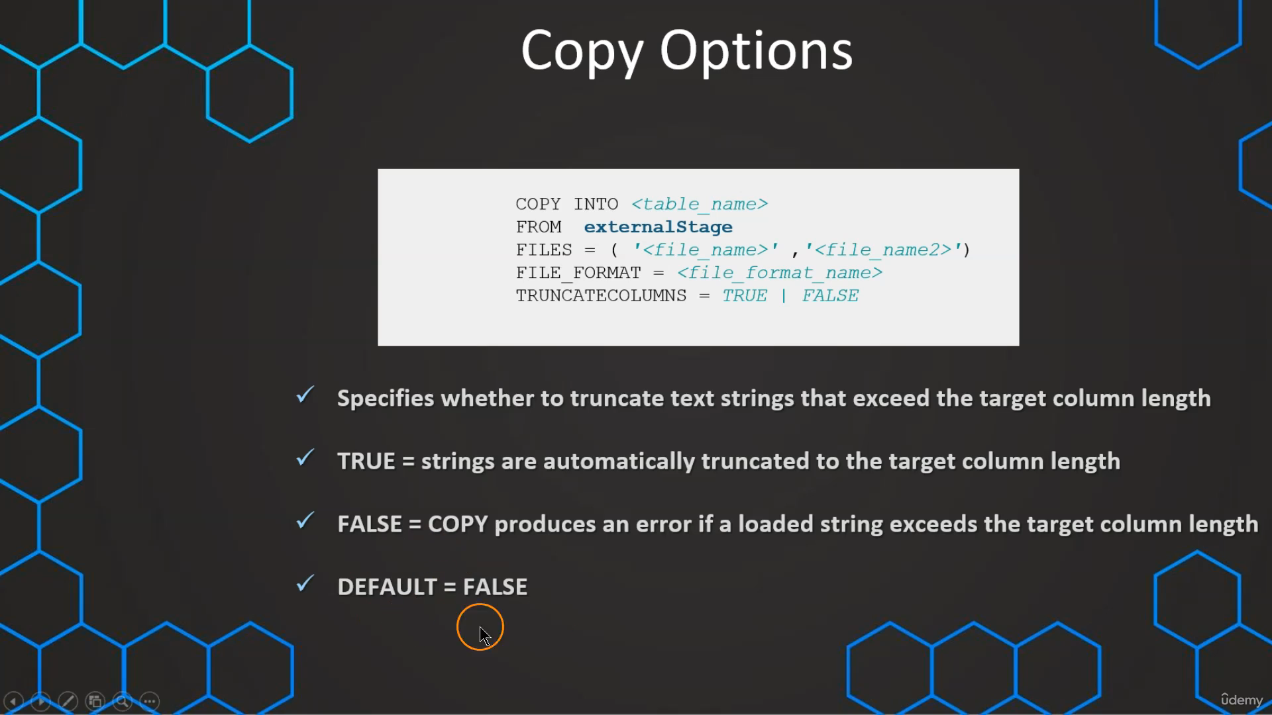

**---- TRUNCATECOLUMNS ----**

**CREATE OR REPLACE TABLE COPY_DB.PUBLIC.ORDERS (**

**ORDER_ID VARCHAR(30),**

**AMOUNT VARCHAR(30),**

**PROFIT INT,**

**QUANTITY INT,**

**CATEGORY VARCHAR(10),**

**SUBCATEGORY VARCHAR(30));**

**// Prepare stage object**

**CREATE OR REPLACE STAGE COPY_DB.PUBLIC.aws_stage_copy**

**url='s3://snowflakebucket-copyoption/size/';**

**LIST @COPY_DB.PUBLIC.aws_stage_copy;**

**//Load data using copy command**

**COPY INTO COPY_DB.PUBLIC.ORDERS**

**FROM @aws_stage_copy**

**file_format= (type = csv field_delimiter=',' skip_header=1)**

**pattern='.*Order.*';**

**COPY INTO COPY_DB.PUBLIC.ORDERS**

**FROM @aws_stage_copy**

**file_format= (type = csv field_delimiter=',' skip_header=1)**

**pattern='.*Order.*'**

**TRUNCATECOLUMNS = true;**

**SELECT * FROM ORDERS;**

**FORCE**

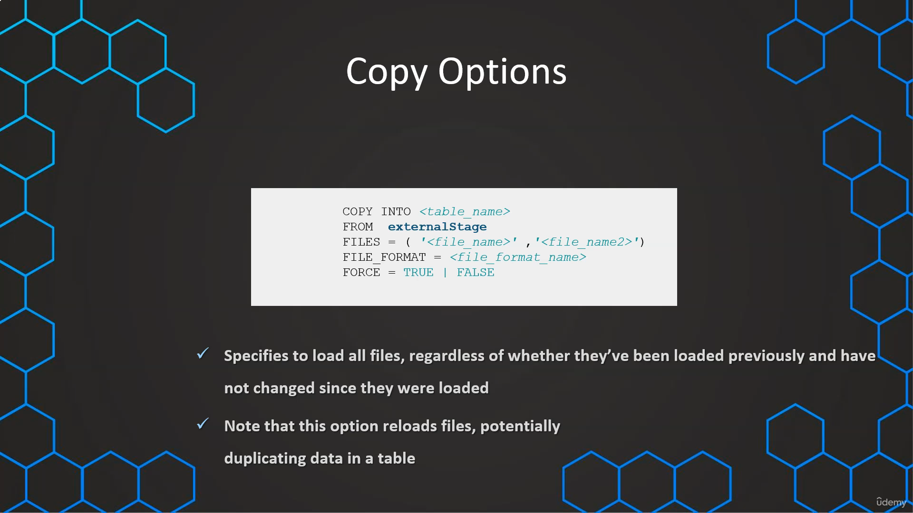

**---- FORCE ----**

**CREATE OR REPLACE TABLE COPY_DB.PUBLIC.ORDERS (**

**ORDER_ID VARCHAR(30),**

**AMOUNT VARCHAR(30),**

**PROFIT INT,**

**QUANTITY INT,**

**CATEGORY VARCHAR(30),**

**SUBCATEGORY VARCHAR(30));**

**// Prepare stage object**

**CREATE OR REPLACE STAGE COPY_DB.PUBLIC.aws_stage_copy**

**url='s3://snowflakebucket-copyoption/size/';**

**LIST @COPY_DB.PUBLIC.aws_stage_copy;**

**//Load data using copy command**

**COPY INTO COPY_DB.PUBLIC.ORDERS**

**FROM @aws_stage_copy**

**file_format= (type = csv field_delimiter=',' skip_header=1)**

**pattern='.*Order.*';**

**// Not possible to load file that have been loaded and data has not been modified**

**COPY INTO COPY_DB.PUBLIC.ORDERS**

**FROM @aws_stage_copy**

**file_format= (type = csv field_delimiter=',' skip_header=1)**

**pattern='.*Order.*';**

**SELECT * FROM ORDERS;**

**// Using the FORCE option**

**COPY INTO COPY_DB.PUBLIC.ORDERS**

**FROM @aws_stage_copy**

**file_format= (type = csv field_delimiter=',' skip_header=1)**

**pattern='.*Order.*'**

**FORCE = TRUE;**

**LOAD HISTORY**

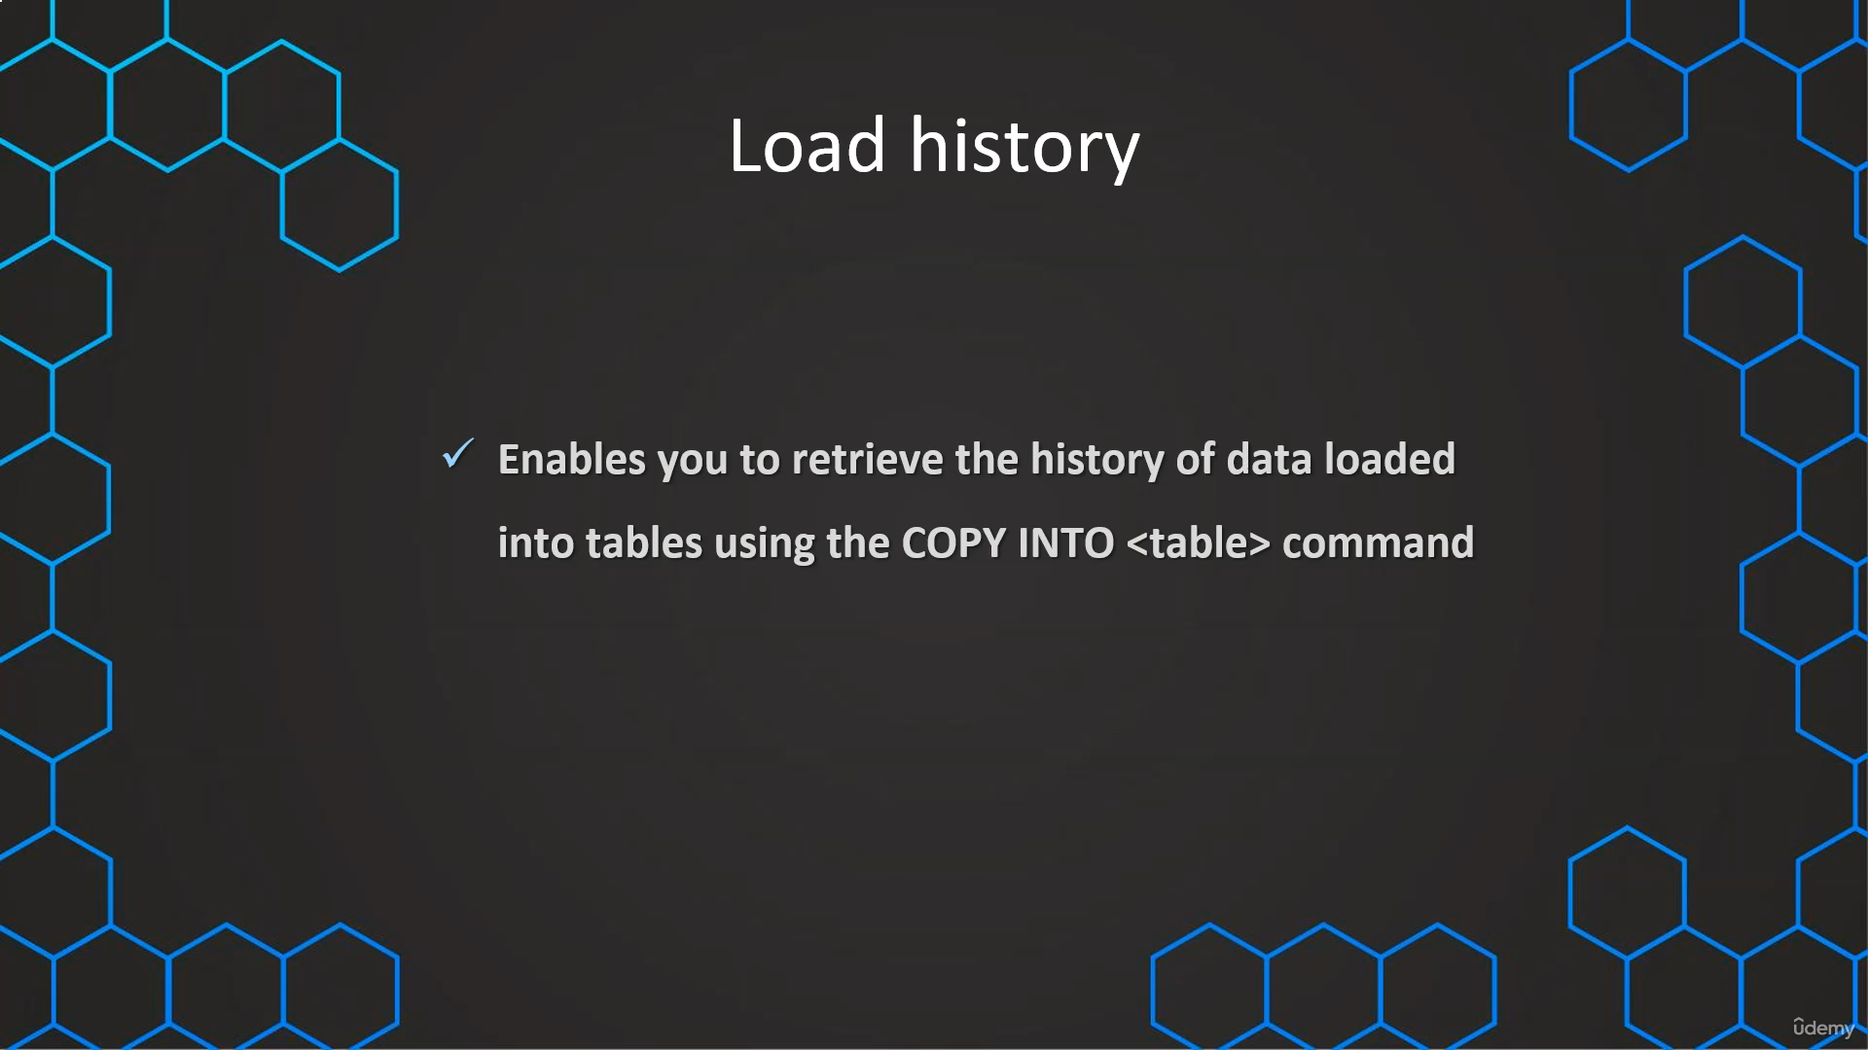

**.**

**-- Query load history within a database --**

**USE COPY_DB;**

**SELECT * FROM information_schema.load_history;**

**-- Query load history gloabally from SNOWFLAKE database --**

**SELECT * FROM snowflake.account_usage.load_history;**

**// Filter on specific table & schema**

**SELECT * FROM snowflake.account_usage.load_history**

**where schema_name='PUBLIC' and**

**table_name='ORDERS';**

**// Filter on specific table & schema**

**SELECT * FROM snowflake.account_usage.load_history**

**where schema_name='PUBLIC' and**

**table_name='ORDERS' and**

**error_count > 0;**

**// Filter on specific table & schema**

**SELECT * FROM snowflake.account_usage.load_history**

**WHERE DATE(LAST_LOAD_TIME) <= DATEADD(days,-1,CURRENT_DATE);**

**-- Use validation mode**

**COPY INTO EXERCISE_DB.PUBLIC.EMPLOYEES**

**FROM @aws_stage**

**file_format= EXERCISE_DB.public.aws_fileformat**

**VALIDATION_MODE = RETURN_ERRORS;**

**CREATE OR REPLACE TABLE rejected_EX AS**

**select rejected_record from table(result_scan('01b943f2-030b-c793-000a-7df70001d386'));**

**select * from rejected_EX;**

**---- 3) Working with rejected records ----**

**SELECT REJECTED_RECORD FROM rejected_EX;**

**CREATE OR REPLACE TABLE rejected_values as**

**SELECT**

**SPLIT_PART(rejected_record,',',1) as customer_id,**

**SPLIT_PART(rejected_record,',',2) as first_name,**

**SPLIT_PART(rejected_record,',',3) as last_name,**

**SPLIT_PART(rejected_record,',',4) as EMAIL,**

**SPLIT_PART(rejected_record,',',5) as AGE,**

**SPLIT_PART(rejected_record,',',6) as department**

**FROM rejected_EX;**

**SELECT * FROM rejected_values;**

**COPY INTO EXERCISE_DB.PUBLIC.EMPLOYEES**

**FROM @aws_stage**

**file_format= EXERCISE_DB.public.aws_fileformat**

**pattern='.*emp.*'**

**TRUNCATECOLUMNS = true;**

**SELECT count(*) FROM EMPLOYEES;**

**Loading Unstructured Data :-**

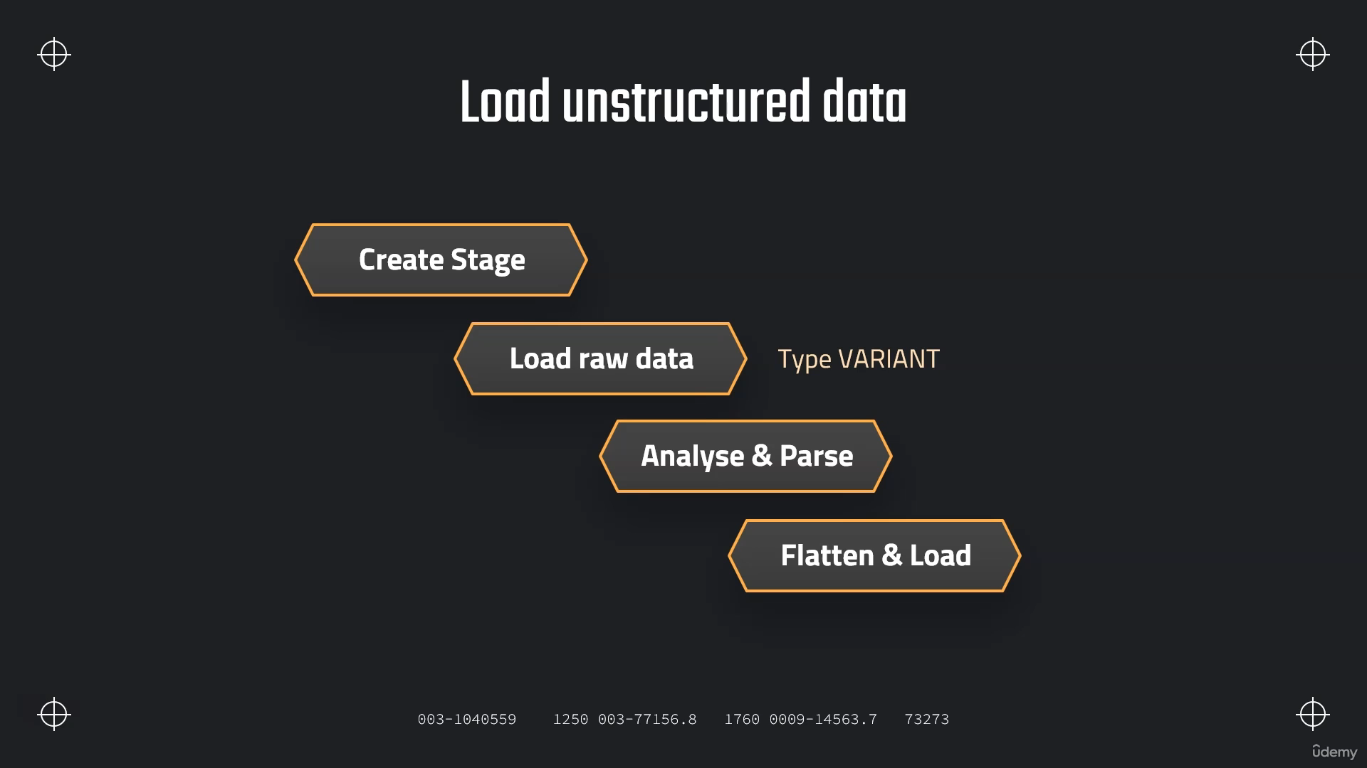

**JSON Example**

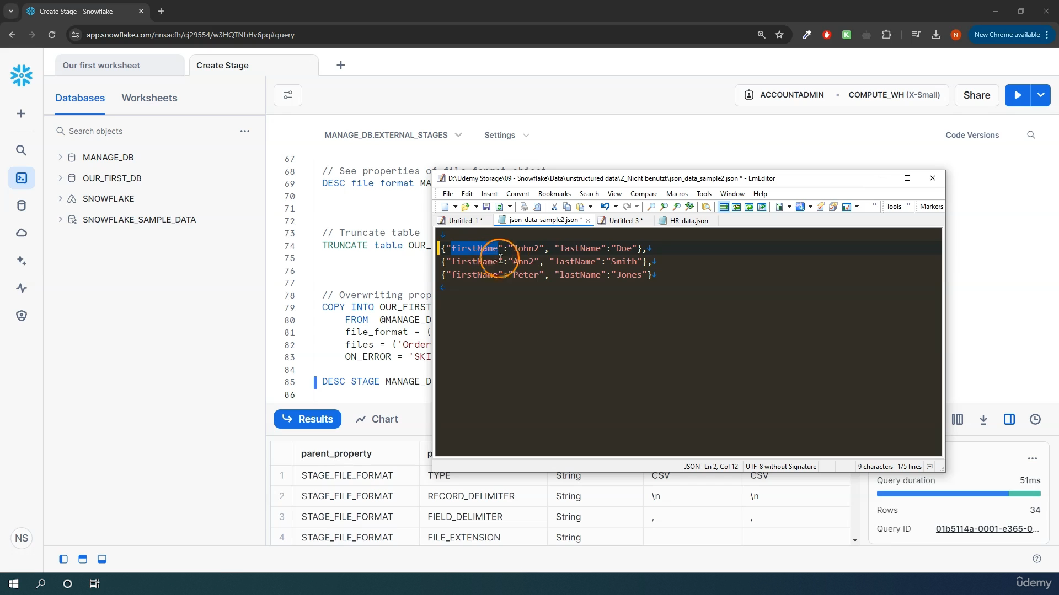

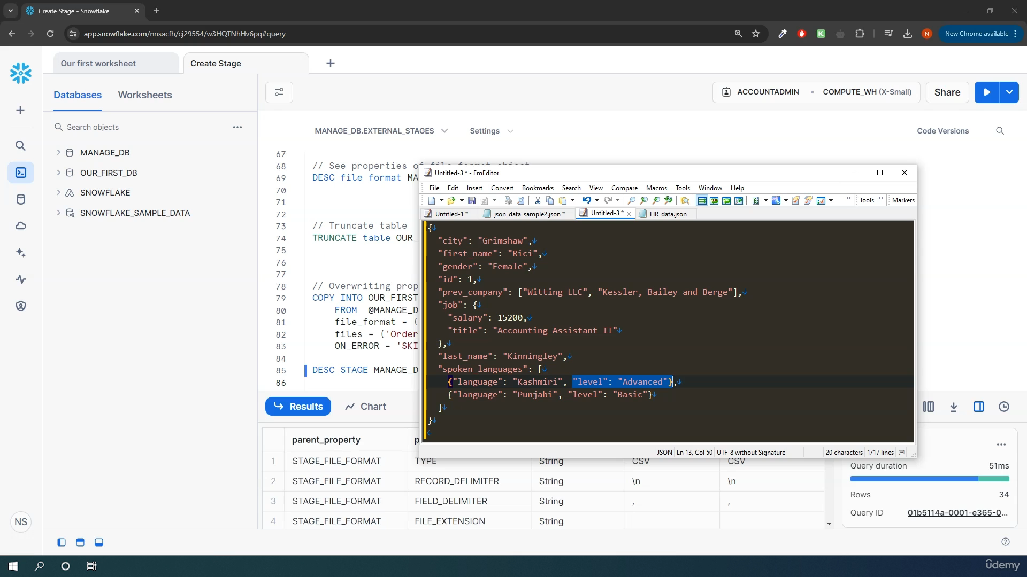

**// First step: Load Raw JSON**

**CREATE OR REPLACE stage MANAGE_DB.EXTERNAL_STAGES.JSONSTAGE**

**url='s3://bucketsnowflake-jsondemo';**

**CREATE OR REPLACE file format MANAGE_DB.FILE_FORMATS.JSONFORMAT**

**TYPE = JSON;**

**CREATE OR REPLACE table OUR_FIRST_DB.PUBLIC.JSON_RAW (**

**raw_file variant);**

**COPY INTO OUR_FIRST_DB.PUBLIC.JSON_RAW**

**FROM @MANAGE_DB.EXTERNAL_STAGES.JSONSTAGE**

**file_format= MANAGE_DB.FILE_FORMATS.JSONFORMAT**

**files = ('HR_data.json');**

**SELECT * FROM OUR_FIRST_DB.PUBLIC.JSON_RAW;**

**Parsing JSON**

**// Second step: Parse & Analyse Raw JSON**

**// Selecting attribute/column**

**SELECT RAW_FILE:city FROM OUR_FIRST_DB.PUBLIC.JSON_RAW;**

**SELECT $1:first_name FROM OUR_FIRST_DB.PUBLIC.JSON_RAW;**

**// Selecting attribute/column - formattted**

**SELECT RAW_FILE:first_name::string as first_name FROM OUR_FIRST_DB.PUBLIC.JSON_RAW;**

**SELECT RAW_FILE:id::int as id FROM OUR_FIRST_DB.PUBLIC.JSON_RAW;**

**SELECT**

**RAW_FILE:id::int as id,**

**RAW_FILE:first_name::STRING as first_name,**

**RAW_FILE:last_name::STRING as last_name,**

**RAW_FILE:gender::STRING as gender**

**FROM OUR_FIRST_DB.PUBLIC.JSON_RAW;**

**// Handling nested data**

**SELECT RAW_FILE:job as job FROM OUR_FIRST_DB.PUBLIC.JSON_RAW;**

**// Handling nested data**

**SELECT RAW_FILE:job as job FROM OUR_FIRST_DB.PUBLIC.JSON_RAW;**

**SELECT**

**RAW_FILE:job.salary::INT as salary**

**FROM OUR_FIRST_DB.PUBLIC.JSON_RAW;**

**SELECT**

**RAW_FILE:first_name::STRING as first_name,**

**RAW_FILE:job.salary::INT as salary,**

**RAW_FILE:job.title::STRING as title**

**FROM OUR_FIRST_DB.PUBLIC.JSON_RAW;**

**// Handling arrays**

**SELECT**

**RAW_FILE:prev_company as prev_company**

**FROM OUR_FIRST_DB.PUBLIC.JSON_RAW;**

**SELECT**

**RAW_FILE:prev_company[1]::STRING as prev_company**

**FROM OUR_FIRST_DB.PUBLIC.JSON_RAW;**

**SELECT**

**ARRAY_SIZE(RAW_FILE:prev_company) as prev_company**

**FROM OUR_FIRST_DB.PUBLIC.JSON_RAW;**

**SELECT**

**RAW_FILE:id::int as id,**

**RAW_FILE:first_name::STRING as first_name,**

**RAW_FILE:prev_company[0]::STRING as prev_company**

**FROM OUR_FIRST_DB.PUBLIC.JSON_RAW**

**UNION ALL**

**SELECT**

**RAW_FILE:id::int as id,**

**RAW_FILE:first_name::STRING as first_name,**

**RAW_FILE:prev_company[1]::STRING as prev_company**

**FROM OUR_FIRST_DB.PUBLIC.JSON_RAW**

**ORDER BY id;**

**EX-4**

**SELECT * FROM JSON_RAW;**

**// Selecting attribute/column**

**SELECT**

**$1:first_name::STRING,**

**$1:last_name::STRING,**

**$1:Skills[0]::STRING,**

**$1:Skills[1]::STRING**

**FROM JSON_RAW;**

**// Copy data in table**

**CREATE TABLE SKILLS AS**

**SELECT**

**$1:first_name::STRING as first_name,**

**$1:last_name::STRING as last_name,**

**$1:Skills[0]::STRING as Skill_1,**

**$1:Skills[1]::STRING as Skill_2**

**FROM JSON_RAW;**

**// Query from table**

**SELECT * FROM SKILLS**

**WHERE FIRST_NAME='Florina';**

**FLATTEN HIERARCHICAL DATA**

**SELECT**

**RAW_FILE:spoken_languages as spoken_languages**

**FROM OUR_FIRST_DB.PUBLIC.JSON_RAW;**

**SELECT * FROM OUR_FIRST_DB.PUBLIC.JSON_RAW;**

**SELECT**

**array_size(RAW_FILE:spoken_languages) as spoken_languages**

**FROM OUR_FIRST_DB.PUBLIC.JSON_RAW;**

**SELECT**

**RAW_FILE:first_name::STRING as first_name,**

**array_size(RAW_FILE:spoken_languages) as spoken_languages**

**FROM OUR_FIRST_DB.PUBLIC.JSON_RAW;**

**SELECT**

**RAW_FILE:spoken_languages[0] as First_language**

**FROM OUR_FIRST_DB.PUBLIC.JSON_RAW;**

**SELECT**

**RAW_FILE:first_name::STRING as first_name,**

**RAW_FILE:spoken_languages[0] as First_language**

**FROM OUR_FIRST_DB.PUBLIC.JSON_RAW;**

**SELECT**

**RAW_FILE:first_name::STRING as First_name,**

**RAW_FILE:spoken_languages[0].language::STRING as First_language,**

**RAW_FILE:spoken_languages[0].level::STRING as Level_spoken**

**FROM OUR_FIRST_DB.PUBLIC.JSON_RAW;**

**SELECT**

**RAW_FILE:id::int as id,**

**RAW_FILE:first_name::STRING as First_name,**

**RAW_FILE:spoken_languages[0].language::STRING as First_language,**

**RAW_FILE:spoken_languages[0].level::STRING as Level_spoken**

**FROM OUR_FIRST_DB.PUBLIC.JSON_RAW**

**UNION ALL**

**SELECT**

**RAW_FILE:id::int as id,**

**RAW_FILE:first_name::STRING as First_name,**

**RAW_FILE:spoken_languages[1].language::STRING as First_language,**

**RAW_FILE:spoken_languages[1].level::STRING as Level_spoken**

**FROM OUR_FIRST_DB.PUBLIC.JSON_RAW**

**UNION ALL**

**SELECT**

**RAW_FILE:id::int as id,**

**RAW_FILE:first_name::STRING as First_name,**

**RAW_FILE:spoken_languages[2].language::STRING as First_language,**

**RAW_FILE:spoken_languages[2].level::STRING as Level_spoken**

**FROM OUR_FIRST_DB.PUBLIC.JSON_RAW**

**ORDER BY ID;**

**select**

**RAW_FILE:first_name::STRING as First_name,**

**f.value:language::STRING as First_language,**

**f.value:level::STRING as Level_spoken**

**from OUR_FIRST_DB.PUBLIC.JSON_RAW, table(flatten(RAW_FILE:spoken_languages)) f;**

**INSERT FINAL DATA**

**// Option 1: CREATE TABLE AS**

**CREATE OR REPLACE TABLE Languages AS**

**select**

**RAW_FILE:first_name::STRING as First_name,**

**f.value:language::STRING as First_language,**

**f.value:level::STRING as Level_spoken**

**from OUR_FIRST_DB.PUBLIC.JSON_RAW, table(flatten(RAW_FILE:spoken_languages)) f;**

**SELECT * FROM Languages;**

**truncate table languages;**

**// Option 2: INSERT INTO**

**INSERT INTO Languages**

**select**

**RAW_FILE:first_name::STRING as First_name,**

**f.value:language::STRING as First_language,**

**f.value:level::STRING as Level_spoken**

**from OUR_FIRST_DB.PUBLIC.JSON_RAW, table(flatten(RAW_FILE:spoken_languages)) f;**

**SELECT * FROM Languages;**

**QUERING PARQUET DATA**

**// Create file format and stage object**

**CREATE OR REPLACE FILE FORMAT MANAGE_DB.FILE_FORMATS.PARQUET_FORMAT**

**TYPE = 'parquet';**

**CREATE OR REPLACE STAGE MANAGE_DB.EXTERNAL_STAGES.PARQUETSTAGE**

**url = 's3://snowflakeparquetdemo'**

**FILE_FORMAT = MANAGE_DB.FILE_FORMATS.PARQUET_FORMAT;**

**// Preview the data**

**LIST @MANAGE_DB.EXTERNAL_STAGES.PARQUETSTAGE;**

**SELECT * FROM @MANAGE_DB.EXTERNAL_STAGES.PARQUETSTAGE;**

**// File format in Queries**

**CREATE OR REPLACE STAGE MANAGE_DB.EXTERNAL_STAGES.PARQUETSTAGE**

**url = 's3://snowflakeparquetdemo' ;**

**SELECT \***

**FROM @MANAGE_DB.EXTERNAL_STAGES.PARQUETSTAGE**

**(file_format => 'MANAGE_DB.FILE_FORMATS.PARQUET_FORMAT');**

**// Quotes can be omitted in case of the current namespace**

**USE MANAGE_DB.FILE_FORMATS;**

**SELECT \***

**FROM @MANAGE_DB.EXTERNAL_STAGES.PARQUETSTAGE**

**(file_format => MANAGE_DB.FILE_FORMATS.PARQUET_FORMAT);**

**CREATE OR REPLACE STAGE MANAGE_DB.EXTERNAL_STAGES.PARQUETSTAGE**

**url = 's3://snowflakeparquetdemo'**

**FILE_FORMAT = MANAGE_DB.FILE_FORMATS.PARQUET_FORMAT;**

**// Syntax for Querying unstructured data**

**SELECT**

**$1:__index_level_0__,**

**$1:cat_id,**

**$1:date,**

**$1:"__index_level_0__",**

**$1:"cat_id",**

**$1:"d",**

**$1:"date",**

**$1:"dept_id",**

**$1:"id",**

**$1:"item_id",**

**$1:"state_id",**

**$1:"store_id",**

**$1:"value"**

**FROM @MANAGE_DB.EXTERNAL_STAGES.PARQUETSTAGE;**

**// Date conversion**

**SELECT 1;**

**SELECT DATE(365*60*60*24);**

**// Querying with conversions and aliases**

**SELECT**

**$1:__index_level_0__::int as index_level,**

**$1:cat_id::VARCHAR(50) as category,**

**DATE($1:date::int ) as Date,**

**$1:"dept_id"::VARCHAR(50) as Dept_ID,**

**$1:"id"::VARCHAR(50) as ID,**

**$1:"item_id"::VARCHAR(50) as Item_ID,**

**$1:"state_id"::VARCHAR(50) as State_ID,**

**$1:"store_id"::VARCHAR(50) as Store_ID,**

**$1:"value"::int as value**

**FROM @MANAGE_DB.EXTERNAL_STAGES.PARQUETSTAGE;**

**Loading Parquet data :-**

**// Adding metadata**

**SELECT**

**$1:__index_level_0__::int as index_level,**

**$1:cat_id::VARCHAR(50) as category,**

**DATE($1:date::int ) as Date,**

**$1:"dept_id"::VARCHAR(50) as Dept_ID,**

**$1:"id"::VARCHAR(50) as ID,**

**$1:"item_id"::VARCHAR(50) as Item_ID,**

**$1:"state_id"::VARCHAR(50) as State_ID,**

**$1:"store_id"::VARCHAR(50) as Store_ID,**

**$1:"value"::int as value,**

**METADATA$FILENAME as FILENAME,**

**METADATA$FILE_ROW_NUMBER as ROWNUMBER,**

**TO_TIMESTAMP_NTZ(current_timestamp) as LOAD_DATE**

**FROM @MANAGE_DB.EXTERNAL_STAGES.PARQUETSTAGE;**

**SELECT TO_TIMESTAMP_NTZ(current_timestamp);**

**// Create destination table**

**CREATE OR REPLACE TABLE OUR_FIRST_DB.PUBLIC.PARQUET_DATA (**

**ROW_NUMBER int,**

**index_level int,**

**cat_id VARCHAR(50),**

**date date,**

**dept_id VARCHAR(50),**

**id VARCHAR(50),**

**item_id VARCHAR(50),**

**state_id VARCHAR(50),**

**store_id VARCHAR(50),**

**value int,**

**Load_date timestamp default TO_TIMESTAMP_NTZ(current_timestamp));**

**// Load the parquet data**

**COPY INTO OUR_FIRST_DB.PUBLIC.PARQUET_DATA**

**FROM (SELECT**

**METADATA$FILE_ROW_NUMBER,**

**$1:__index_level_0__::int,**

**$1:cat_id::VARCHAR(50),**

**DATE($1:date::int ),**

**$1:"dept_id"::VARCHAR(50),**

**$1:"id"::VARCHAR(50),**

**$1:"item_id"::VARCHAR(50),**

**$1:"state_id"::VARCHAR(50),**

**$1:"store_id"::VARCHAR(50),**

**$1:"value"::int,**

**TO_TIMESTAMP_NTZ(current_timestamp)**

**FROM @MANAGE_DB.EXTERNAL_STAGES.PARQUETSTAGE);**

**SELECT * FROM OUR_FIRST_DB.PUBLIC.PARQUET_DATA;**

**Performance Optimization :-**

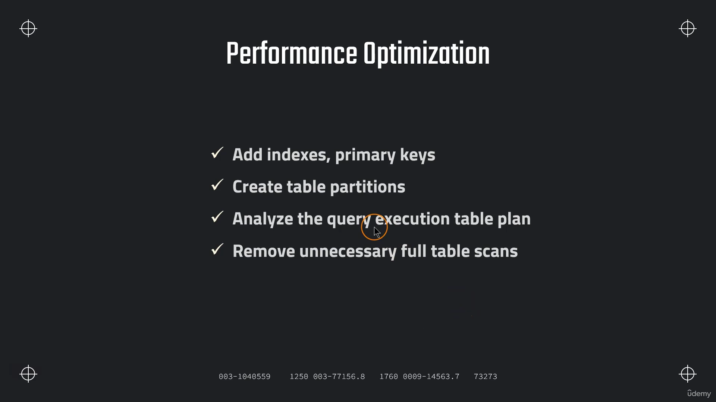

**In Snowflake above not required**

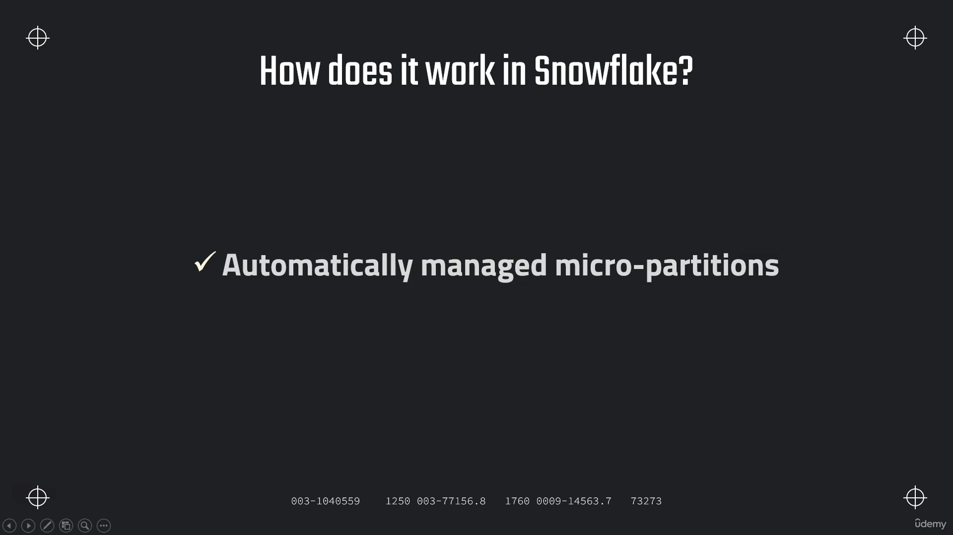

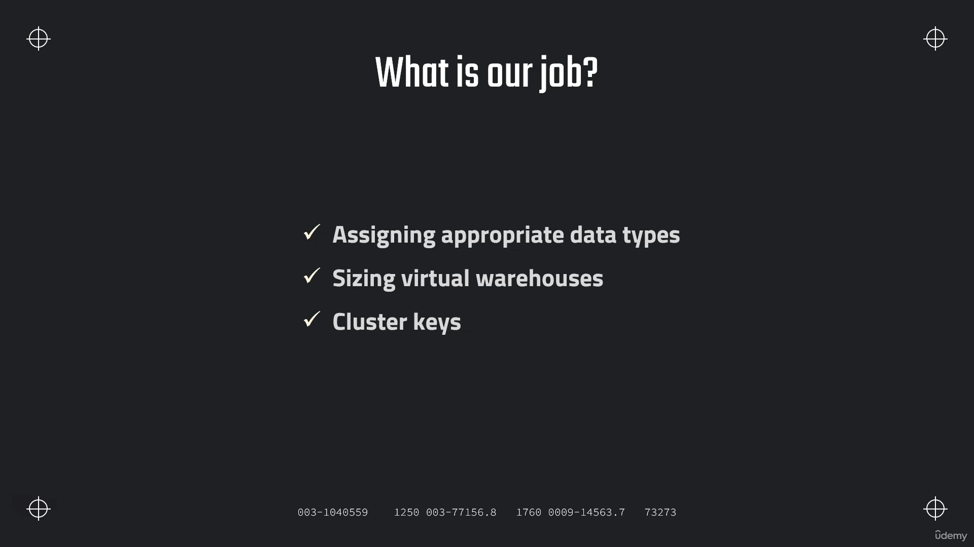

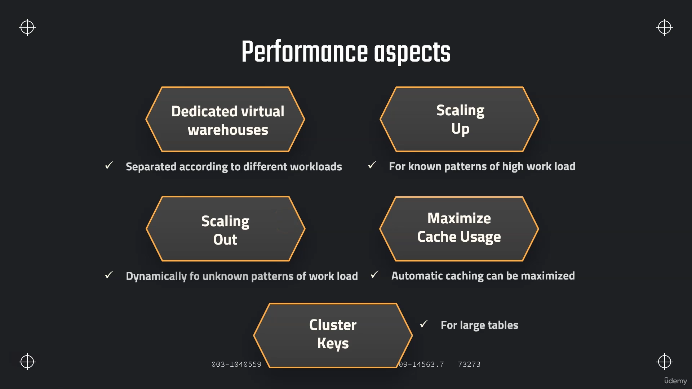

**Dedicated Virtual Warehouse :-**

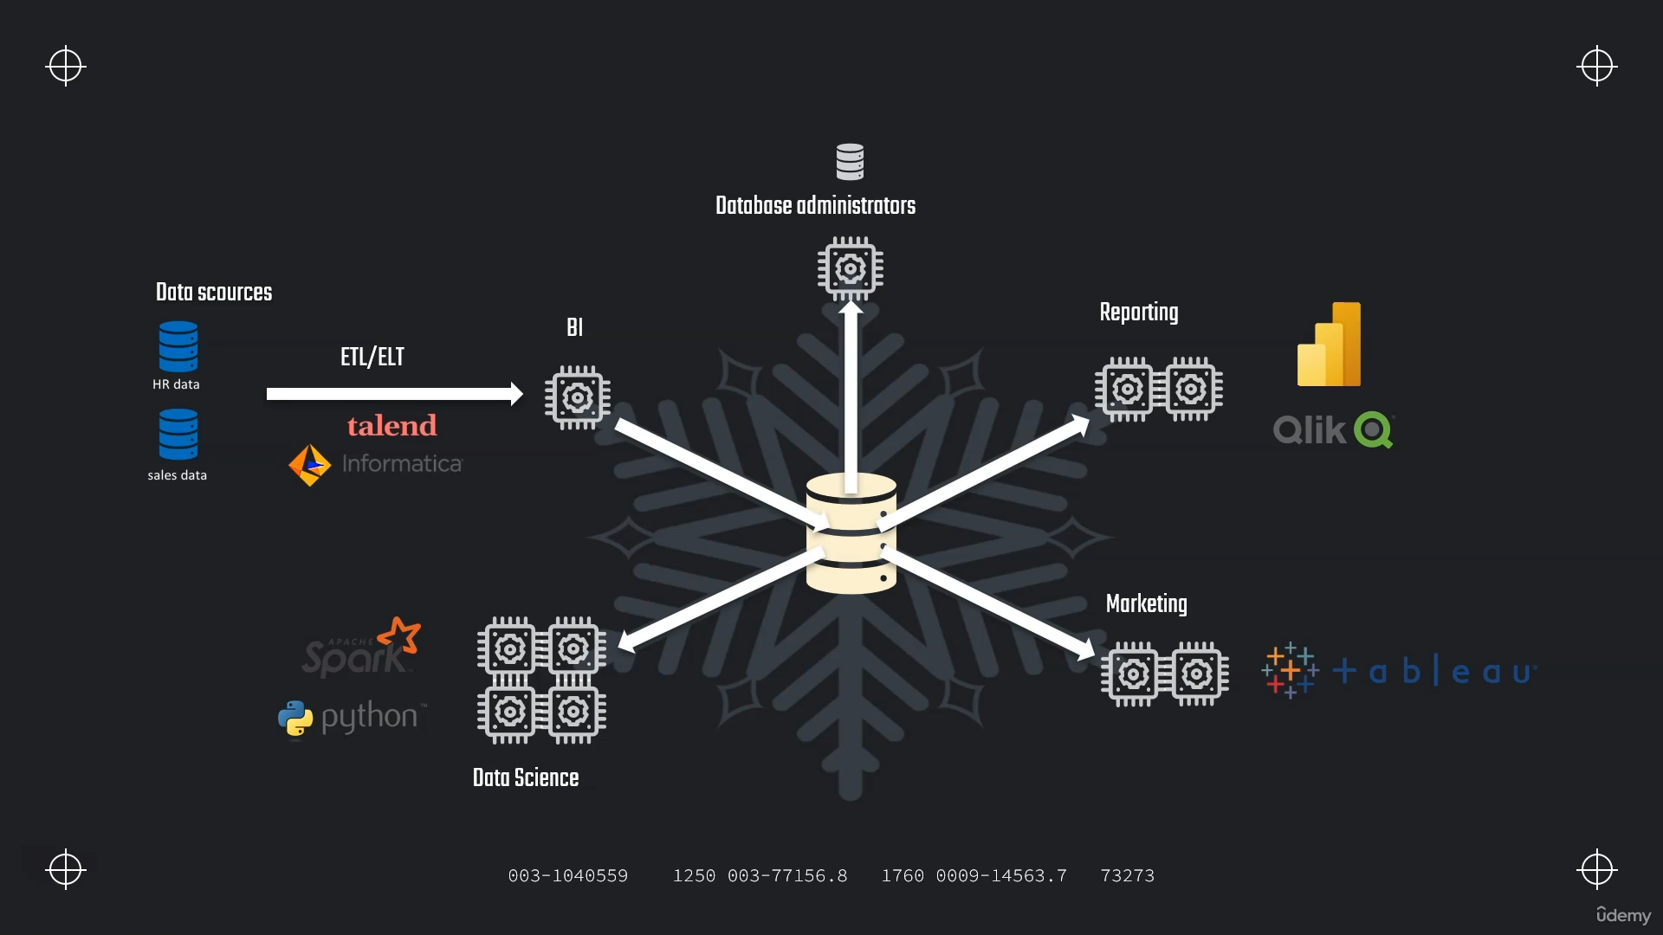



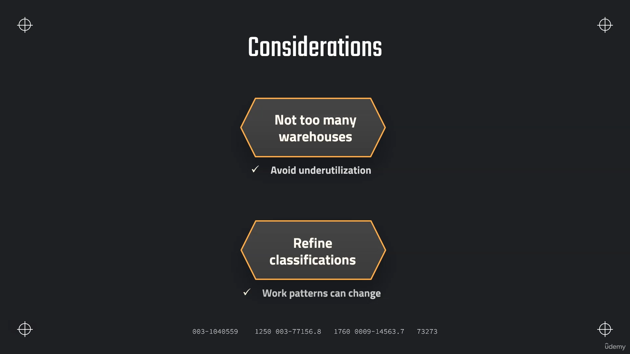

**Scaling Up/Down**

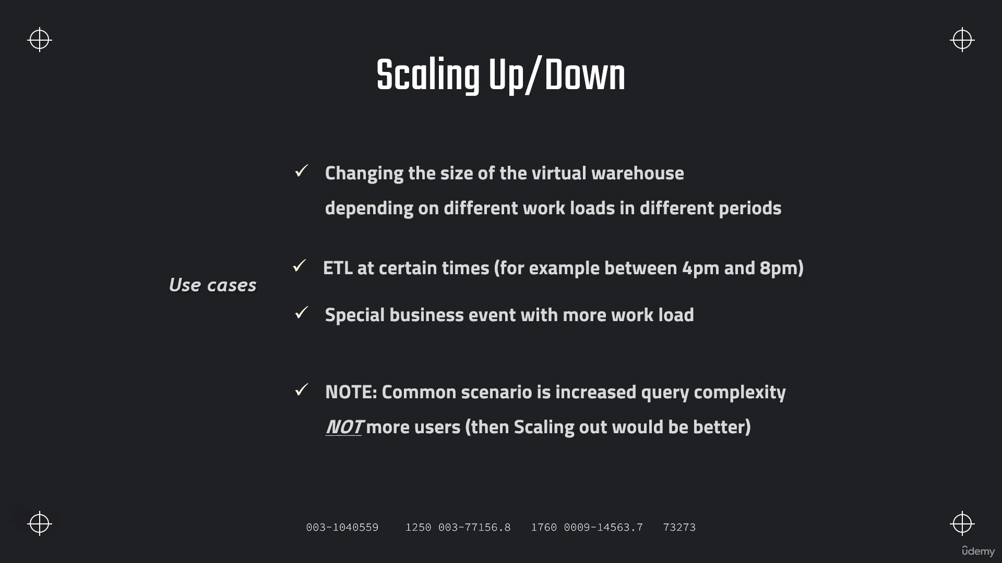

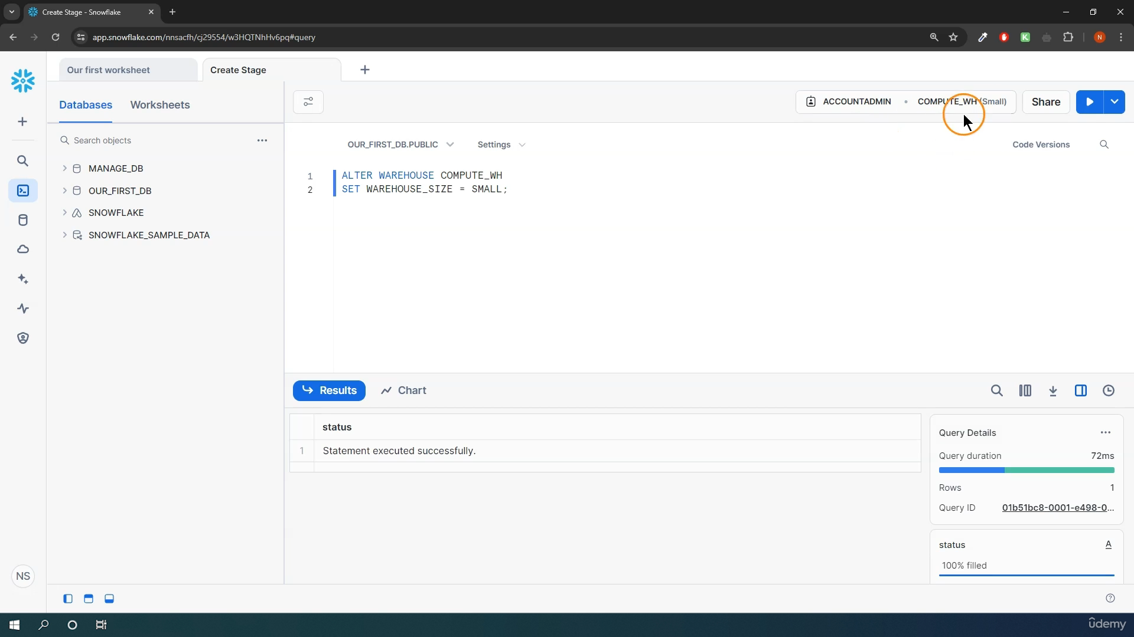

**Scaling Out**

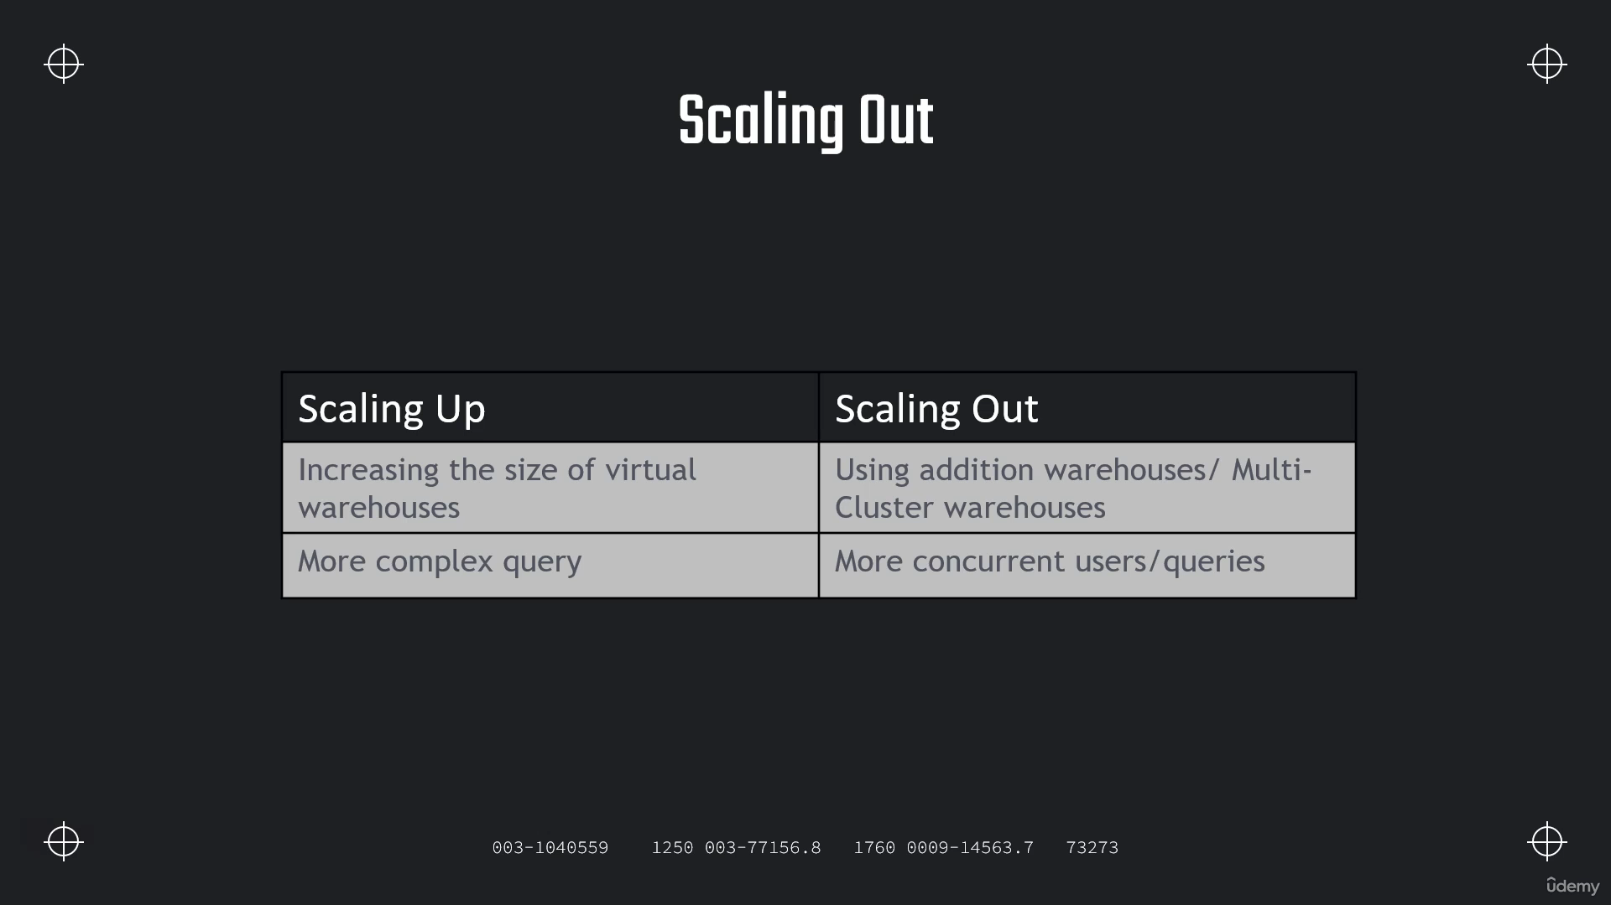

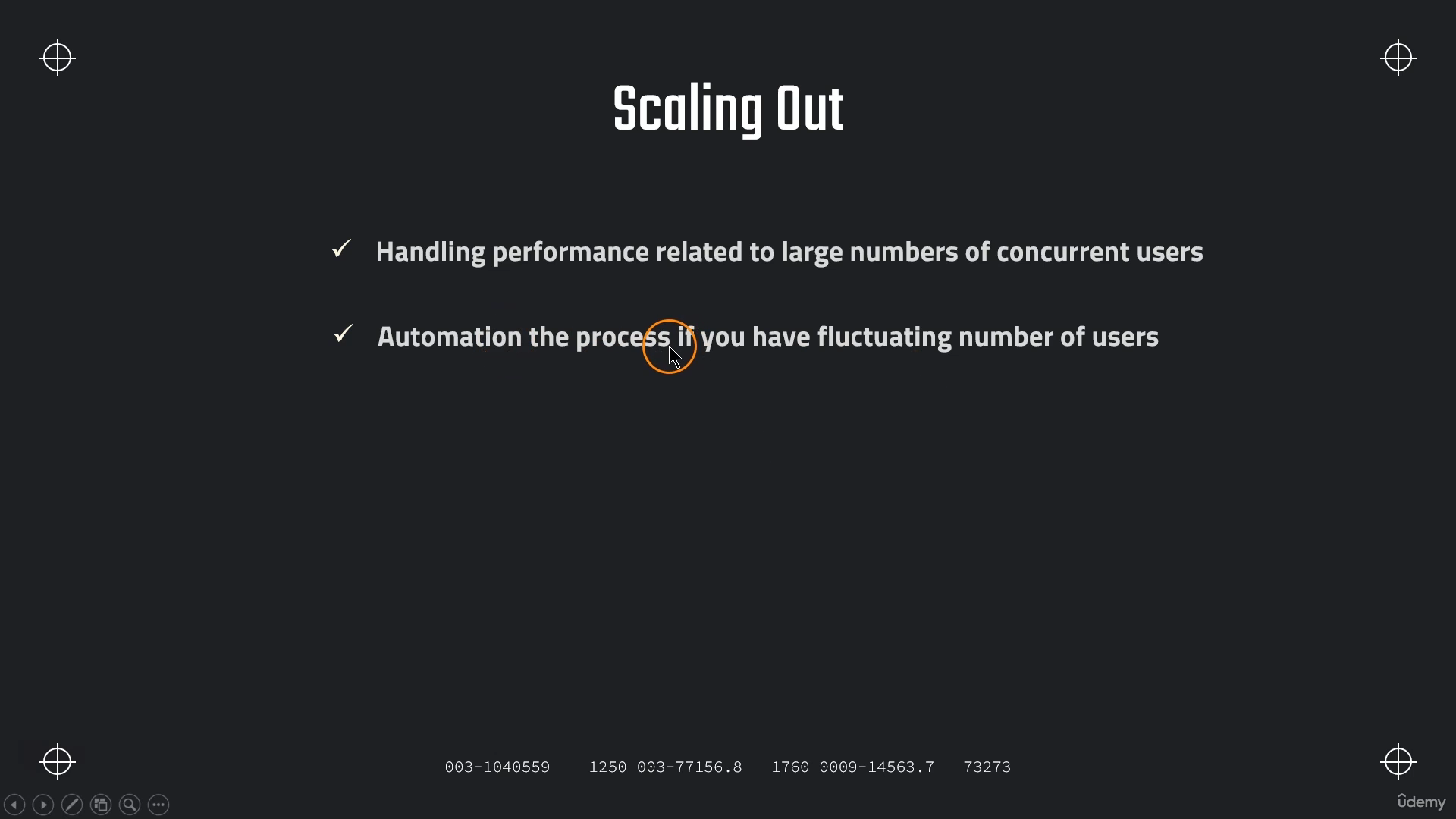

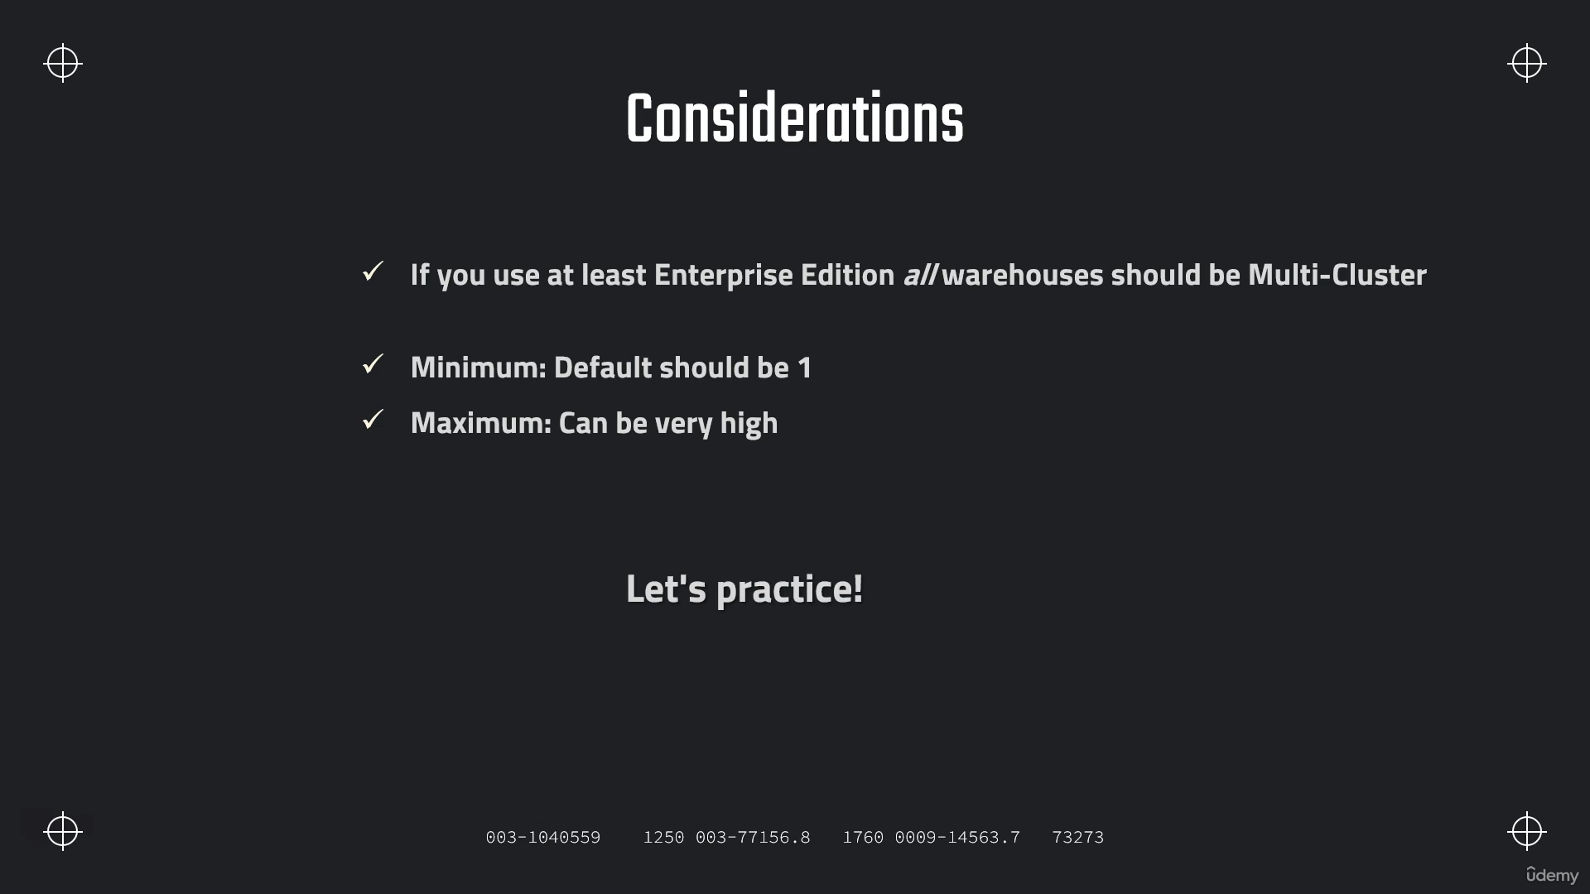

**Ex:-**

**SELECT * FROM SNOWFLAKE_SAMPLE_DATA.TPCDS_SF100TCL.WEB_SITE T1**

**CROSS JOIN SNOWFLAKE_SAMPLE_DATA.TPCDS_SF100TCL.WEB_SITE T2**

**CROSS JOIN SNOWFLAKE_SAMPLE_DATA.TPCDS_SF100TCL.WEB_SITE T3**

**CROSS JOIN (SELECT TOP 57 * FROM SNOWFLAKE_SAMPLE_DATA.TPCDS_SF100TCL.WEB_SITE) T4;**

**Caching**

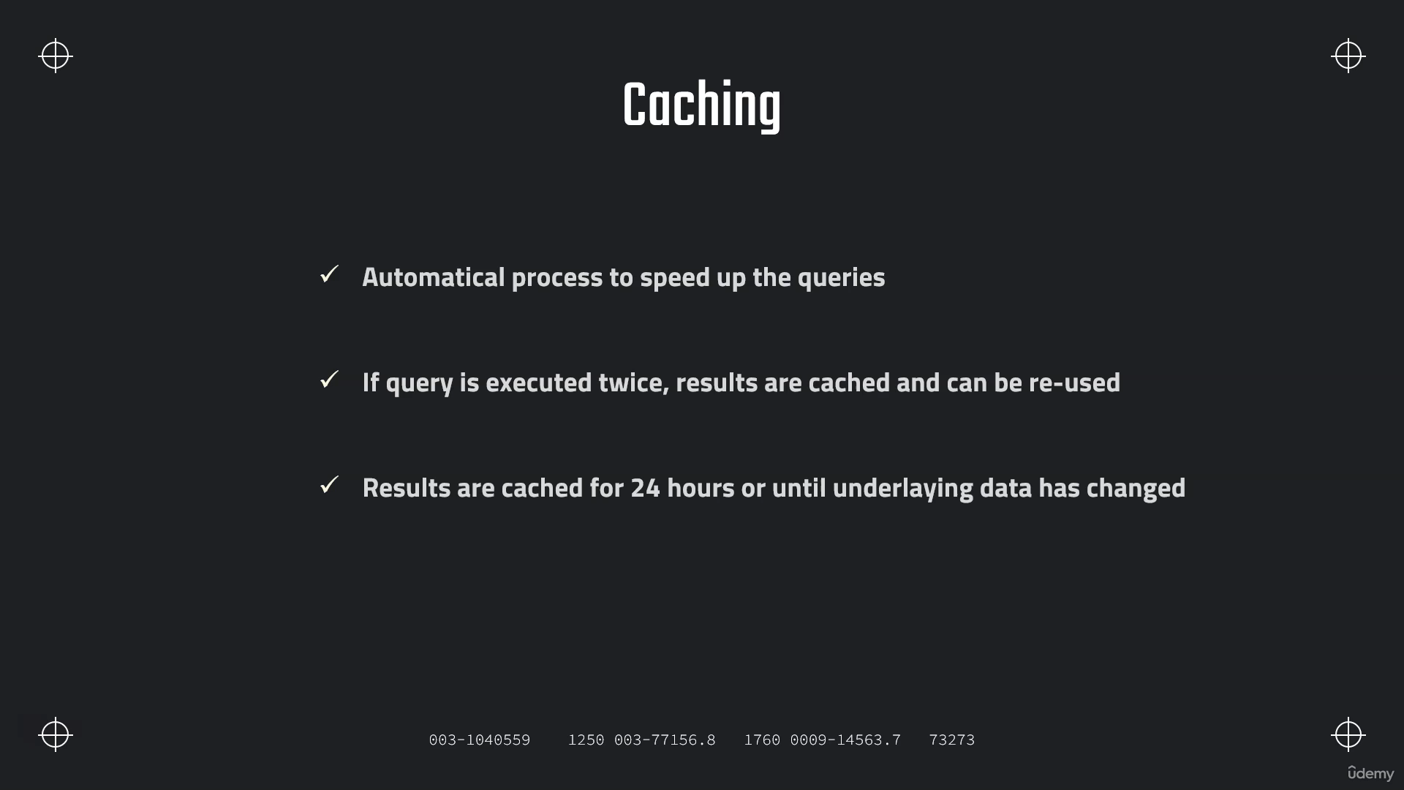

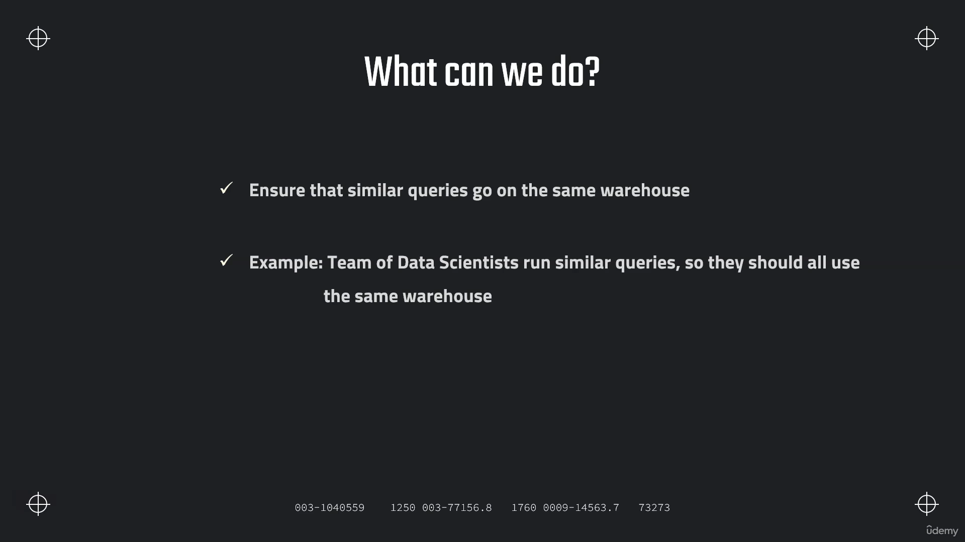

**Maximizing Caching**

**SELECT AVG(C_BIRTH_YEAR) FROM SNOWFLAKE_SAMPLE_DATA.TPCDS_SF100TCL.CUSTOMER**

**// Setting up an additional user**

**CREATE ROLE DATA_SCIENTIST;**

**GRANT USAGE ON WAREHOUSE COMPUTE_WH TO ROLE DATA_SCIENTIST;**

**CREATE USER DS1 PASSWORD = 'DS1' LOGIN_NAME = 'DS1' DEFAULT_ROLE='DATA_SCIENTIST' DEFAULT_WAREHOUSE = 'DS_WH' MUST_CHANGE_PASSWORD = FALSE;**

**GRANT ROLE DATA_SCIENTIST TO USER DS1;**

**Clustering**

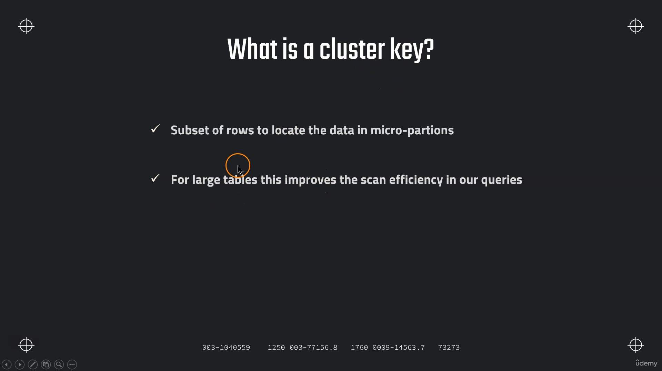

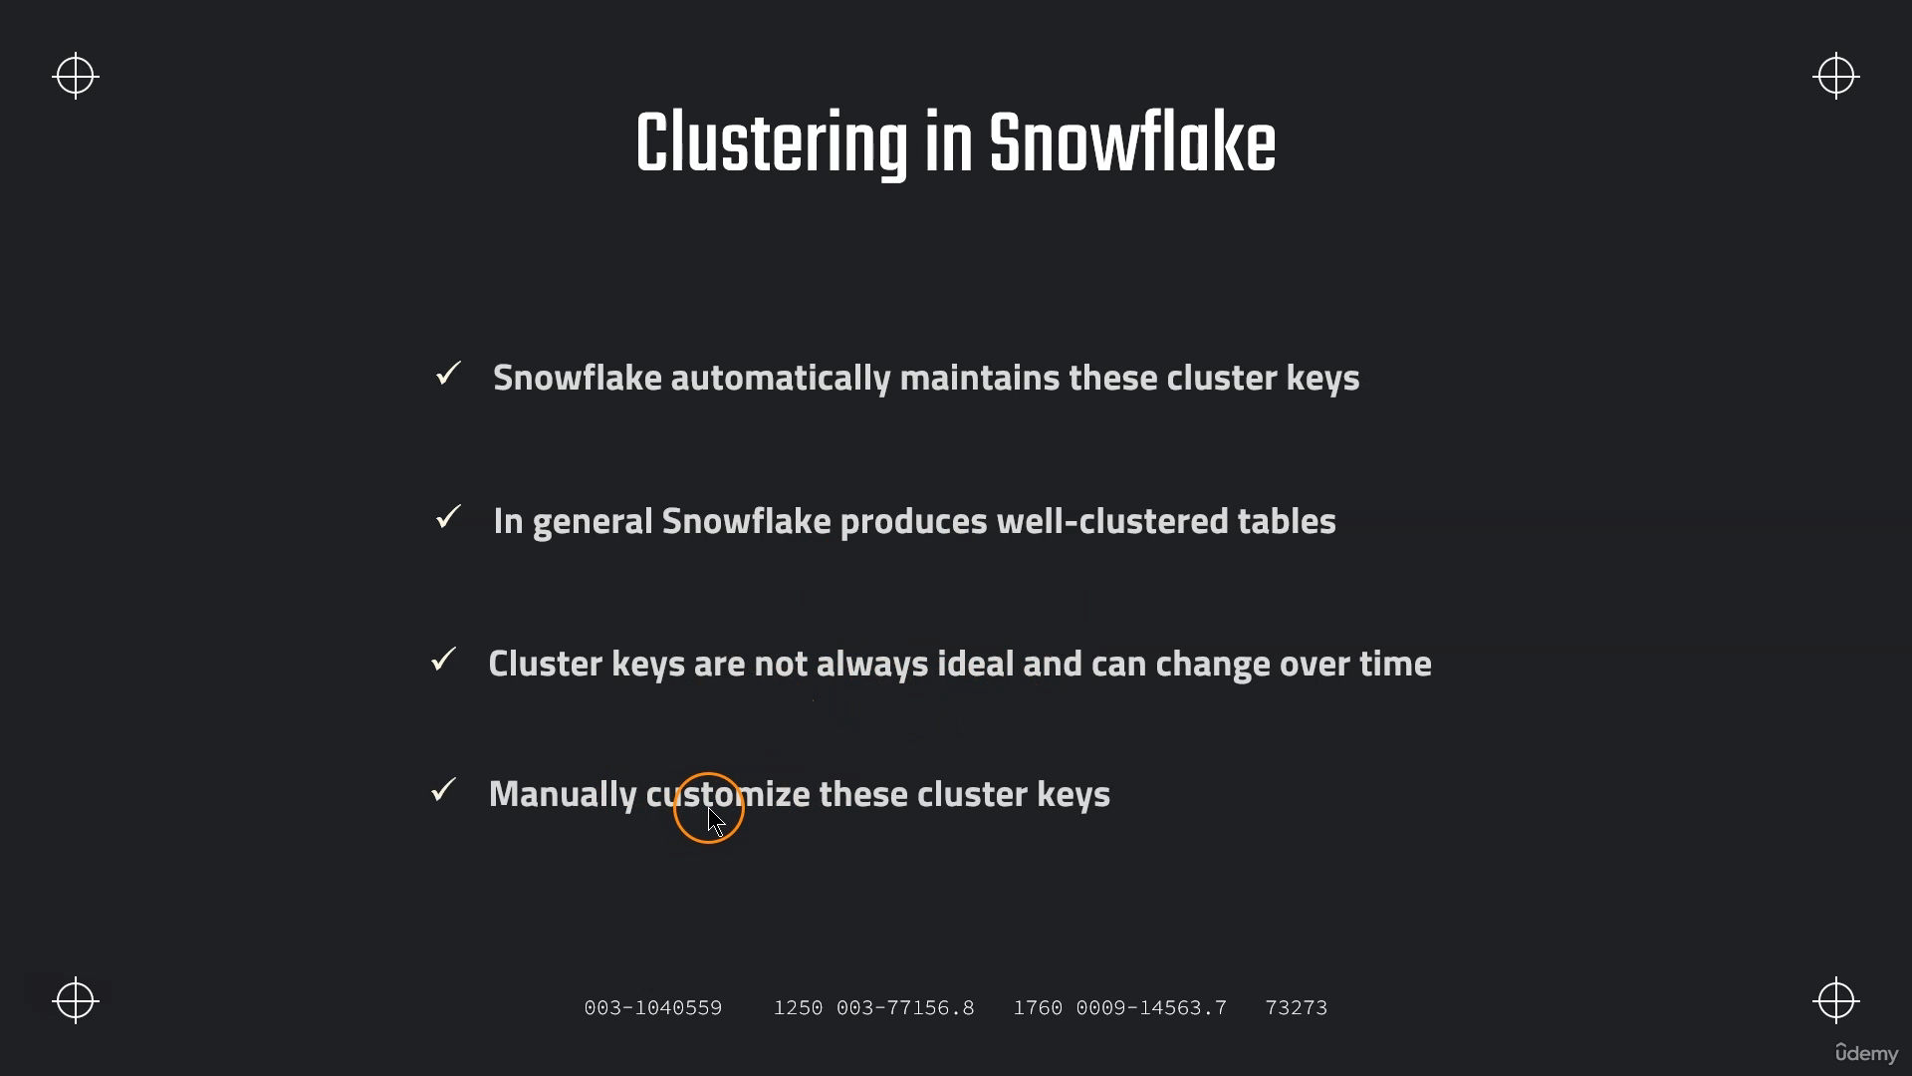

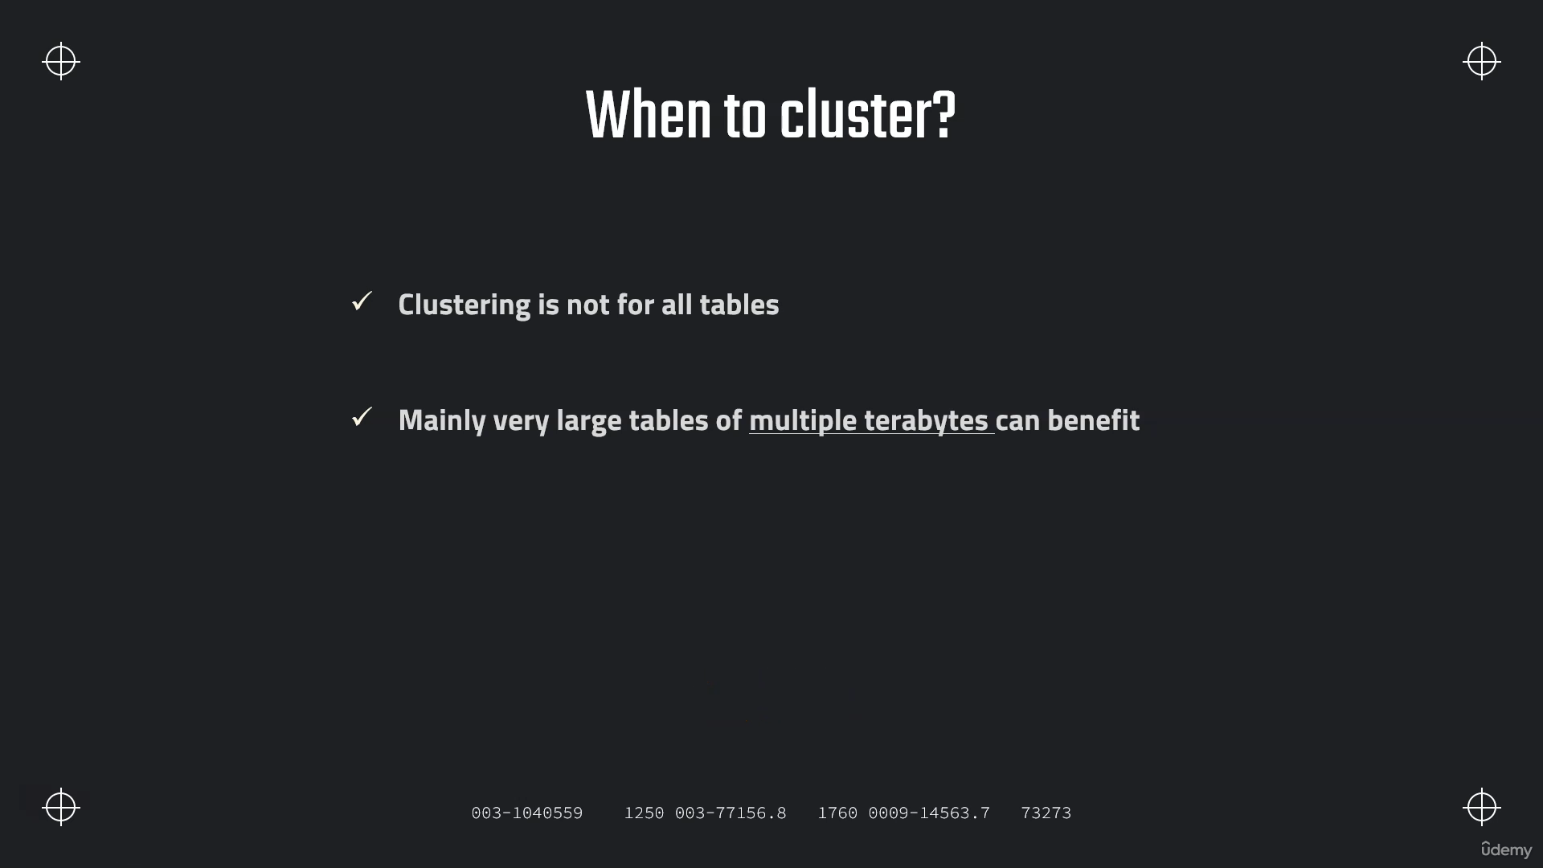

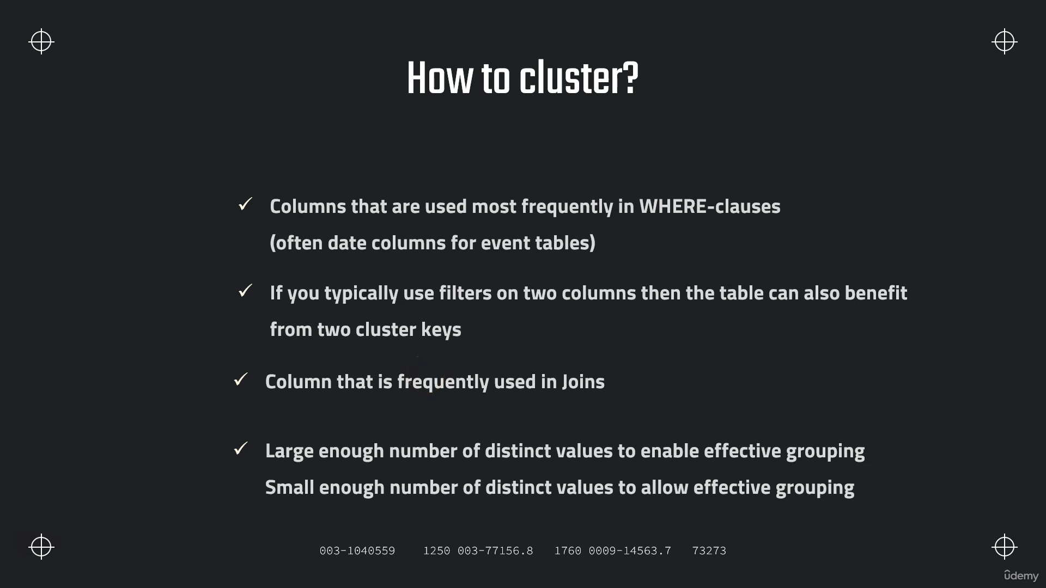

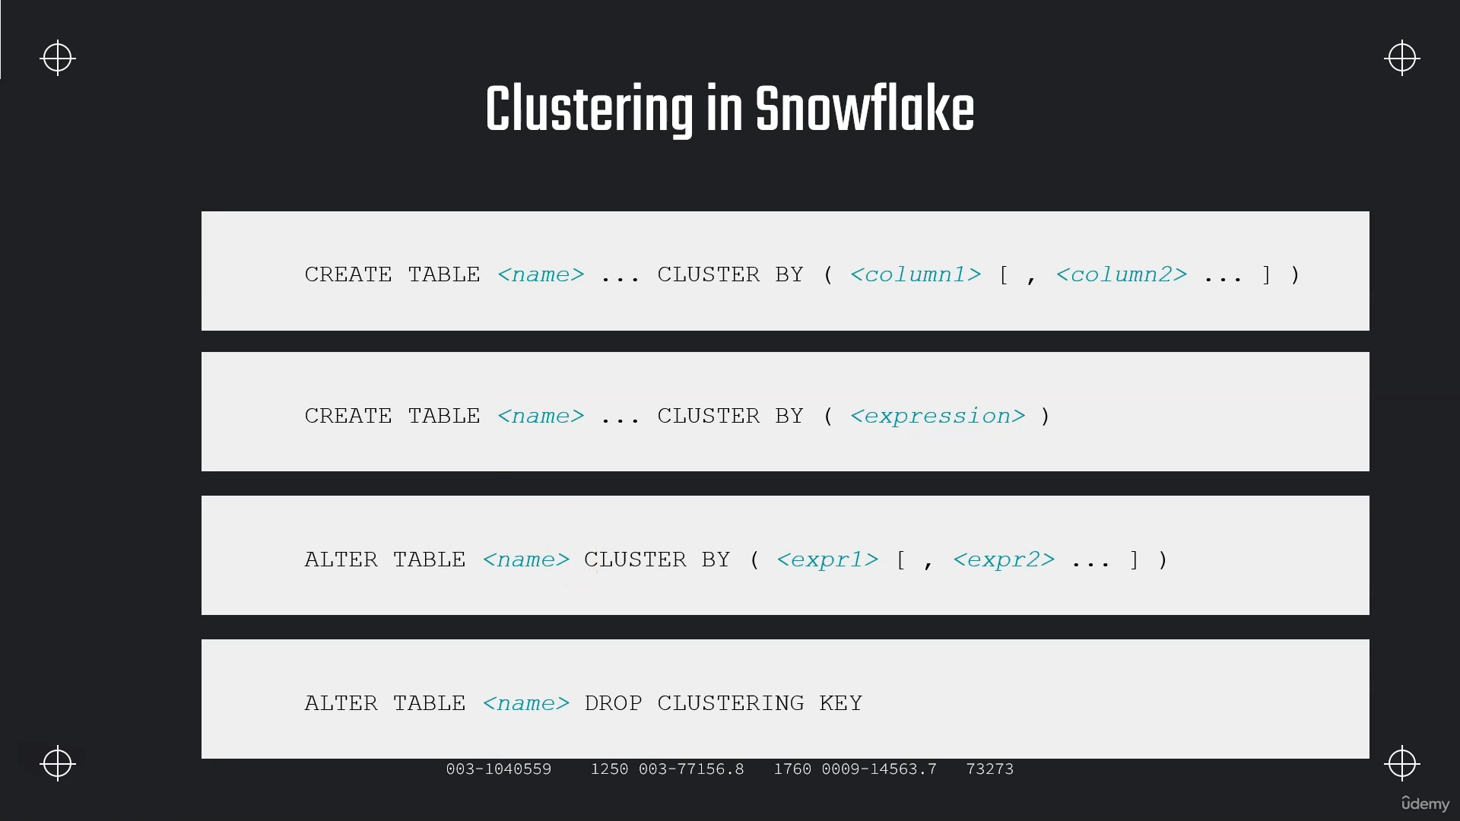

**Loading data from AWS :**

[**Manage AWS Resources - AWS Management Console - AWS**](https://aws.amazon.com/console/)

**Step 1:-After Sign in go to All services-> Storage ->s3(Simple Storage Service)->create bucket**

**Step 2:-Go to** [**Security, Identity, & Compliance**](https://us-east-1.console.aws.amazon.com/console/services#security_and_identity)**->IAM->Roles->other aws account->give account id and external id as ‘00000’->Create Role**

**Step 3:-Click on role-> Permissions ->Search->AmazonS3FullAcess**

**Step 4:- Click on Role and copy ARN.**

**Step 5:-login into snowflake account->create storage integration Object.**

**Creating integration Object :-**

**// Create storage integration object**

**create or replace storage integration s3_int**

**TYPE = EXTERNAL_STAGE**

**STORAGE_PROVIDER = S3**

**ENABLED = TRUE**

**STORAGE_AWS_ROLE_ARN = 'arn:aws:iam::796973497207:role/snowflake-access-role'**

**STORAGE_ALLOWED_LOCATIONS = ('s3://snowflake-sample-223/csv/', 's3://s3://snowflake-sample-223/json/')**

**COMMENT = 'This an optional comment' ;**

**// See storage integration properties to fetch external_id so we can update it in S3**

**DESC integration s3_int;**

**alter STORAGE integration s3_int**

**set STORAGE_ALLOWED_LOCATIONS=('s3://snowflake-s3bucket-1234/csv/','s3://snowflake-s3bucket-1234/json/');**

**Step 6 :-**

**DESC integration s3_int;**

**Copy STORAGE_AWS_IAM_USER_ARN and STORAGE_AWS_EXTERNAL_ID then in AWS Account click on role->Trust Relationships->Edit trust policy-_then update AWS-> STORAGE_AWS_IAM_USER_ARN**

**External ID-> STORAGE_AWS_EXTERNAL_ID**

**// Create table first**

**CREATE OR REPLACE TABLE OUR_FIRST_DB.PUBLIC.movie_titles (**

**show_id STRING,**

**type STRING,**

**title STRING,**

**director STRING,**

**cast STRING,**

**country STRING,**

**date_added STRING,**

**release_year STRING,**

**rating STRING,**

**duration STRING,**

**listed_in STRING,**

**description STRING );**

**// Create file format object**

**CREATE OR REPLACE file format MANAGE_DB.file_formats.csv_fileformat**

**type = csv**

**field_delimiter = ','**

**skip_header = 1**

**null_if = ('NULL','null')**

**empty_field_as_null = TRUE**

**Field_optionally_enclosed_by='"';**

**// Create stage object with integration object & file format object**

**CREATE OR REPLACE stage MANAGE_DB.external_stages.csv_folder**

**URL = 's3://snowflake-s3bucket-1234/csv/'**

**STORAGE_INTEGRATION = s3_int**

**FILE_FORMAT = MANAGE_DB.file_formats.csv_fileformat;**

**// Use Copy command**

**COPY INTO OUR_FIRST_DB.PUBLIC.movie_titles**

**FROM @MANAGE_DB.external_stages.csv_folder;**

**// Create file format object**

**CREATE OR REPLACE file format MANAGE_DB.file_formats.csv_fileformat**

**type = csv**

**field_delimiter = ','**

**skip_header = 1**

**null_if = ('NULL','null')**

**empty_field_as_null = TRUE**

**FIELD_OPTIONALLY_ENCLOSED_BY = '"' ;**

**SELECT * FROM OUR_FIRST_DB.PUBLIC.movie_titles;**

**Handling JSON file ;-**

**DESC integration s3_int;**

**CREATE OR REPLACE file format MANAGE_DB.file_formats.json_fileformat**

**type = json;**

**CREATE OR REPLACE stage MANAGE_DB.external_stages.json_folder**

**URL = 's3://snowflake-s3bucket-1234/json/'**

**STORAGE_INTEGRATION = s3_int**

**FILE_FORMAT = MANAGE_DB.file_formats.json_fileformat;**

**// Taming the JSON file**

**// First query from S3 Bucket**

**SELECT * FROM @MANAGE_DB.external_stages.json_folder;**

**// Introduce columns**

**SELECT**

**$1:asin,**

**$1:helpful,**

**$1:overall,**

**$1:reviewText,**

**$1:reviewTime,**

**$1:reviewerID,**

**$1:reviewTime,**

**$1:reviewerName,**

**$1:summary,**

**$1:unixReviewTime**

**FROM @MANAGE_DB.external_stages.json_folder;**

**// Format columns & use DATE function**

**SELECT**

**$1:asin::STRING as ASIN,**

**$1:helpful as helpful,**

**$1:overall as overall,**

**$1:reviewText::STRING as reviewtext,**

**$1:reviewTime::STRING,**

**$1:reviewerID::STRING,**

**$1:reviewTime::STRING,**

**$1:reviewerName::STRING,**

**$1:summary::STRING,**

**DATE($1:unixReviewTime::int) as Revewtime**

**FROM @MANAGE_DB.external_stages.json_folder;**

**// Format columns & handle custom date**

**SELECT**

**$1:asin::STRING as ASIN,**

**$1:helpful as helpful,**

**$1:overall as overall,**

**$1:reviewText::STRING as reviewtext,**

**//DATE_FROM_PARTS( <year>, <month>, <day> )**

**$1:reviewTime::STRING,**

**$1:reviewerID::STRING,**

**$1:reviewTime::STRING,**

**$1:reviewerName::STRING,**

**$1:summary::STRING,**

**DATE($1:unixReviewTime::int) as Revewtime**

**FROM @MANAGE_DB.external_stages.json_folder;**

**// Use DATE_FROM_PARTS and see another difficulty**

**SELECT**

**$1:asin::STRING as ASIN,**

**$1:helpful as helpful,**

**$1:overall as overall,**

**$1:reviewText::STRING as reviewtext,**

**DATE_FROM_PARTS( RIGHT($1:reviewTime::STRING,4), LEFT($1:reviewTime::STRING,2), SUBSTRING($1:reviewTime::STRING,4,2) ),**

**$1:reviewerID::STRING,**

**$1:reviewTime::STRING,**

**$1:reviewerName::STRING,**

**$1:summary::STRING,**

**DATE($1:unixReviewTime::int) as unixRevewtime**

**FROM @MANAGE_DB.external_stages.json_folder;**

**// Use DATE_FROM_PARTS and handle the case difficulty**

**SELECT**

**$1:asin::STRING as ASIN,**

**$1:helpful as helpful,**

**$1:overall as overall,**

**$1:reviewText::STRING as reviewtext,**

**DATE_FROM_PARTS(**

**RIGHT($1:reviewTime::STRING,4),**

**LEFT($1:reviewTime::STRING,2),**

**CASE WHEN SUBSTRING($1:reviewTime::STRING,5,1)=','**

**THEN SUBSTRING($1:reviewTime::STRING,4,1) ELSE SUBSTRING($1:reviewTime::STRING,4,2) END),**

**$1:reviewerID::STRING,**

**$1:reviewTime::STRING,**

**$1:reviewerName::STRING,**

**$1:summary::STRING,**

**DATE($1:unixReviewTime::int) as UnixRevewtime**

**FROM @MANAGE_DB.external_stages.json_folder;**

**// Create destination table**

**CREATE OR REPLACE TABLE OUR_FIRST_DB.PUBLIC.reviews (**

**asin STRING,**

**helpful STRING,**

**overall STRING,**

**reviewtext STRING,**

**reviewtime DATE,**

**reviewerid STRING,**

**reviewername STRING,**

**summary STRING,**

**unixreviewtime DATE**

**);**

**// Copy transformed data into destination table**

**COPY INTO OUR_FIRST_DB.PUBLIC.reviews**

**FROM (SELECT**

**$1:asin::STRING as ASIN,**

**$1:helpful as helpful,**

**$1:overall as overall,**

**$1:reviewText::STRING as reviewtext,**

**DATE_FROM_PARTS(**

**RIGHT($1:reviewTime::STRING,4),**

**LEFT($1:reviewTime::STRING,2),**

**CASE WHEN SUBSTRING($1:reviewTime::STRING,5,1)=','**

**THEN SUBSTRING($1:reviewTime::STRING,4,1) ELSE SUBSTRING($1:reviewTime::STRING,4,2) END),**

**$1:reviewerID::STRING,**

**$1:reviewerName::STRING,**

**$1:summary::STRING,**

**DATE($1:unixReviewTime::int) Revewtime**

**FROM @MANAGE_DB.external_stages.json_folder);**

**// Validate results**

**SELECT * FROM OUR_FIRST_DB.PUBLIC.reviews ;**

**Loading Data from Azure :-**

[**Home - Microsoft Azure**](https://portal.azure.com/#home)

**Step 1: After Sign need to create Storage account**

**Search Storage accounts->Create->Resource Group->New->give name like Snowflake**

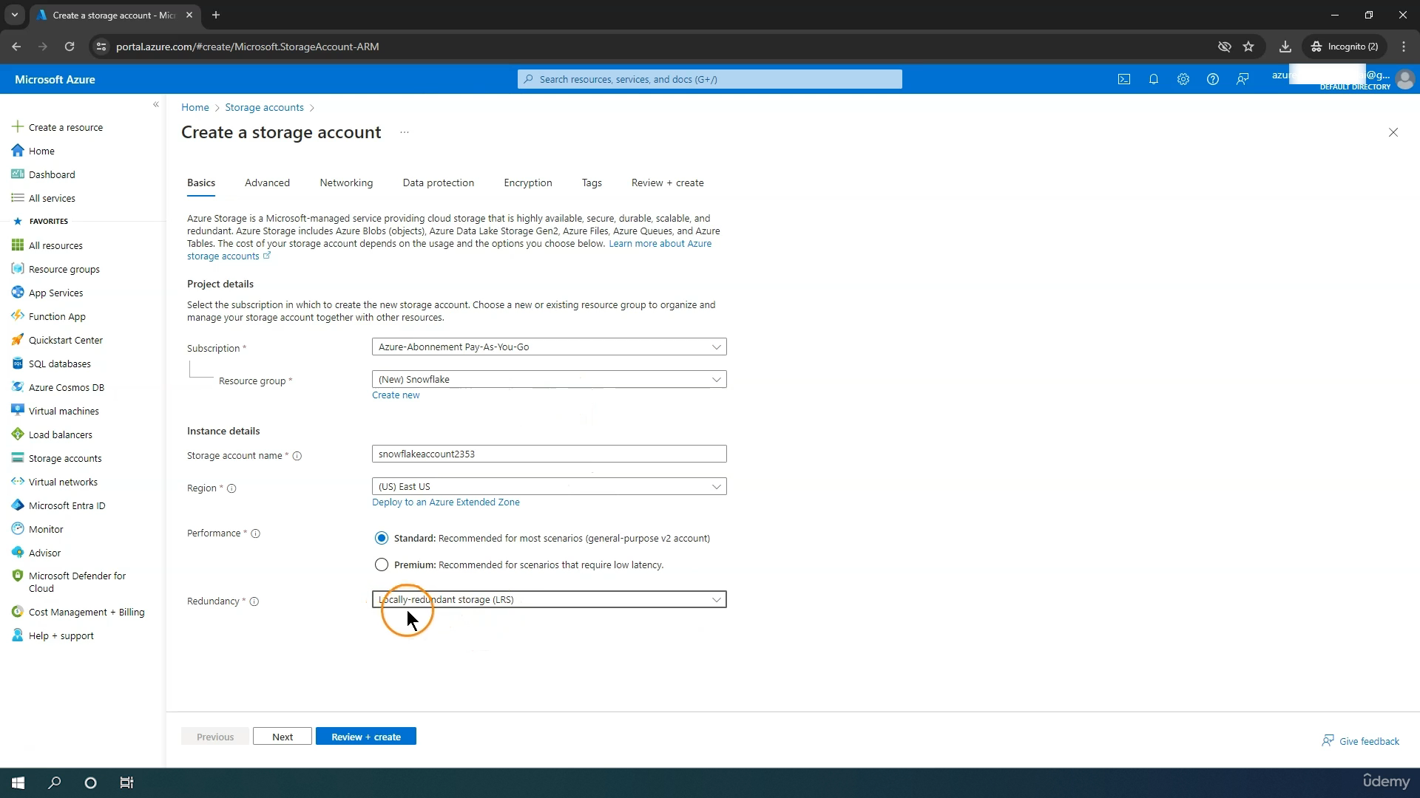

**Step 2 :-Create Container**

**Storage Accounts->Click on newly created storage account name->Data Storage->Container-> create new container name like csv,json…etc**

**->click on container name (csv)->then upload file**

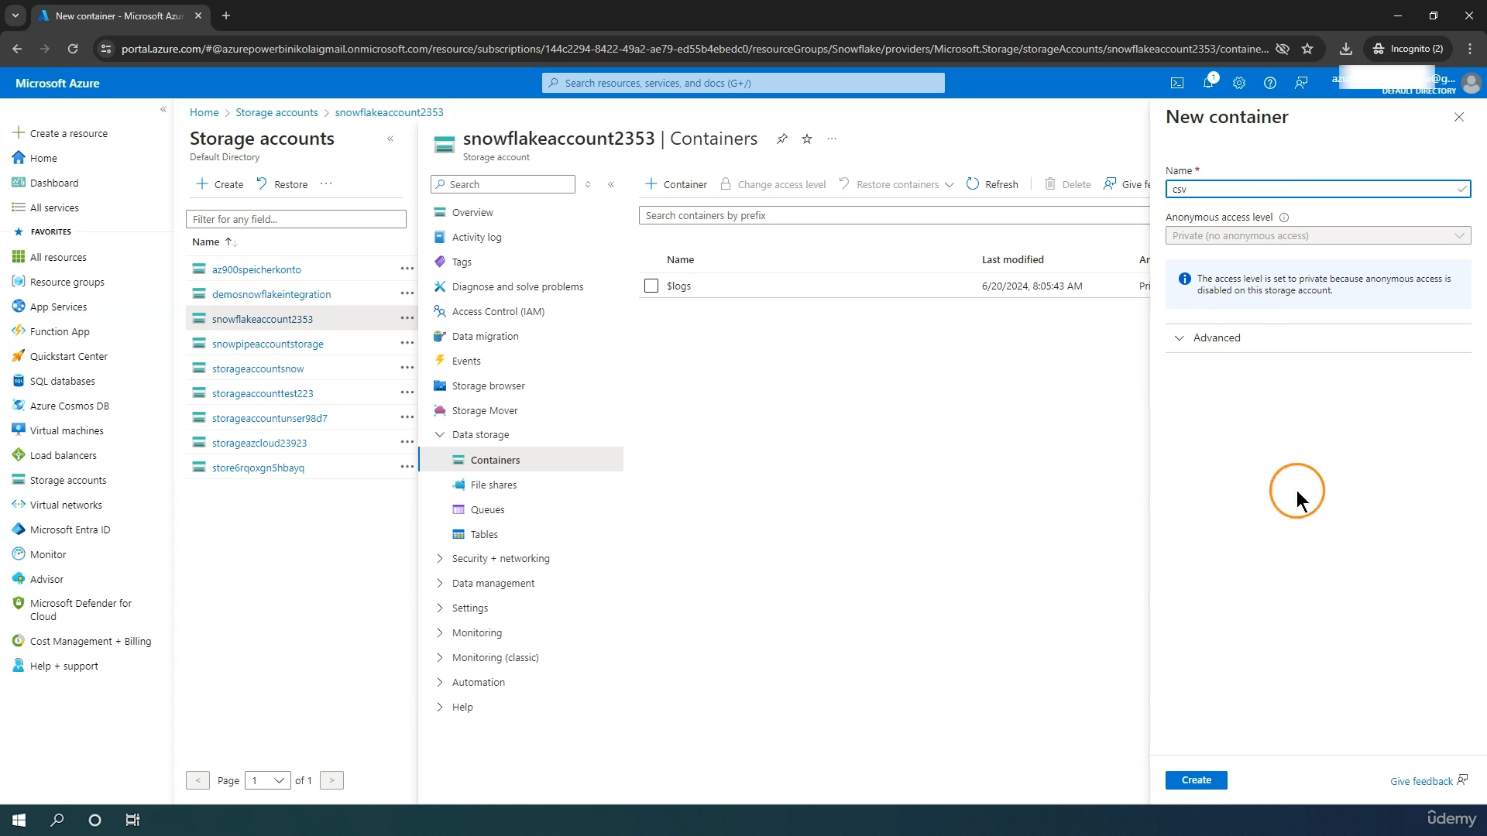

**Tenant ID->to get Tenant ID in search bar->tenant properties**

**Step 3 :- Create Integration Object**

**USE DATABASE DEMO_DB;**

**-- create integration object that contains the access information**

**CREATE STORAGE INTEGRATION azure_integration**

**TYPE = EXTERNAL_STAGE**

**STORAGE_PROVIDER = AZURE**

**ENABLED = TRUE**

**AZURE_TENANT_ID = 'ff355289-721e-4dd7-a663-afec62ab9d54'**

**STORAGE_ALLOWED_LOCATIONS = ('azure://snowflake765.blob.core.windows.net/csv', 'azure://snowflake765.blob.core.windows.net/json');**

**-- Describe integration object to provide access**

**DESC STORAGE integration azure_integration;**

**Step 4 :-**

**DESC STORAGE integration azure_integration;**

**Note down the Azure Consent Url and AZURE_MULTI_TENANT_APP_NAME column data**

**Azure Consent Url->click on that url and give permission ->**

**https://login.microsoftonline.com/ff355289-721e-4dd7-a663-afec62ab9d54/oauth2/authorize?client_id=ea87aaf9-6f63-457d-a32b-8b446a4bc274&response_type=code**

**Azure Consent Url->click on that url and give permission ->**

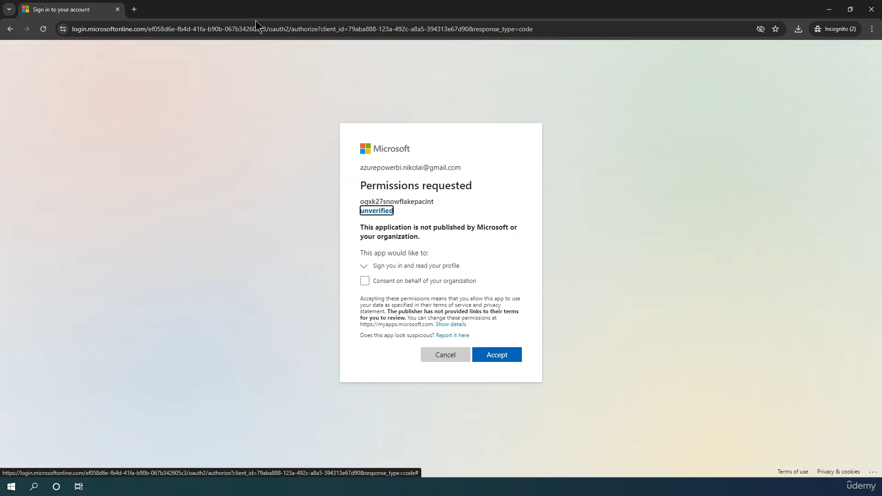

Save above generated ID

**Step 5 : In Azure Account->Click on Storage Account->**

**Access Control->Add role assignment->search->Storage Blob data Contributor->Click on storage Blob data Contributor->members->select member-> seach with** generated ID or **AZURE_MULTI_TENANT_APP_NAME ->select then click on review and assign**

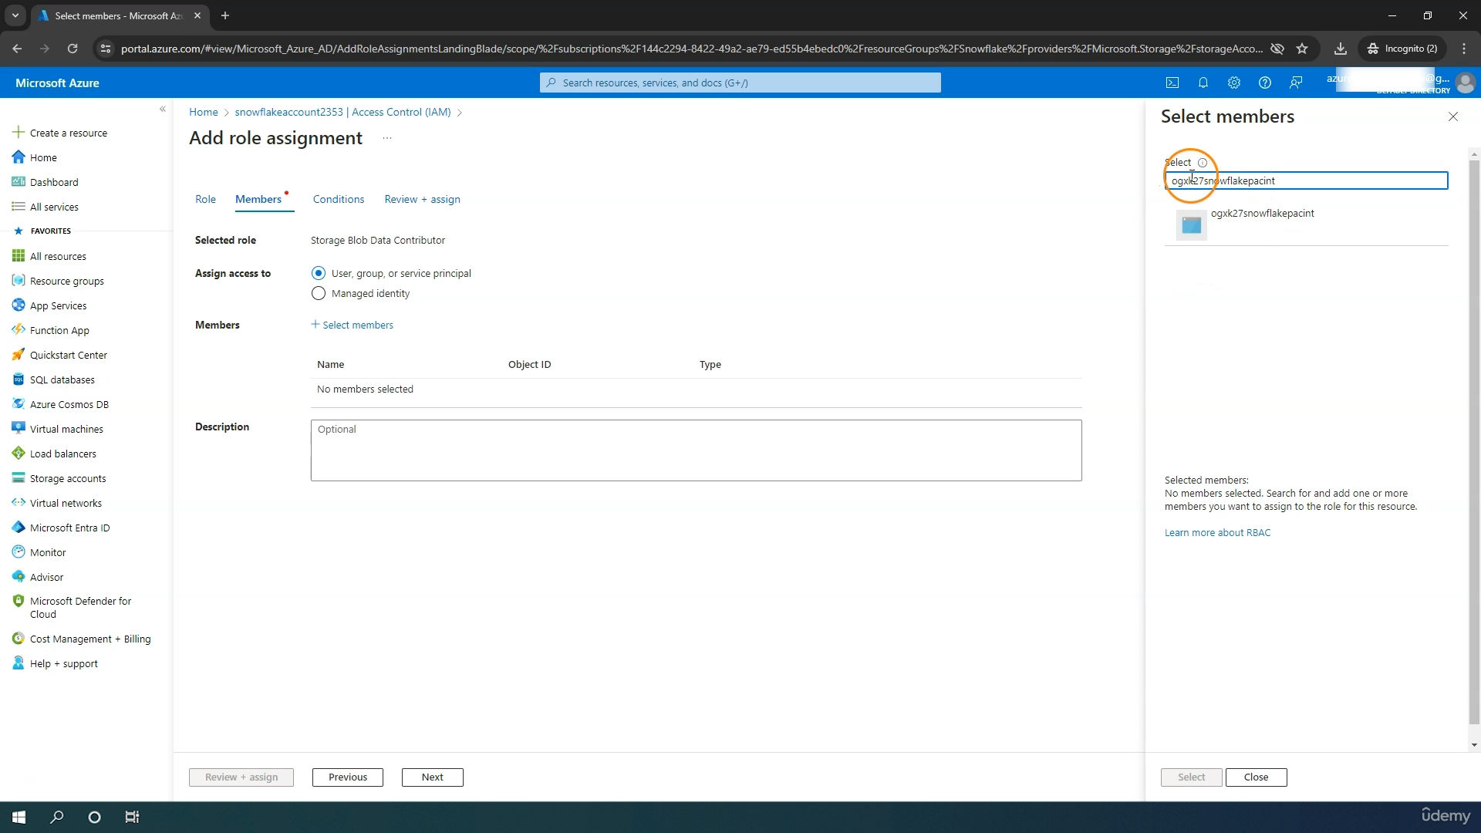

**Create Stage and Test Connection :-**

**create or replace database demo_db;**

**---- Create file format & stage objects ----**

**-- create file format**

**create or replace file format demo_db.public.fileformat_azure**

**TYPE = CSV**

**FIELD_DELIMITER = ','**

**SKIP_HEADER = 1;**

**-- create stage object**

**create or replace stage demo_db.public.stage_azure**

**STORAGE_INTEGRATION = azure_integration**

**URL = 'azure://snowflake765.blob.core.windows.net/csv'**

**FILE_FORMAT = fileformat_azure;**

**-- list files**

**LIST @demo_db.public.stage_azure;**

**Load CSV file**

**---- Query files & Load data ----**

**--query files**

**SELECT**

**$1,**

**$2,**

**$3,**

**$4,**

**$5,**

**$6,**

**$7,**

**$8,**

**$9,**

**$10,**

**$11,**

**$12,**

**$13,**

**$14,**

**$15,**

**$16,**

**$17,**

**$18,**

**$19,**

**$20**

**FROM @demo_db.public.stage_azure;**

**create or replace table happiness (**

**country_name varchar,**

**regional_indicator varchar,**

**ladder_score number(4,3),**

**standard_error number(4,3),**

**upperwhisker number(4,3),**

**lowerwhisker number(4,3),**

**logged_gdp number(5,3),**

**social_support number(4,3),**

**healthy_life_expectancy number(5,3),**

**freedom_to_make_life_choices number(4,3),**

**generosity number(4,3),**

**perceptions_of_corruption number(4,3),**

**ladder_score_in_dystopia number(4,3),**

**explained_by_log_gpd_per_capita number(4,3),**

**explained_by_social_support number(4,3),**

**explained_by_healthy_life_expectancy number(4,3),**

**explained_by_freedom_to_make_life_choices number(4,3),**

**explained_by_generosity number(4,3),**

**explained_by_perceptions_of_corruption number(4,3),**

**dystopia_residual number (4,3));**

**COPY INTO HAPPINESS**

**FROM @demo_db.public.stage_azure;**

**SELECT * FROM HAPPINESS;**

**Load JSON File :-**

**--- Load JSON ----**

**create or replace file format demo_db.public.fileformat_azure_json**

**TYPE = JSON;**

**create or replace stage demo_db.public.stage_azure**

**STORAGE_INTEGRATION = azure_integration**

**URL = 'azure://storageaccountsnow.blob.core.windows.net/snowflakejson'**

**FILE_FORMAT = fileformat_azure_json;**

**LIST @demo_db.public.stage_azure;**

**-- Query from stage**

**SELECT * FROM @demo_db.public.stage_azure;**

**-- Query one attribute/column**

**SELECT $1:"Car Model" FROM @demo_db.public.stage_azure;**

**-- Convert data type**

**SELECT $1:"Car Model"::STRING FROM @demo_db.public.stage_azure;**

**-- Query all attributes**

**SELECT**

**$1:"Car Model"::STRING,**

**$1:"Car Model Year"::INT,**

**$1:"car make"::STRING,**

**$1:"first_name"::STRING,**

**$1:"last_name"::STRING**

**FROM @demo_db.public.stage_azure;**

**-- Query all attributes and use aliases**

**SELECT**

**$1:"Car Model"::STRING as car_model,**

**$1:"Car Model Year"::INT as car_model_year,**

**$1:"car make"::STRING as "car make",**

**$1:"first_name"::STRING as first_name,**

**$1:"last_name"::STRING as last_name**

**FROM @demo_db.public.stage_azure;**

**Create or replace table car_owner (**

**car_model varchar,**

**car_model_year int,**

**car_make varchar,**

**first_name varchar,**

**last_name varchar);**

**COPY INTO car_owner**

**FROM**

**(SELECT**

**$1:"Car Model"::STRING as car_model,**

**$1:"Car Model Year"::INT as car_model_year,**

**$1:"car make"::STRING as "car make",**

**$1:"first_name"::STRING as first_name,**

**$1:"last_name"::STRING as last_name**

**FROM @demo_db.public.stage_azure);**

**SELECT * FROM CAR_OWNER;**

**-- Alternative: Using a raw file table step**

**truncate table car_owner;**

**select * from car_owner;**

**create or replace table car_owner_raw (**

**raw variant);**

**COPY INTO car_owner_raw**

**FROM @demo_db.public.stage_azure;**

**SELECT * FROM car_owner_raw;**

**INSERT INTO car_owner**

**(SELECT**

**$1:"Car Model"::STRING as car_model,**

**$1:"Car Model Year"::INT as car_model_year,**

**$1:"car make"::STRING as car_make,**

**$1:"first_name"::STRING as first_name,**

**$1:"last_name"::STRING as last_name**

**FROM car_owner_raw) ;**

**select * from car_owner;**

**Loading From GCP :-**

[**Welcome – My First Project – Google Cloud console**](https://console.cloud.google.com/welcome/new?_gl=1*fbf8eb*_up*MQ..&gclid=8f7d1228853917280961755ebf3184bf&gclsrc=3p.ds&inv=1&invt=Ablv6A&project=model-command-446606-r6)

**Step 1 :-Create a Bucket**

**After Sign into GCP go to Menu-> Cloud Storage-> Buckets->Create Bucket->Upload->Upload files**

**Step 2 :- Create Integration Object**

**-> Cloud Storage-> Buckets->Copy the Bucket Name**

**-- create integration object that contains the access information**

**CREATE STORAGE INTEGRATION gcp_integration**

**TYPE = EXTERNAL_STAGE**

**STORAGE_PROVIDER = GCS**

**ENABLED = TRUE**

**STORAGE_ALLOWED_LOCATIONS = ('gcs://snowflakegcp765', 'gcs://snowflakegcp765json');**

**-- Describe integration object to provide access**

**DESC STORAGE integration gcp_integration;**

**Note Down the STORAGE_GCP_SERVICE_ACCOUNT column value.**

**Step 3: Grant Permission**

**-> Cloud Storage-> Buckets-> Select the Bucket->Permission->Add Principal**

**->New Principal->Copy STORAGE_GCP_SERVICE_ACCOUNT data**

**->Assign Role->Cloud Storage->Storage Admin->Save**

**Step 4 :- Create Stage**

**-- create file format**

**create or replace file format demo_db.public.fileformat_gcp**

**TYPE = CSV**

**FIELD_DELIMITER = ','**

**SKIP_HEADER = 1;**

**-- create stage object**

**create or replace stage demo_db.public.stage_gcp**

**STORAGE_INTEGRATION = gcp_integration**

**URL = 'gcs://snowflakegcp765'**

**FILE_FORMAT = fileformat_gcp;**

**LIST @demo_db.public.stage_gcp;**

**Step 5 :- Query and Load Data**

**---- Query files & Load data ----**

**--query files**

**SELECT**

**$1,$2,$3,$4,$5,$6,$7,$8,$9,$10,$11,**

**$12,$13,$14,$15,$16,$17,$18,$19,$20**

**FROM @demo_db.public.stage_gcp;**

**create or replace table happiness (**

**country_name varchar,**

**regional_indicator varchar,**

**ladder_score number(4,3),**

**standard_error number(4,3),**

**upperwhisker number(4,3),**

**lowerwhisker number(4,3),**

**logged_gdp number(5,3),**

**social_support number(4,3),**

**healthy_life_expectancy number(5,3),**

**freedom_to_make_life_choices number(4,3),**

**generosity number(4,3),**

**perceptions_of_corruption number(4,3),**

**ladder_score_in_dystopia number(4,3),**

**explained_by_log_gpd_per_capita number(4,3),**

**explained_by_social_support number(4,3),**

**explained_by_healthy_life_expectancy number(4,3),**

**explained_by_freedom_to_make_life_choices number(4,3),**

**explained_by_generosity number(4,3),**

**explained_by_perceptions_of_corruption number(4,3),**

**dystopia_residual number (4,3));**

**COPY INTO HAPPINESS**

**FROM @demo_db.public.stage_gcp;**

**SELECT * FROM HAPPINESS;**

**Step 6 :-Unload Data**

**-- create stage object**

**create or replace stage demo_db.public.stage_gcp**

**STORAGE_INTEGRATION = gcp_integration**

**URL = 'gcs://snowflakegcp765/csv_happiness'**

**FILE_FORMAT = fileformat_gcp;**

**SELECT * FROM HAPPINESS;**

**COPY INTO @stage_gcp**

**FROM**

**HAPPINESS;**

**Snowpipe :-**

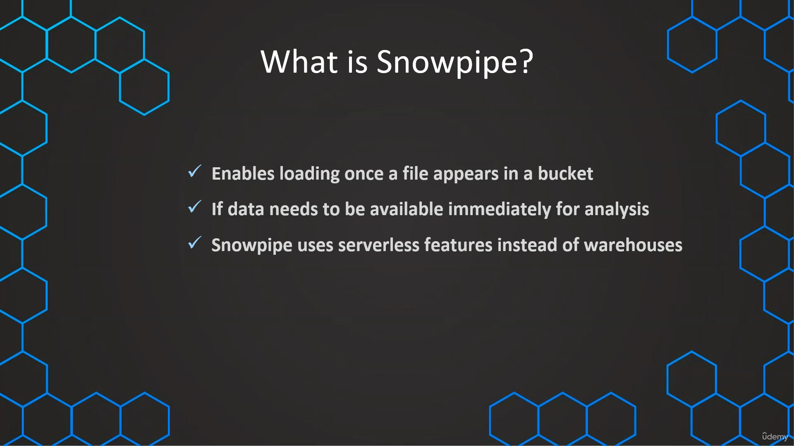

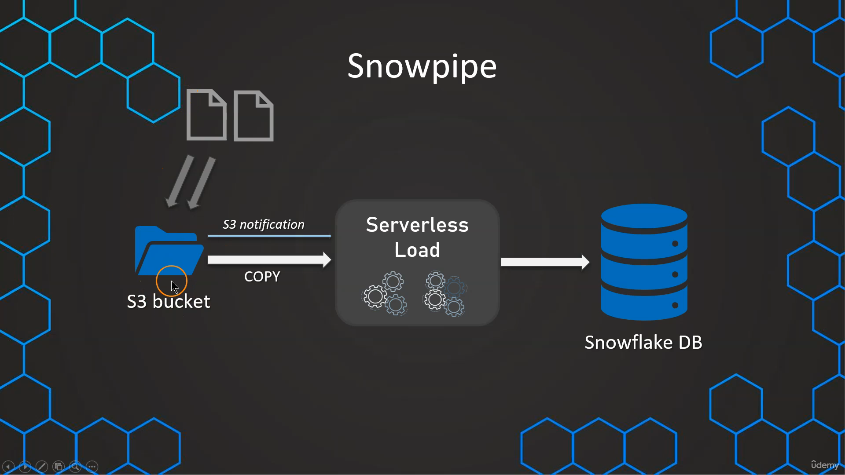

**High Level Steps**

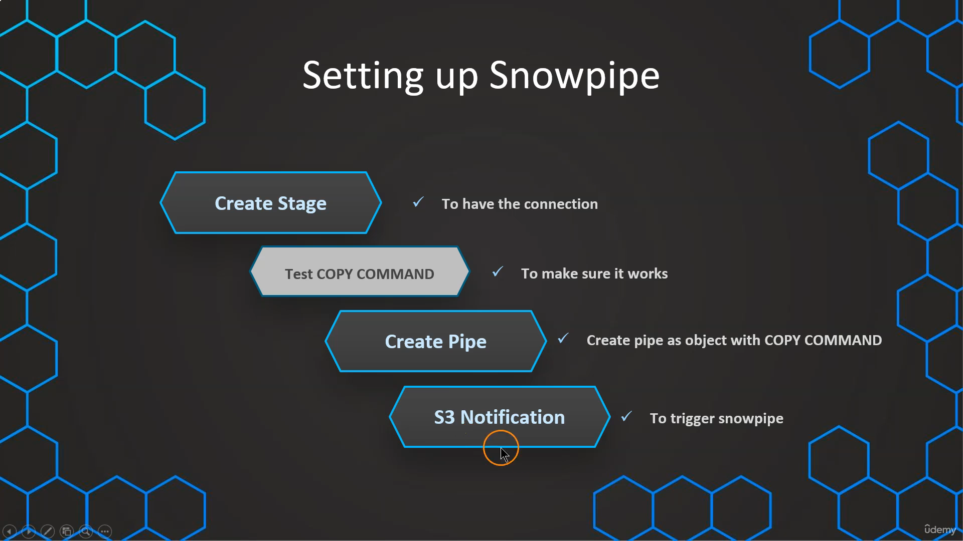

**Create and Configure Pipe :-**

**// Create table first**

**CREATE OR REPLACE TABLE OUR_FIRST_DB.PUBLIC.employees (**

**id INT,**

**first_name STRING,**

**last_name STRING,**

**email STRING,**

**location STRING,**

**department STRING**

**);**

**// Create file format object**

**CREATE OR REPLACE file format MANAGE_DB.file_formats.csv_fileformat**

**type = csv**

**field_delimiter = ','**

**skip_header = 1**

**null_if = ('NULL','null')**

**empty_field_as_null = TRUE;**

**// Create stage object with integration object & file format object**

**CREATE OR REPLACE stage MANAGE_DB.external_stages.csv_folder**

**URL = 's3://snowflake-s3bucket-1234/csv/snowpipe'**

**STORAGE_INTEGRATION = s3_int**

**FILE_FORMAT = MANAGE_DB.file_formats.csv_fileformat;**

**// Create stage object with integration object & file format object**

**LIST @MANAGE_DB.external_stages.csv_folder;**

**// Create table first**

**CREATE OR REPLACE TABLE OUR_FIRST_DB.PUBLIC.employees (**

**id INT,**

**first_name STRING,**

**last_name STRING,**

**email STRING,**

**location STRING,**

**department STRING**

**);**

**// Create file format object**

**CREATE OR REPLACE file format MANAGE_DB.file_formats.csv_fileformat**

**type = csv**

**field_delimiter = ','**

**skip_header = 1**

**null_if = ('NULL','null')**

**empty_field_as_null = TRUE;**

**// Create stage object with integration object & file format object**

**CREATE OR REPLACE stage MANAGE_DB.external_stages.csv_folder**

**URL = 's3://snowflake-s3bucket-1234/csv/snowpipe'**

**STORAGE_INTEGRATION = s3_int**

**FILE_FORMAT = MANAGE_DB.file_formats.csv_fileformat;**

**// Create stage object with integration object & file format object**

**LIST @MANAGE_DB.external_stages.csv_folder;**

**// Create schema to keep things organized**

**CREATE OR REPLACE SCHEMA MANAGE_DB.pipes;**

**// Define pipe**

**CREATE OR REPLACE pipe MANAGE_DB.pipes.employee_pipe**

**auto_ingest = TRUE**

**AS**

**COPY INTO OUR_FIRST_DB.PUBLIC.employees**

**FROM @MANAGE_DB.external_stages.csv_folder ;**

**// Describe pipe**

**DESC pipe employee_pipe;->copy Notification_Channel Column data->arn:aws:sqs:us-east-1:586794479661:sf-snowpipe-AIDAYRH5NGAWQHQEAB7E2-Wuq5HMWdf6V_7esQt-3Pzw**

**SELECT * FROM OUR_FIRST_DB.PUBLIC.employees ;**

**Step 1:**

**Login to AWS and click on bucket->snowflake-s3bucket-1234->Properties->Event notifications->Create event notification->**

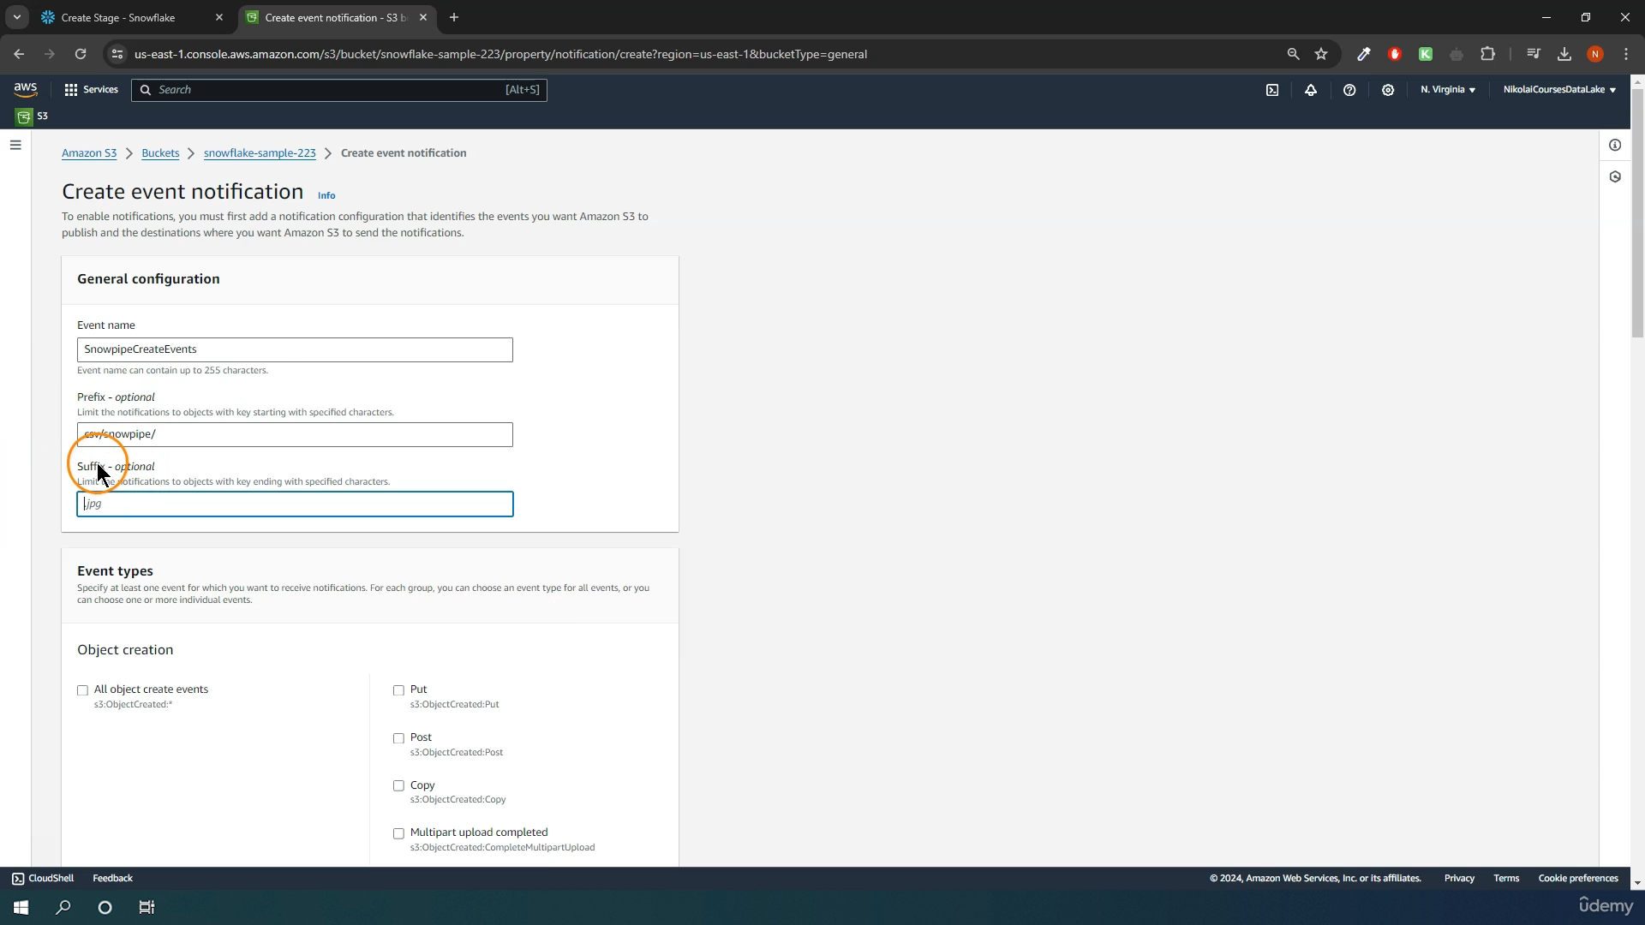

**Events Types**

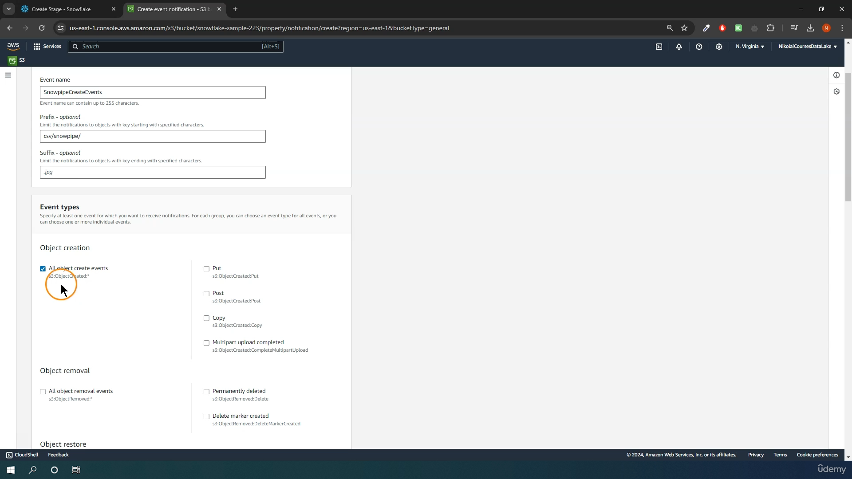

**Destination**

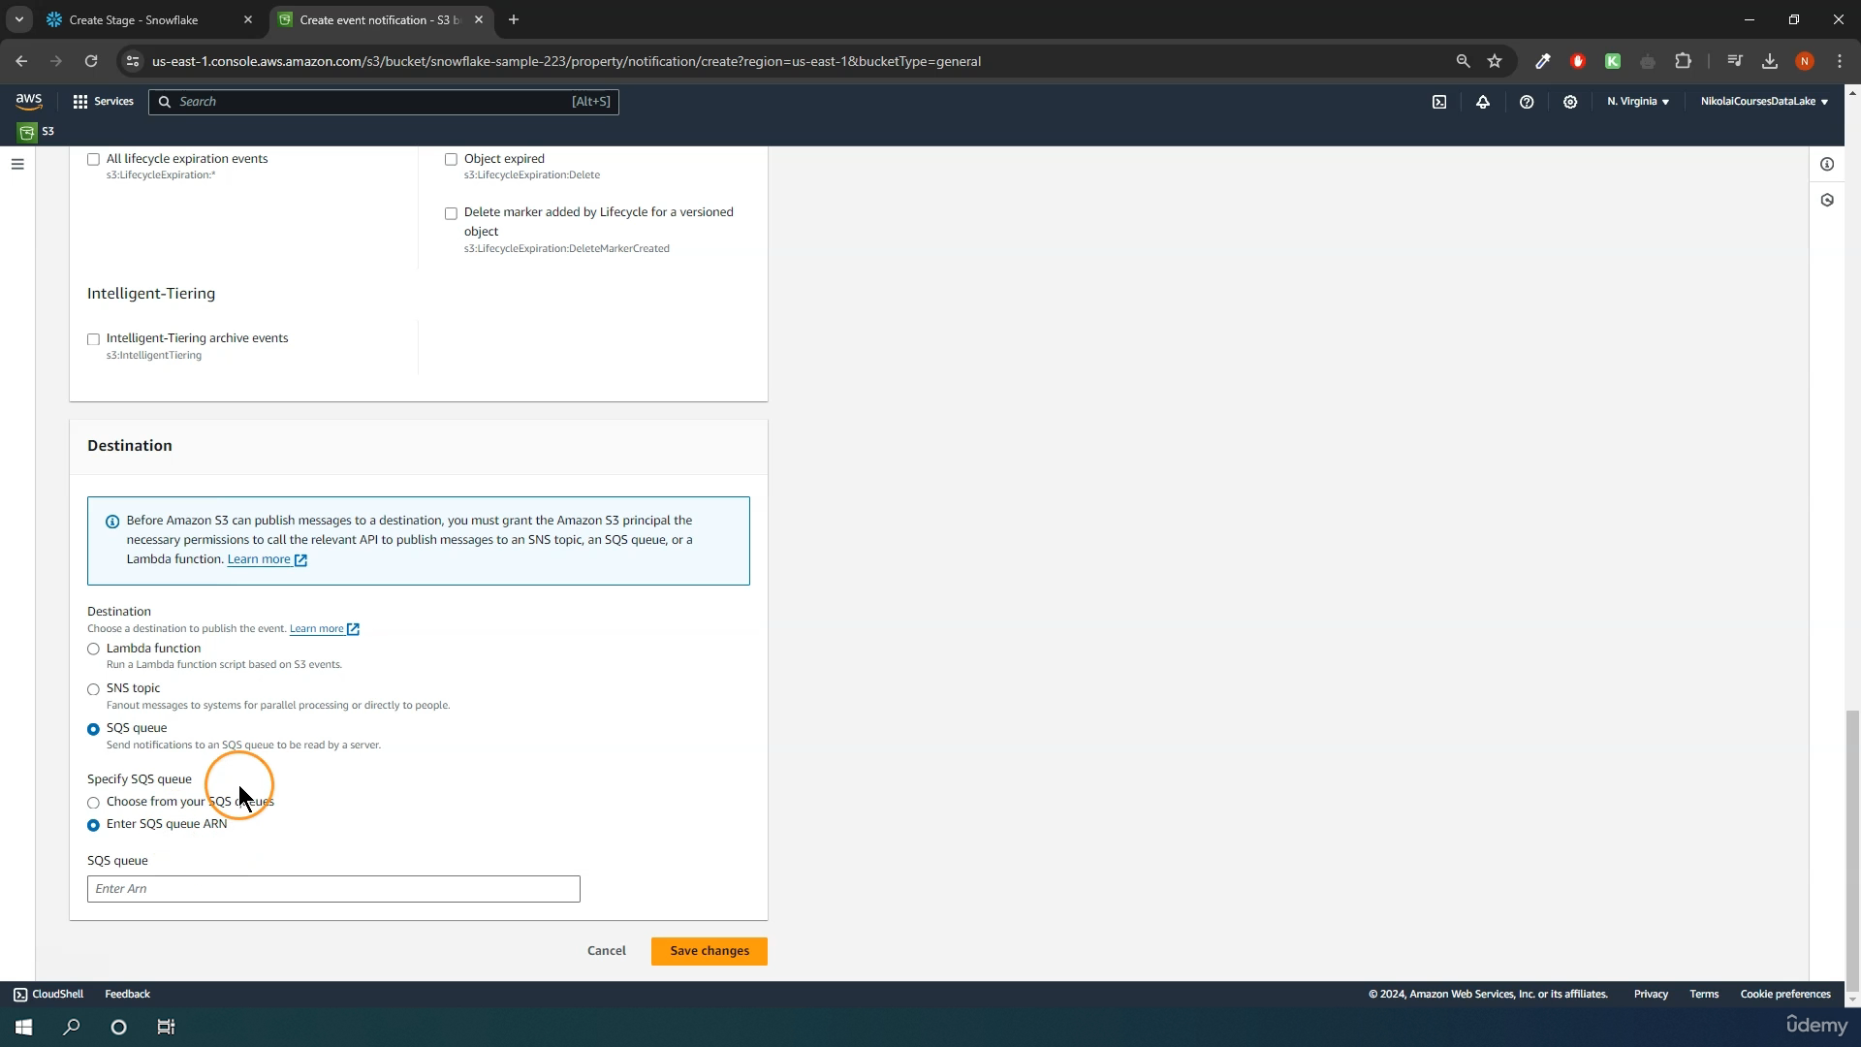

**// Create schema to keep things organized**

**CREATE OR REPLACE SCHEMA MANAGE_DB.pipes;**

**// Define pipe**

**CREATE OR REPLACE pipe MANAGE_DB.pipes.employee_pipe**

**auto_ingest = TRUE**

**AS**

**COPY INTO OUR_FIRST_DB.PUBLIC.employees**

**FROM @MANAGE_DB.external_stages.csv_folder ;**

**// Describe pipe**

**DESC pipe employee_pipe;**

**SELECT count(*) FROM OUR_FIRST_DB.PUBLIC.employees ;**

**Error Handling for Snowpipe Loads :-**

**// Handling errors**

**// Create file format object**

**CREATE OR REPLACE file format MANAGE_DB.file_formats.csv_fileformat**

**type = csv**

**field_delimiter = ','**

**skip_header = 1**

**null_if = ('NULL','null')**

**empty_field_as_null = TRUE;**

**SELECT * FROM OUR_FIRST_DB.PUBLIC.employees ;**

**ALTER PIPE employee_pipe refresh;**

**// Validate pipe is actually working**

**SELECT SYSTEM$PIPE_STATUS('employee_pipe');**

**// Snowpipe error message**

**SELECT * FROM TABLE(VALIDATE_PIPE_LOAD(**

**PIPE_NAME => 'MANAGE_DB.pipes.employee_pipe',**

**START_TIME => DATEADD(HOUR,-2,CURRENT_TIMESTAMP())));**

**// COPY command history from table to see error massage**

**SELECT * FROM TABLE (INFORMATION_SCHEMA.COPY_HISTORY(**

**table_name => 'OUR_FIRST_DB.PUBLIC.EMPLOYEES',**

**START_TIME =>DATEADD(HOUR,-2,CURRENT_TIMESTAMP())));**

**Manage Pipes**

**-- Manage pipes --**

**DESC pipe MANAGE_DB.pipes.employee_pipe;**

**SHOW PIPES;**

**SHOW PIPES like '%employee%';**

**SHOW PIPES in database MANAGE_DB;**

**SHOW PIPES in schema MANAGE_DB.pipes;**

**SHOW PIPES like '%employee%' in Database MANAGE_DB;**

**-- Changing pipe (alter stage or file format) --**

**// Preparation table first**

**CREATE OR REPLACE TABLE OUR_FIRST_DB.PUBLIC.employees2 (**

**id INT,**

**first_name STRING,**

**last_name STRING,**

**email STRING,**

**location STRING,**

**department STRING**

**);**

**// Pause pipe**

**ALTER PIPE MANAGE_DB.pipes.employee_pipe SET PIPE_EXECUTION_PAUSED = true;**

**// Verify pipe is paused and has pendingFileCount 0**

**SELECT SYSTEM$PIPE_STATUS('MANAGE_DB.pipes.employee_pipe') ;**

**// Recreate the pipe to change the COPY statement in the definition**

**CREATE OR REPLACE pipe MANAGE_DB.pipes.employee_pipe**

**auto_ingest = TRUE**

**AS**

**COPY INTO OUR_FIRST_DB.PUBLIC.employees2**

**FROM @MANAGE_DB.external_stages.csv_folder ;**

**ALTER PIPE MANAGE_DB.pipes.employee_pipe refresh;**

**// List files in stage**

**LIST @MANAGE_DB.external_stages.csv_folder ;**

**SELECT * FROM OUR_FIRST_DB.PUBLIC.employees2;**

**// Reload files manually that where aleady in the bucket**

**COPY INTO OUR_FIRST_DB.PUBLIC.employees2**

**FROM @MANAGE_DB.external_stages.csv_folder;**

**// Resume pipe**

**ALTER PIPE MANAGE_DB.pipes.employee_pipe SET PIPE_EXECUTION_PAUSED = false;**

**// Verify pipe is running again**

**SELECT SYSTEM$PIPE_STATUS('MANAGE_DB.pipes.employee_pipe') ;**

**Snowpipe for Azure :-**

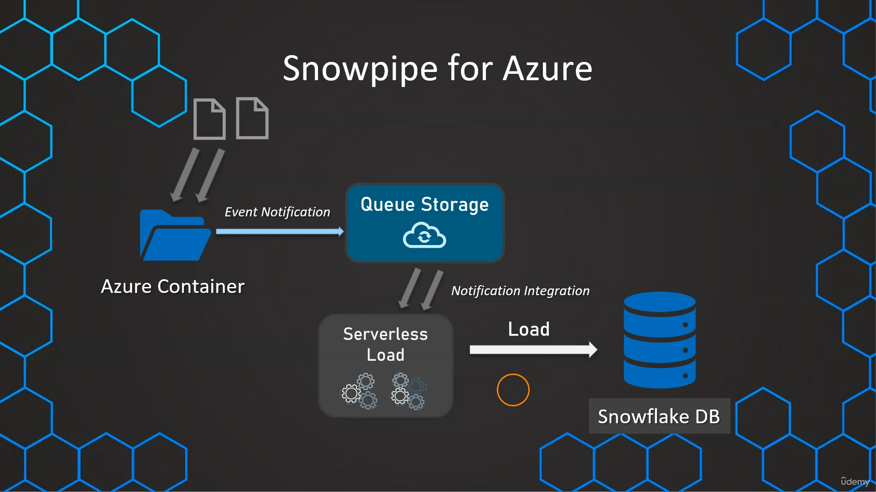

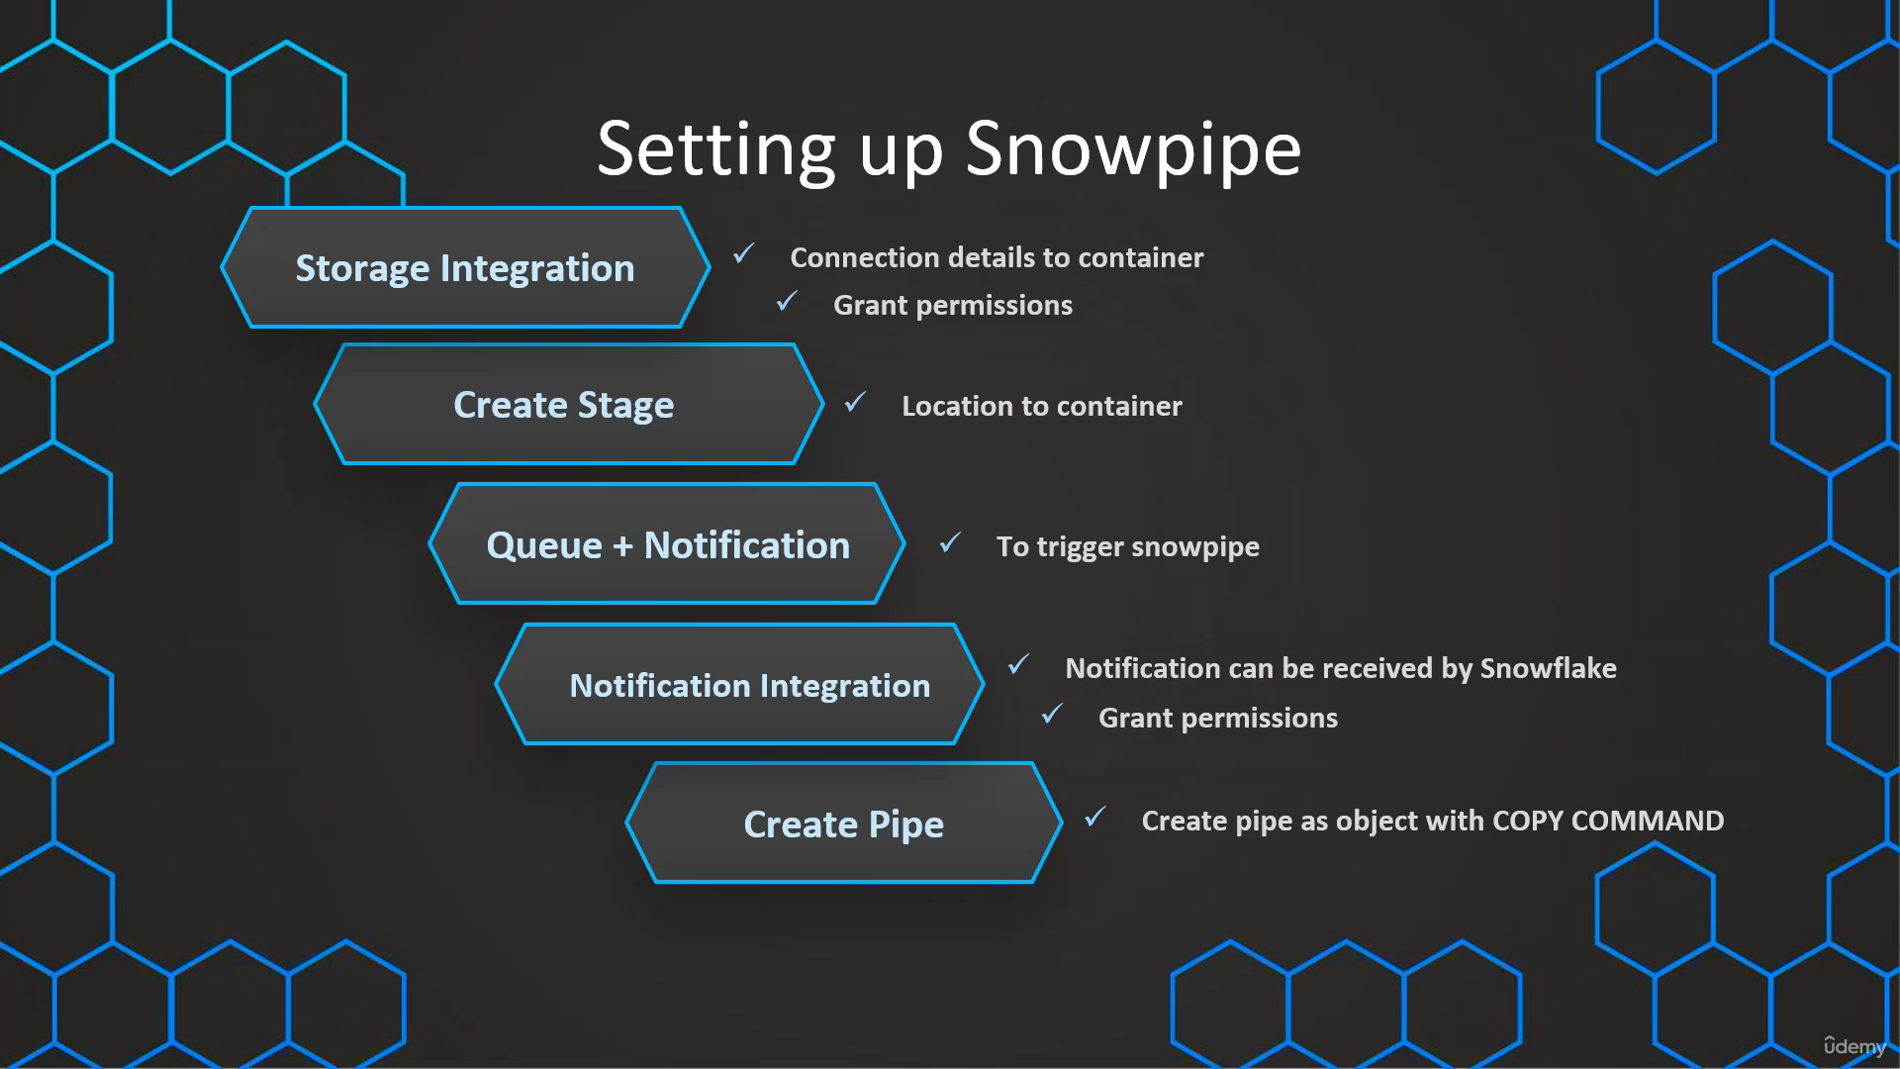

**Create Stage and Storage Integration :**

**Step 1 :-**

**Login into Azure Account->Storage Account->create->Resource group->new->Redundancy->Local Redundant Storage(LRS)->Review and create->create**

**Step 2 :-**

**Storage Accounts->Click on newly created storage account name->Data Storage->Container-> create new container name like csv,json…etc**

**->click on container name (csv)->then upload file**

**Step 3:**

**First find Tetant id->** **Tetant Properties-> Tetant ID**

**To find STORAGE_ALLOWED_LOCATIONS ->Containers-> Click on newly created Container Name-> Properties-> Container Properties->Copy URL**

**CREATE OR REPLACE DATABASE SNOWPIPE;**

**-- create integration object that contains the access information**

**CREATE OR REPLACE STORAGE INTEGRATION azure_snowpipe_integration**

**TYPE = EXTERNAL_STAGE**

**STORAGE_PROVIDER = AZURE**

**ENABLED = TRUE**

**AZURE_TENANT_ID = 'ff355289-721e-4dd7-a663-afec62ab9d54'**

**STORAGE_ALLOWED_LOCATIONS =('azure://snowpipestorageaccount7.blob.core.windows.net/snowpipecsv');**

**-- Describe integration object to provide access**

**DESC STORAGE integration azure_snowpipe_integration;**

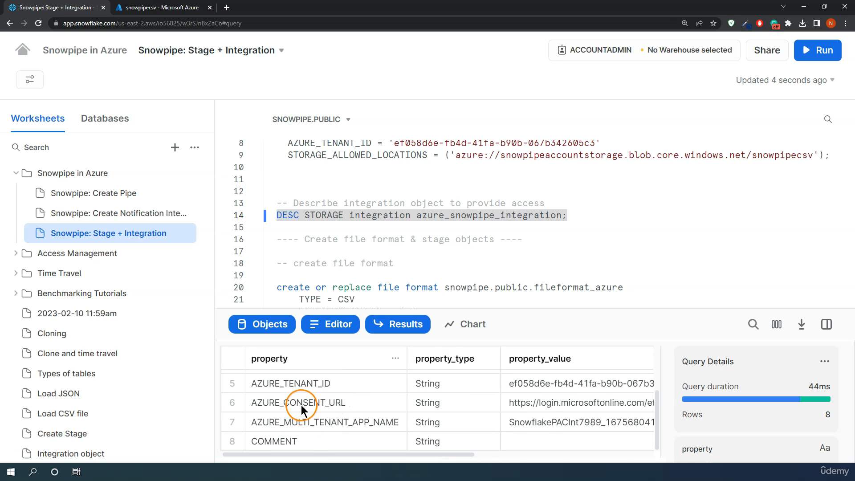

**Copy Azure_Consent_URL column data->** [**https://login.microsoftonline.com/ff355289-721e-4dd7-a663-afec62ab9d54/oauth2/authorize?client_id=ea87aaf9-6f63-457d-a32b-8b446a4bc274&response_type=code**](https://login.microsoftonline.com/ff355289-721e-4dd7-a663-afec62ab9d54/oauth2/authorize?client_id=ea87aaf9-6f63-457d-a32b-8b446a4bc274&response_type=code)

**Open above link and give grant permission**

**Step :**

**Storage Accounts->Click on newly created storage account name->Access Control->Add->add role assignment->search->storage blob data reader->next->select members->search with AZURE_MULTI_TENANT_APP_NAME(its available in snowflake (DESC STORAGE integration azure_snowpipe_integration;))->select ->Review and assign**

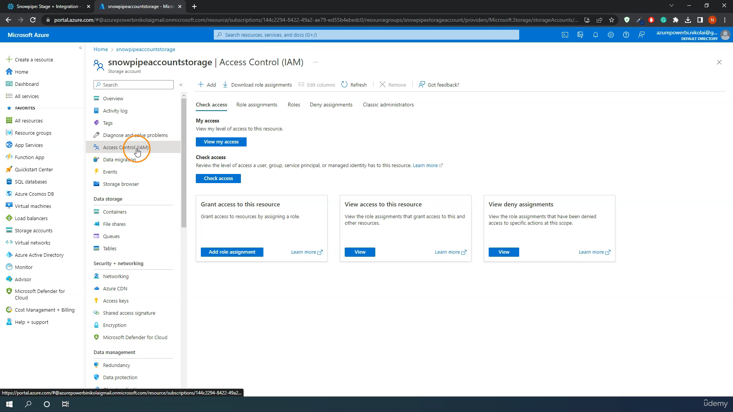

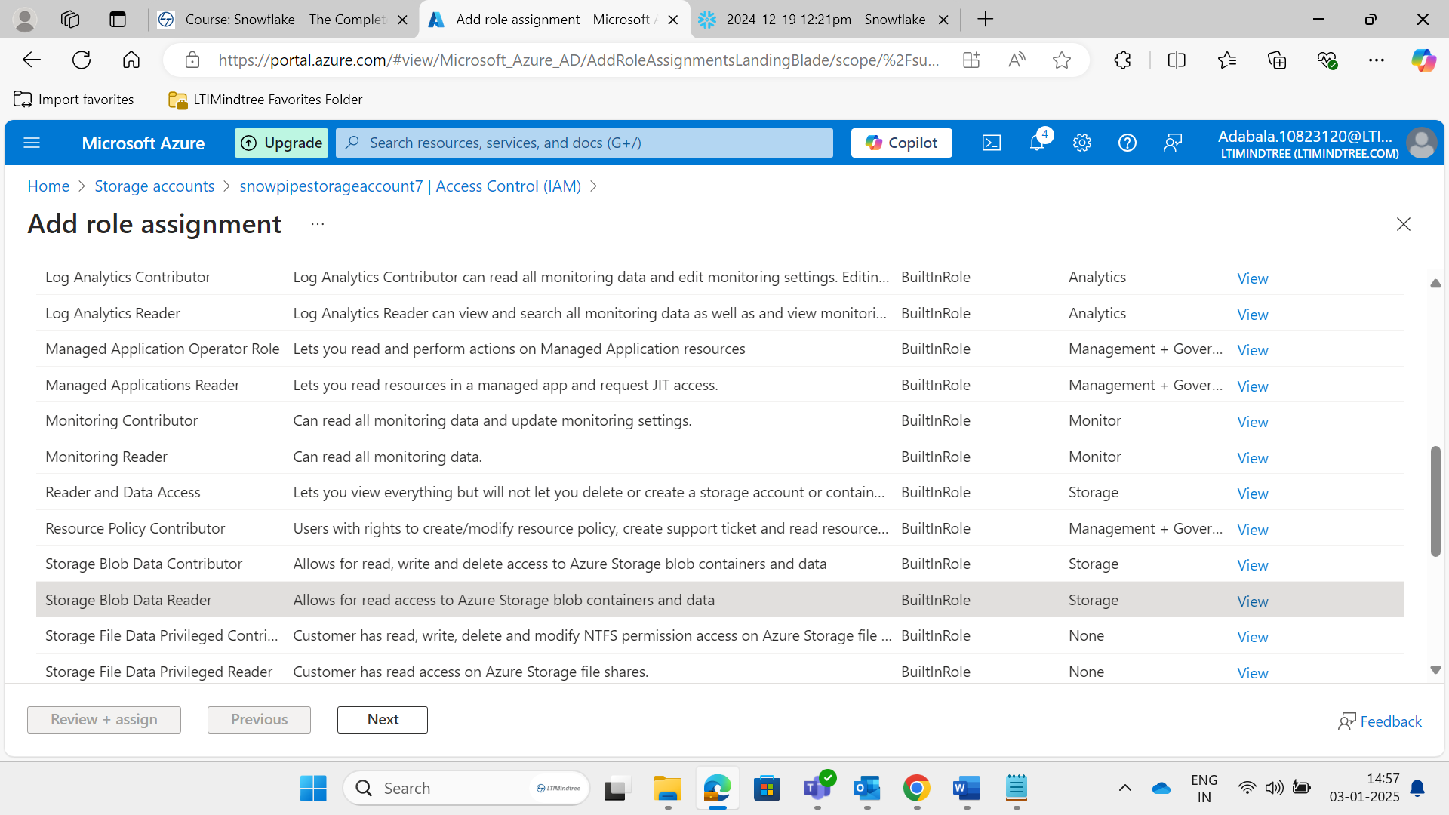

**Step:**

**-- create file format**

**create or replace file format snowpipe.public.fileformat_azure**

**TYPE = CSV**

**FIELD_DELIMITER = ','**

**SKIP_HEADER = 1;**

**Step :**

**-- create stage object**

**create or replace stage snowpipe.public.stage_azure**

**STORAGE_INTEGRATION = azure_snowpipe_integration**

**URL = 'azure://snowpipestorageaccount7.blob.core.windows.net/snowpipecsv'**

**FILE_FORMAT = fileformat_azure;**

**-- list files**

**LIST @snowpipe.public.stage_azure;**

**Step : Create notification integration**

**Storage Accounts->Click on newly created storage account name->Data Storage->queues->Create Queue**

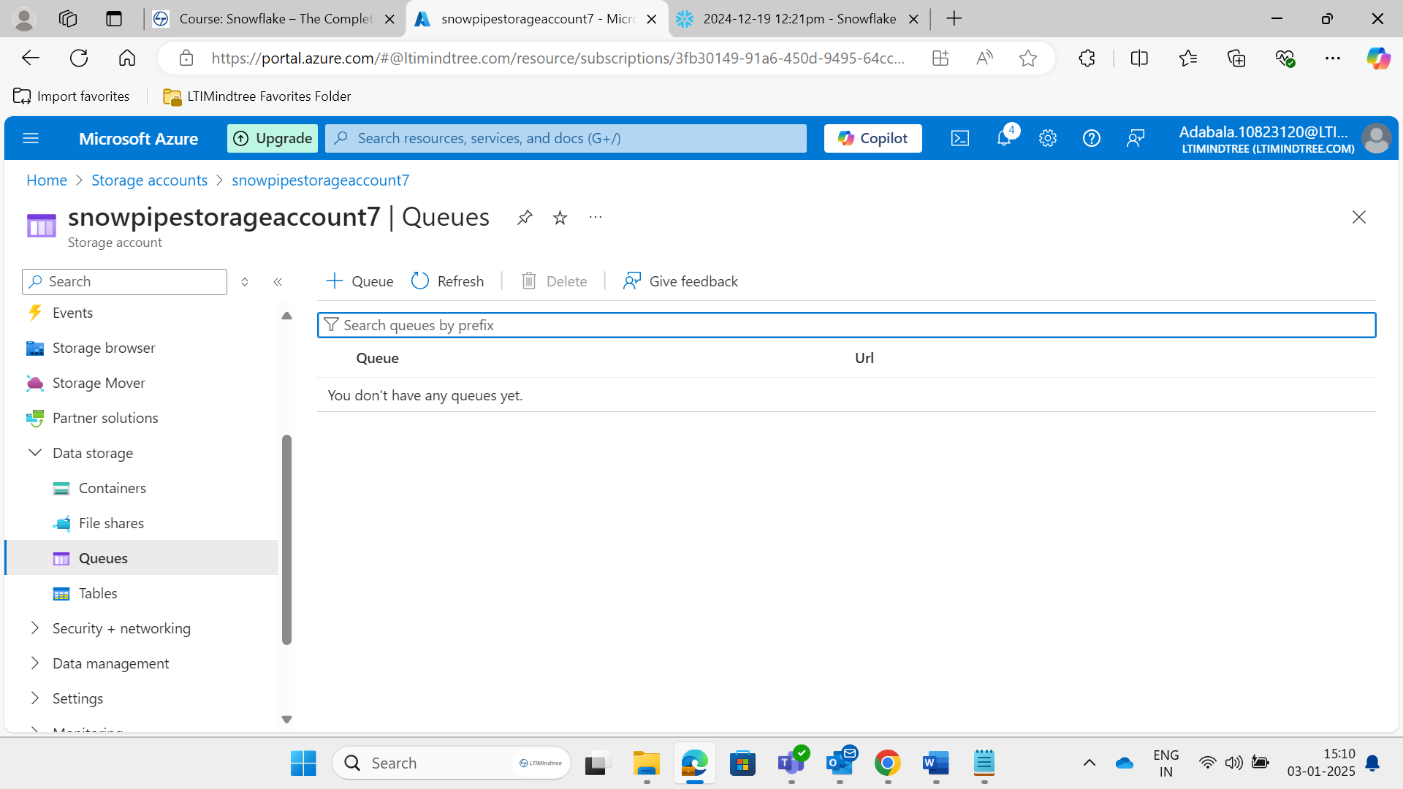

**Step :**

**Events->Create Event Subcription**

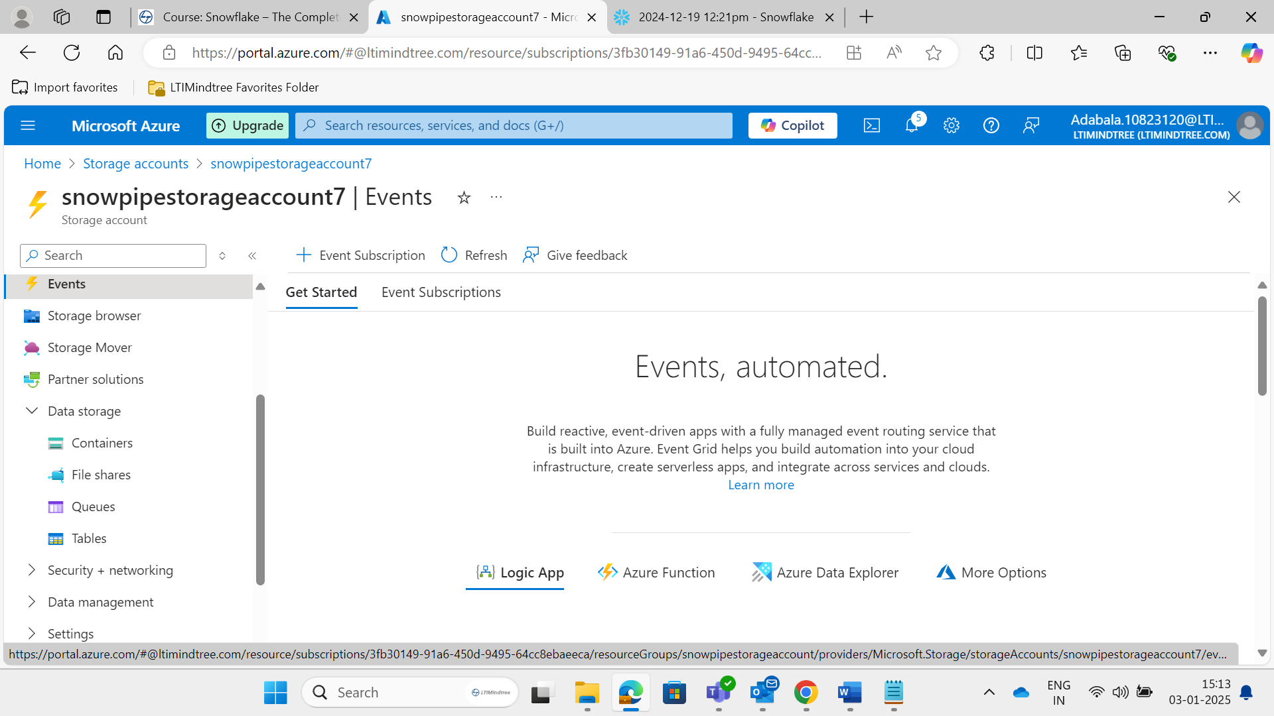

**Create Event Subcription**

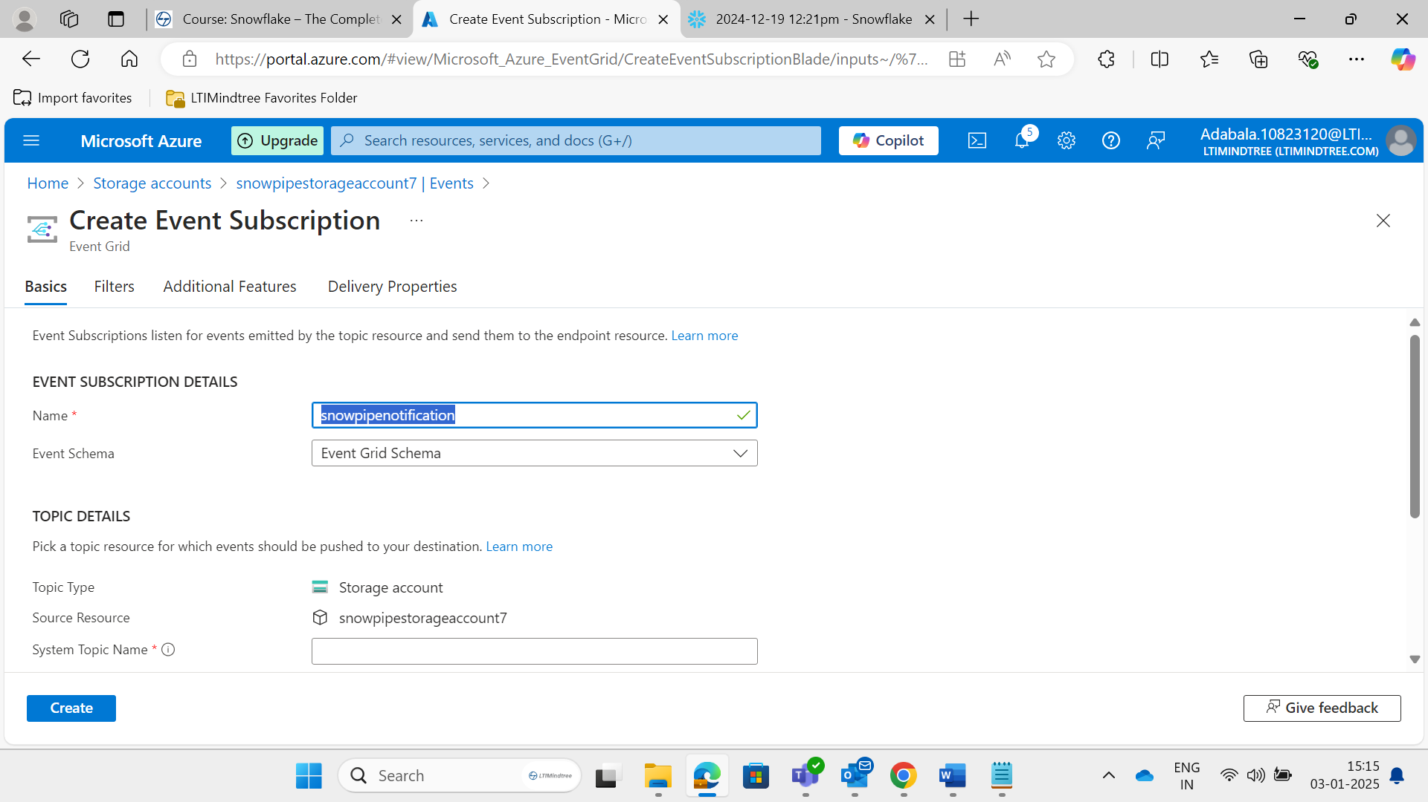

**Select filter to Event Types->Blob Created**

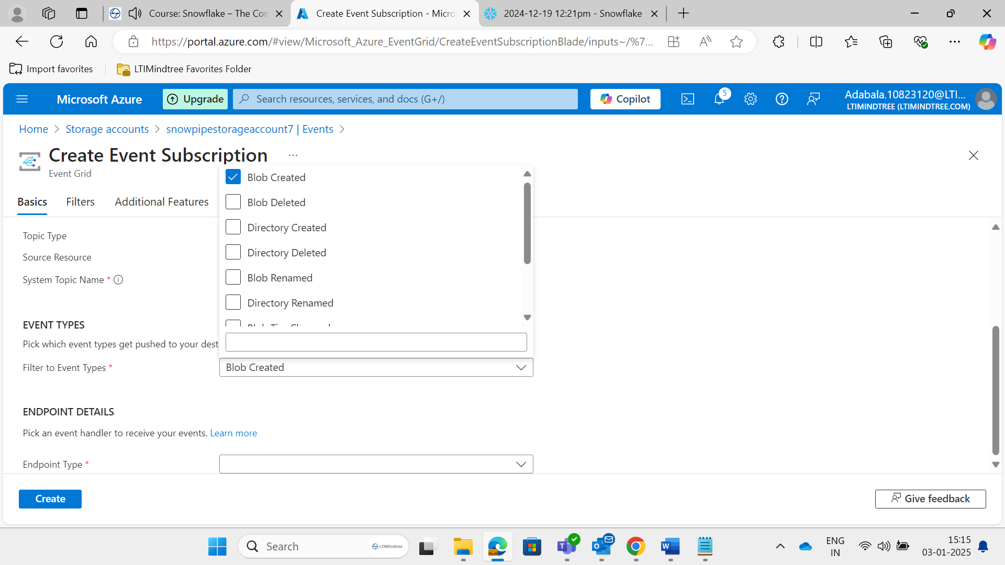

**Select ->Endpoint type->Storage Queue**

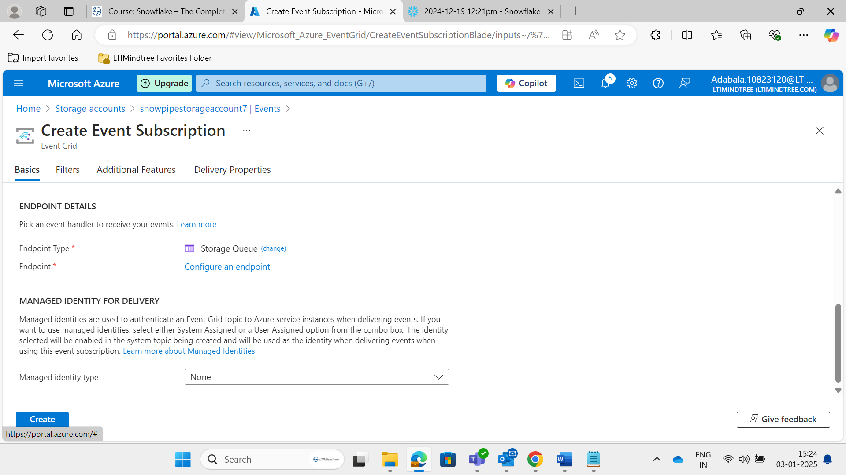

**Then click on configure an endpoint then click on select->create**

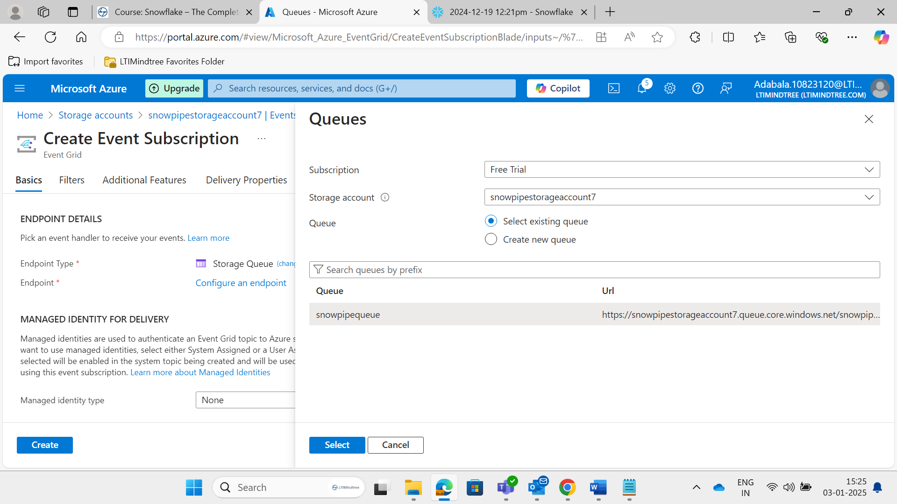

**Its giving error**

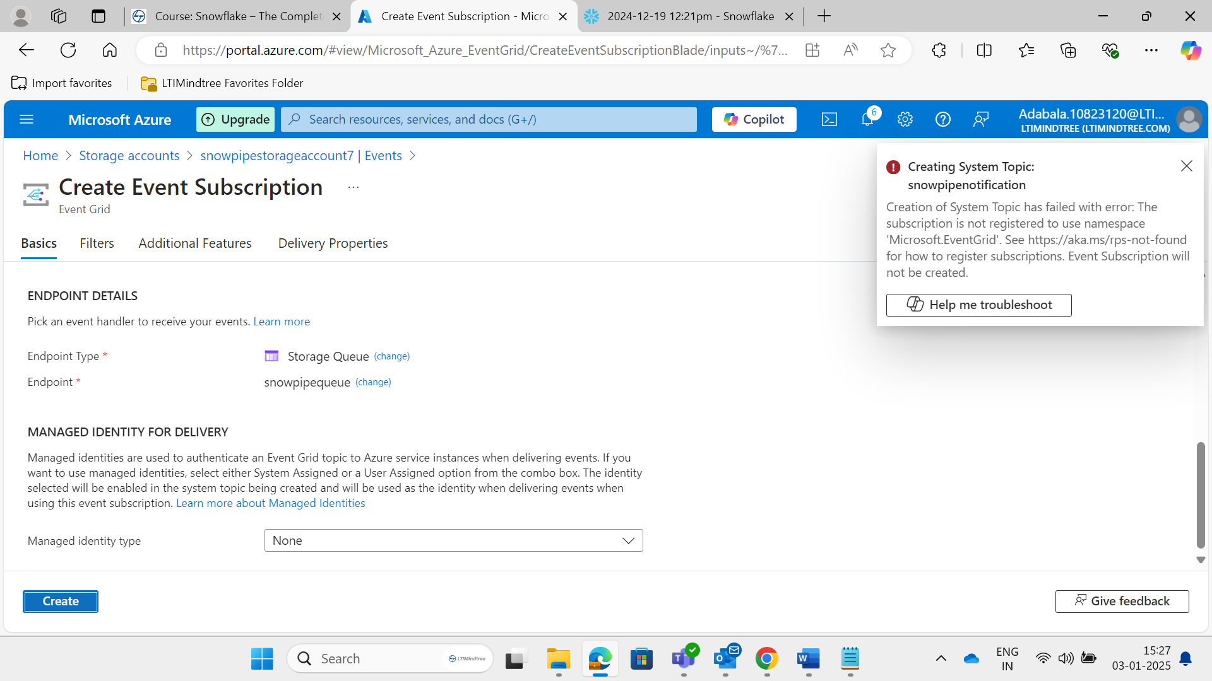

**So need to do subscription first**

**Home->Search-> subscriptions**

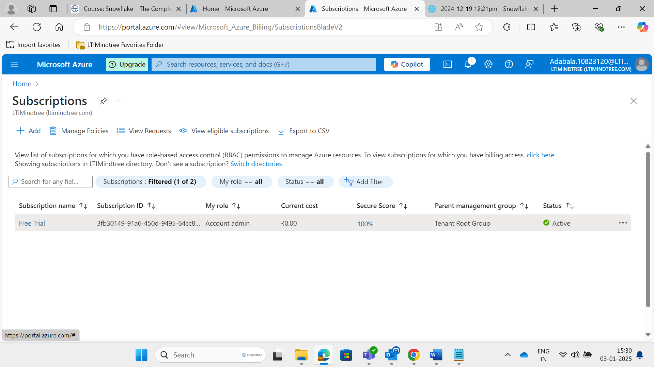

**Click on our subscription name->Click on resource providers->search->eventgrid->select->register**

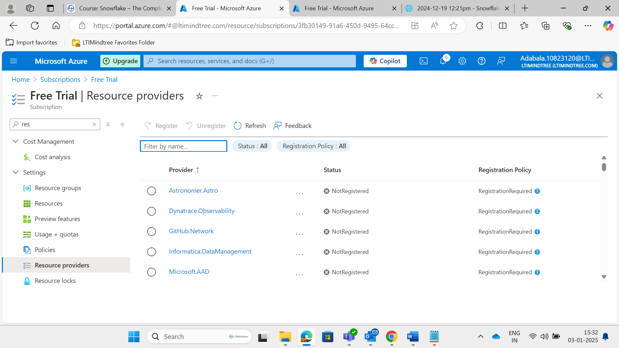

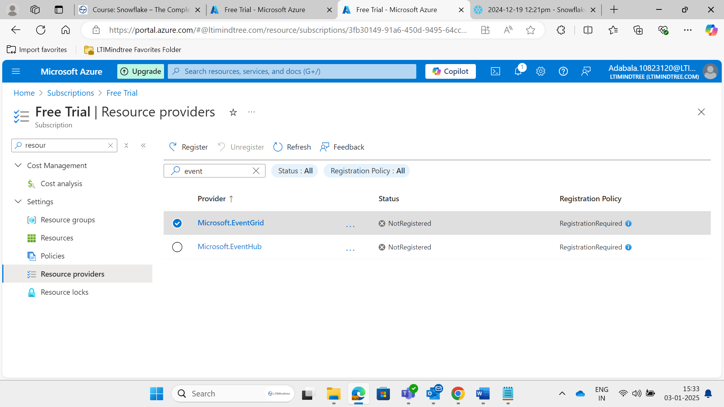

**After now try to click on create Event Subcription**

**Step :Notification Integration**

**First in Azure goto data storage->queues->then copy the url(AZURE_STORAGE_QUEUE_PRIMARY_URI)**

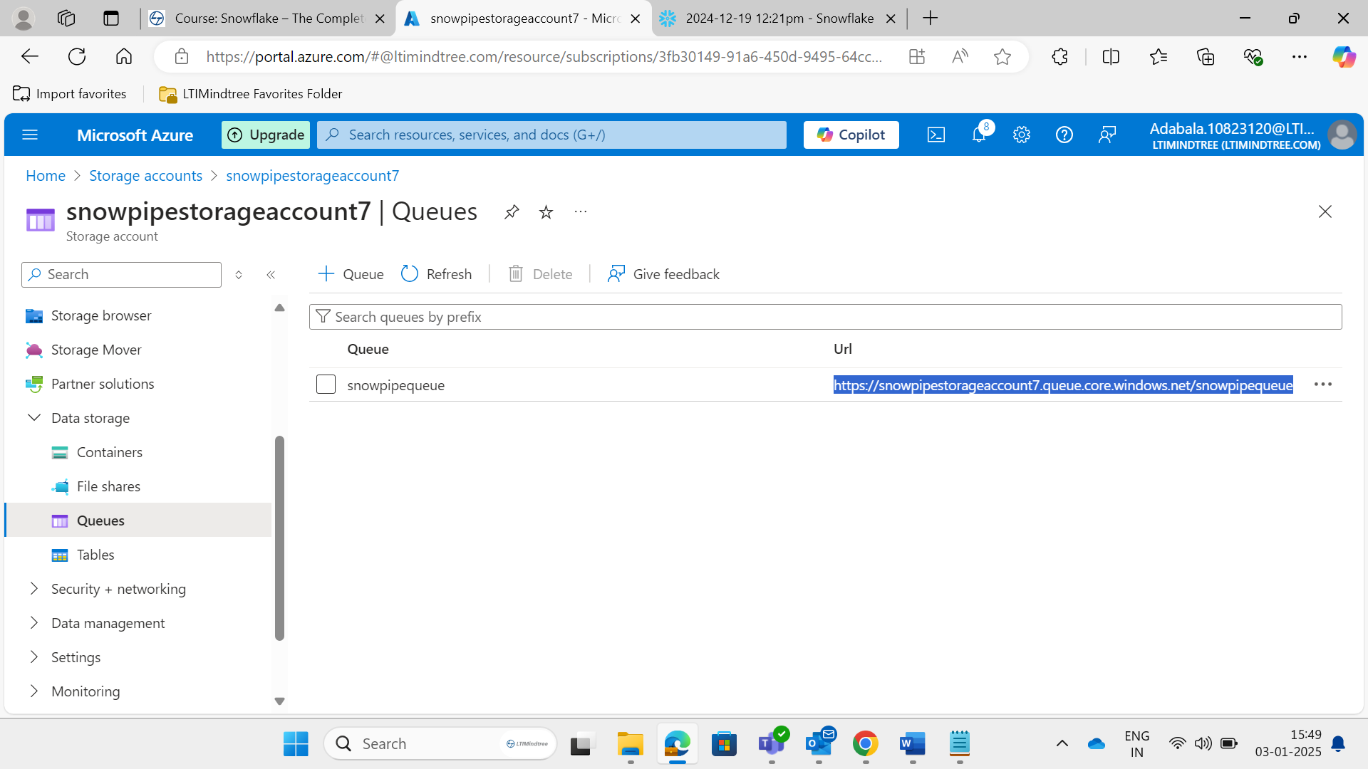

**CREATE OR REPLACE NOTIFICATION INTEGRATION snowpipe_event**

**ENABLED = true**

**TYPE = QUEUE**

**NOTIFICATION_PROVIDER = AZURE_STORAGE_QUEUE**

**AZURE_STORAGE_QUEUE_PRIMARY_URI = 'https://snowpipestorageaccount7.queue.core.windows.net/snowpipequeue'**

**AZURE_TENANT_ID = 'ff355289-721e-4dd7-a663-afec62ab9d54';**

**-- Register Integration**

**DESC notification integration snowpipe_event;**

**Copy Azure_Consent_URL column data->** [**https://login.microsoftonline.com/ff355289-721e-4dd7-a663-afec62ab9d54/oauth2/authorize?client_id=00802c61-0800-4f86-b881-7af445c8ba83&response_type=code**](https://login.microsoftonline.com/ff355289-721e-4dd7-a663-afec62ab9d54/oauth2/authorize?client_id=00802c61-0800-4f86-b881-7af445c8ba83&response_type=code)

**Open above link and give grant permission**

**Step**

**After again login into Azure Account and create new role.**

**Storage Accounts->Click on newly created storage account name->Access Control->Add->add role assignment->search->storage blob data reader->next->select members->search with AZURE_MULTI_TENANT_APP_NAME(its available in snowflake (DESC notification integration snowpipe_event;))->select ->Review and assign**

**Create Pipe and Load Data**

**Storage Accounts->Click on newly created storage account name->Data Storage->containers->click on newly created container->upload** **--query file**

**SELECT**

**$1,**

**$2,**

**$3,**

**$4,**

**$5,**

**$6,**

**$7,**

**$8,**

**$9,**

**$10,**

**$11,**

**$12,**

**$13,**

**$14,**

**$15,**

**$16,**

**$17,**

**$18,**

**$19,**

**$20**

**FROM @snowpipe.public.stage_azure;**

**-- create destination table**

**create or replace table snowpipe.public.happiness (**

**country_name varchar,**

**regional_indicator varchar,**

**ladder_score number(4,3),**

**standard_error number(4,3),**

**upperwhisker number(4,3),**

**lowerwhisker number(4,3),**

**logged_gdp number(5,3),**

**social_support number(4,3),**

**healthy_life_expectancy number(5,3),**

**freedom_to_make_life_choices number(4,3),**

**generosity number(4,3),**

**perceptions_of_corruption number(4,3),**

**ladder_score_in_dystopia number(4,3),**

**explained_by_log_gpd_per_capita number(4,3),**

**explained_by_social_support number(4,3),**

**explained_by_healthy_life_expectancy number(4,3),**

**explained_by_freedom_to_make_life_choices number(4,3),**

**explained_by_generosity number(4,3),**

**explained_by_perceptions_of_corruption number(4,3),**

**dystopia_residual number (4,3));**

**COPY INTO HAPPINESS**

**FROM @snowpipe.public.stage_azure;**

**SELECT * FROM snowpipe.public.happiness;**

**TRUNCATE TABLE snowpipe.public.happiness;**

**-- create pipe**

**create pipe azure_pipe**

**auto_ingest = true**

**integration = 'SNOWPIPE_EVENT'**

**as**

**copy into snowpipe.public.happiness**

**from @snowpipe.public.stage_azure;**

**SELECT SYSTEM$PIPE_STATUS( 'AZURE_PIPE' )**